DSWD DROMIC Report #2 on the
Flashflood Incident in Banaue, Ifugao
as of 09 July 2022, 6PM
- Situation Overview

On 07 July 2022, a flashflood incident occurred in several barangays (Poblacion, Tam-an, Bocos, Poitan, Amganad, and Viewpoint) of Banaue, Ifugao caused by heavy rains.
Source: DSWD Field Office (FO) Cordillera Administrative Region (CAR)

- Status of Affected Areas and Population

A total of 500 families or 1,500 persons are affected in six (6) barangays in Banaue, Ifugao (see Table 1).

Table 1. Number of Affected Families / Persons
REGION / PROVINCE / MUNICIPALITY |  | NUMBER OF AFFECTED
 |  | Barangays | Families | Persons
GRAND TOTAL |  | 6 | 500 | 1,500
CAR |  | 6 | 500 | 1,500
Ifugao |  | 6 | 500 | 1,500
 | Banaue | 6 | 500 | 1,500
Note: Ongoing assessment and validation being conducted.
Source: DSWD FO CAR

- Status of Displaced Population

- Inside Evacuation Center
There are two (2) families or four (4) persons currently taking temporary shelter at the Poblacion Multipurpose Building in Banaue, Ifugao (see Table 2).

Table 2. Number of Displaced Families / Persons Inside Evacuation Center
REGION / PROVINCE / MUNICIPALITY |  | NUMBER OF EVACUATION CENTERS (ECs) |  | NUMBER OF DISPLACED
 |  |  |  | INSIDE ECs
 |  |  |  | Families |  | Persons
 |  | CUM | NOW | CUM | NOW | CUM | NOW
GRAND TOTAL |  | 1 | 1 | 13 | 2 | 23 | 4
CAR |  | 1 | 1 | 13 | 2 | 23 | 4
Ifugao |  | 1 | 1 | 13 | 2 | 23 | 4
 | Banaue | 1 | 1 | 13 | 2 | 23 | 4
Note: Ongoing assessment and validation being conducted.
Source: DSWD FO CAR

- Outside Evacuation Center
There are two (2) families or four (4) persons temporarily staying with their relatives and/or friends (see Table 3).

Table 3. Number of Displaced Families / Persons Outside Evacuation Center
REGION / PROVINCE / MUNICIPALITY |  | NUMBER OF DISPLACED
 |  | OUTSIDE ECs
 |  | Families |  | Persons
 |  | CUM | NOW | CUM | NOW
GRAND TOTAL |  | 2 | 2 | 4 | 4
CAR |  | 2 | 2 | 4 | 4
Ifugao |  | 2 | 2 | 4 | 4
 | Banaue | 2 | 2 | 4 | 4
Note: Ongoing assessment and validation being conducted.
Source: DSWD FO CAR

- Total Displaced Population
There are four (4) families or eight (8) persons taking temporarily shelter either in evacuation center or with their relatives and/or friends (see Table 4).

Table 4. Total Number of Displaced Families / Persons
REGION / PROVINCE / MUNICIPALITY |  | TOTAL DISPLACED SERVED
 |  | Families |  | Persons
 |  | Total Families |  | Total Persons
 |  | CUM | NOW | CUM | NOW
GRAND TOTAL |  | 15 | 4 | 27 | 8
CAR |  | 15 | 4 | 27 | 8
Ifugao |  | 15 | 4 | 27 | 8
 | Banaue | 15 | 4 | 27 | 8
Note: Ongoing assessment and validation being conducted.
Source: DSWD FO CAR

- Damaged Houses

A total of 433 houses were damaged; of which, two (2) are totally damaged and 431 are partially damaged in Banaue, Ifugao (see Table 5).
Table 5. Number of Damaged Houses
REGION / PROVINCE / MUNICIPALITY |  | NO. OF DAMAGED HOUSES
 |  | Total | Totally | Partially
GRAND TOTAL |  | 433 | 2 | 431
CAR |  | 433 | 2 | 431
Ifugao |  | 433 | 2 | 431
 | Banaue | 433 | 2 | 431
Note: Ongoing assessment and validation being conducted.
Source: DSWD FO CAR

- Cost of Humanitarian Assistance Provided

A total of ₱1,013,299.35 worth of assistance was provided to the affected families; of which, ₱948,299.35 from the DSWD and ₱65,000.00 from the Local Government Unit (LGU) (see Table 6).

Table 6. Cost of Assistance Provided to Affected Families / Persons
REGION / PROVINCE / MUNICIPALITY |  | COST OF ASSISTANCE
 |  | DSWD | LGU | NGOs | OTHERS | GRAND TOTAL
GRAND TOTAL |  | 948,299.35 | 65,000.00 | - | - | 1,013,299.35
CAR |  | 948,299.35 | 65,000.00 | - | - | 1,013,299.35
Ifugao |  | 948,299.35 | 65,000.00 | - | - | 1,013,299.35
 | Banaue | 948,299.35 | 65,000.00 | - | - | 1,013,299.35
Source: DSWD FO CAR

- Response Actions and Interventions

- Standby Funds and Prepositioned Relief Stockpile
OFFICE | STANDBY FUNDS | STOCKPILE |  |  | TOTAL STANDBY FUNDS & STOCKPILE
 |  | FAMILY FOOD PACKS (FFPs) |  | OTHER FOOD AND NON-FOOD ITEMS (FNIs)
 |  | QUANTITY | TOTAL COST
TOTAL | 614,156,574.80 | 546,032 | 339,464,527.27 | 675,650,712.23 | 1,629,271,814.30
DSWD CO | 548,378,151.49 | - | - | - | 548,378,151.49
NRLMB NROC | - | 98,764 | 64,031,320.00 | 108,138,933.36 | 172,170,253.36
NRLMB VDRC | - | 51,729 | 32,742,910.00 | 51,409,005.80 | 84,151,915.80
DSWD FO CAR | 5,000,819.12 | 24,934 | 16,705,471.26 | 36,400,523.47 | 58,106,813.85
Other FOs | 60,777,604.19 | 370,605 | 225,984,826.01 | 479,702,249.60 | 766,464,679.80
Note: The Inventory Summary is as of 09 July 2022, 4PM.
Source: DSWD-DRMB and DSWD-NRLMB

  - Standby Funds
    - ₱548.38 million Quick Response Fund (QRF) at the DSWD Central Office.
    - ₱5 million available at DSWD FO CAR.
    - ₱60.78 million in other DSWD FOs which may support the relief needs through inter-FO augmentation.

  - Prepositioned FFPs and Other Relief Items
    - 150,493 FFPs available in Disaster Response Centers; of which, 98,764 FFPs are at the National Resource Operations Center (NROC), Pasay City and 51,729 FFPs are at the Visayas Disaster Resource Center (VDRC), Mandaue City.
    - 24,934 FFPs available at DSWD FO CAR.
    - 370,605 FFPs in other DSWD FOs which may support the relief needs through inter-FO augmentation.
    - ₱675.65 million worth of other FNIs at NROC, VDRC, and DSWD FO warehouses.

- Food and Non-food Items (FNIs)

DATE | ACTIVITIES
09 July 2022 | - DSWD FO CAR unloaded 1,300 FFPs at Lagawe satellite warehouse in Ifugao.
08 July 2022 | - DSWD FO CAR delivered 1,000 FFPs as prepositioned goods at PAT Ifugao.  - DSWD FO CAR assisted the PLGU Ifugao in the hauling 1,000 FFPs bound to Banaue, Ifugao.

- Other Activities

DATE | ACTIVITIES
09 July 2022 | - DSWD FO CAR Psychosocial Support Program (PSP) Team is on standby for possible deployment to Ifugao.  - The Crisis Intervention Section (CIS) of DSWD FO CAR is on standby for possible provision of assistance to affected families and individuals.  - DSWD FO CAR coordinated with the Department of Human Settlements and Urban Development (DHSUD) for possible shelter assistance to families with damaged houses.
08 July 2022 | - DSWD FO CAR discussed updates and actions taken to Sec. Erwin T. Tulfo in a virtual meeting.  - DSWD FO CAR coordinated with DSWD FO II for possible augmentation support from Nueva Vizcaya to Ifugao.  - The Regional Quick Response Team (QRT) of DSWD FO CAR was alerted to be on standby for possible deployment.  - The Disaster Response Management Division (DRMD) and PAT Ifugao QRTs were activated to continuously monitor the incident and ensure the availability of FFPs.  - DSWD FO CAR coordinated with the Office of Civil Defense (OCD) and Department of Public Works and Highways (DPWH) for the possible delivery of FFPs to Mountain Province satellite warehouse as need arises.

- Photo Documentation

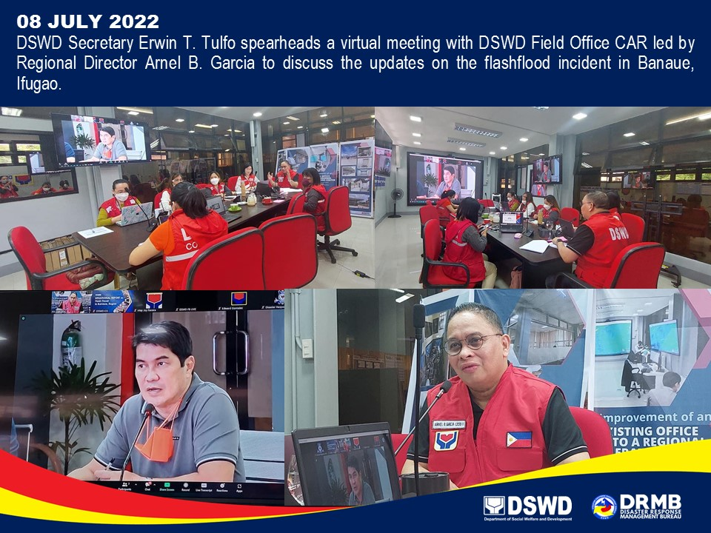
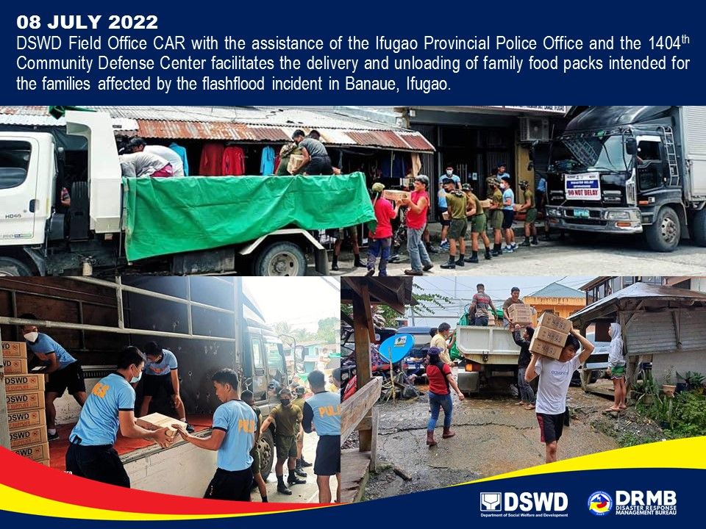

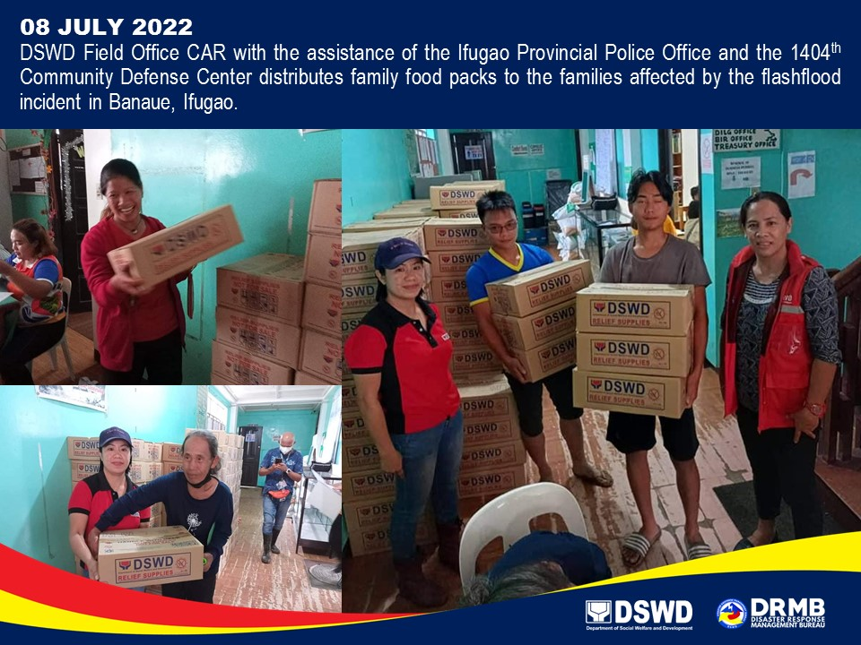

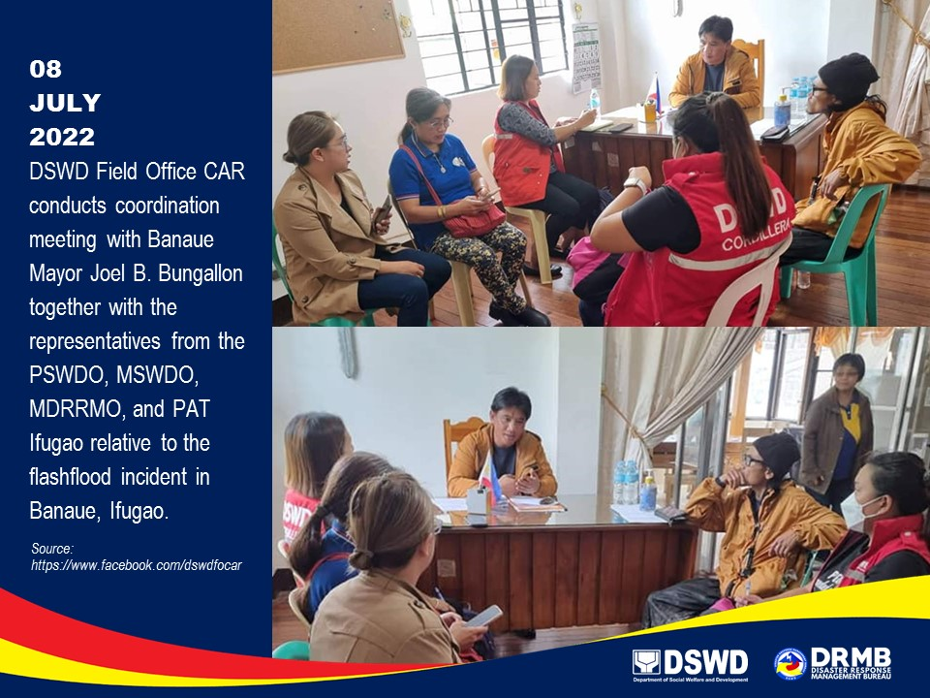

*****
The Disaster Response Operations Monitoring and Information Center (DROMIC) of DSWD-DRMB is closely coordinating with DSWD FO CAR for significant disaster response updates and assistance provided.

Prepared by:  AARON JOHN B. PASCUA | Released by:  MARC LEO L. BUTAC

