DSWD DROMIC Report #2 on the Flashflood Incident
in Zamboanga del Sur
as of 07 July 2022, 6PM
- Situation Overview

On 05 July 2022, two (2) municipalities in Zamboanga del Sur experienced flashfloods brought by cloudy skies with scattered rainshowers and thunderstorms caused by the Low-Pressure Area (LPA) which is embedded along the Intertropical Convergence Zone (ITCZ).
Source: DOST-PAGASA Weather Bulletin and DSWD Field Office (FO) IX

- Status of Affected Areas and Population

A total of 2,907 families or 14,533 persons are affected in eight (8) Barangays in Zamboanga del Sur (see Table 1).

Table 1. Number of Affected Families / Persons
REGION / PROVINCE / MUNICIPALITY |  | NUMBER OF AFFECTED
 |  | Barangays | Families | Persons
GRAND TOTAL |  | 8 | 2,907 | 14,533
REGION IX |  | 8 | 2,907 | 14,533
Zamboanga del Sur |  | 8 | 2,907 | 14,533
 | Dinas | 1 | 9 | 43
 | Molave | 7 | 2,898 | 14,490
Note: Ongoing assessment and validation being conducted.
*All of the affected families have returned home.
Source: DSWD FO IX

- Cost of Humanitarian Assistance Provided

A total of ₱465,609.48 worth of assistance was provided by DSWD to the affected
families (see Table 2).

Table 2. Cost of Assistance Provided to Affected Families / Persons
REGION / PROVINCE / MUNICIPALITY |  | COST OF ASSISTANCE
 |  | DSWD | LGU | NGOs | OTHERS | GRAND TOTAL
GRAND TOTAL |  | 465,609.48 | - | - | - | 465,609.48
REGION IX |  | 465,609.48 | - | - | - | 465,609.48
Zamboanga del Sur |  | 465,609.48 | - | - | - | 465,609.48
 | Molave | 465,609.48 | - | - | - | 465,609.48
Source: DSWD FO IX

- Response Actions and Interventions

- Standby Funds and Prepositioned Relief Stockpile
OFFICE | STANDBY FUNDS | STOCKPILE |  |  | TOTAL STANDBY FUNDS & STOCKPILE
 |  | FAMILY FOOD PACKS |  | OTHER FOOD AND NON-FOOD ITEMS (FNIs)
 |  | QUANTITY | TOTAL COST
TOTAL | 553,378,151.49 | 163,949 | 104,377,819.44 | 181,401,464.96 | 839,157,435.89
DSWD CO | 548,378,151.49 | - | - | - | 548,378,151.49
NRLMB NROC | - | 100,764 | 65,387,320.00 | 108,138,933.36 | 173,526,253.36
NRLMB VDRC | - | 51,729 | 32,729,910.00 | 47,584,005.80 | 80,313,915.80
DSWD FO IX | 5,000,000.00 | 11,456 | 6,260,589.44 | 25,678,525.80 | 36,939,115.24
Note: The Inventory Summary is as of 07 July 2022, 4PM.
Source: DSWD-DRMB and DSWD-NRLMB

  - Standby Funds
    - ₱548.38 million Quick Response Fund (QRF) at the DSWD-Central Office.
    - ₱5 million available at DSWD-FO IX.

  - Prepositioned FFPs and Other Relief Items
    - 152,493 FFPs available in Disaster Response Centers; of which, 100,764 FFPs are at the National Resource Operations Center (NROC), Pasay City and 51,729 FFPs are at the Visayas Disaster Response Center (VDRC), Cebu City.
    - 11,456 FFPs available at DSWD FO IX.
    - ₱181.40 million worth of other FNIs at NROC, VDRC and DSWD-FO IX warehouses.

- Other Activities

DATE | ACTIVITIES
06 July 2022 | - The DSWD FO IX through the Disaster Response Management Division (DRMD) continuously coordinates with the concerned Local Government Units (LGUs) for significant updates on the status of affected families and for possible request for augmentation assistance.

- Photo Documentation

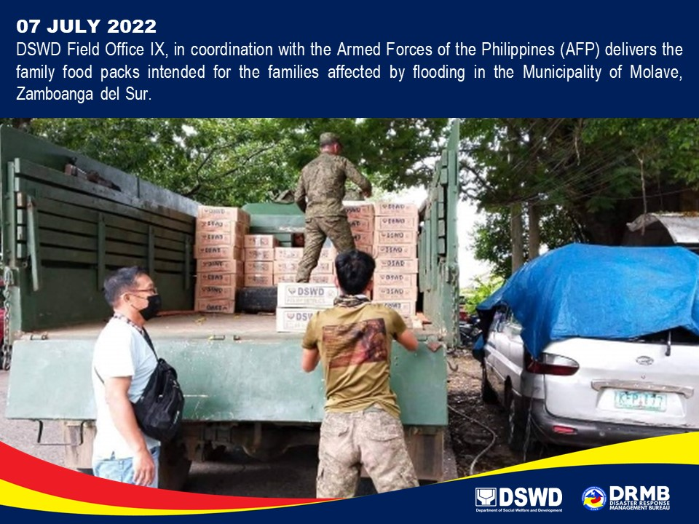

*****
The Disaster Response Operations Monitoring and Information Center (DROMIC) of DSWD-DRMB is closely coordinating with DSWD-FO IX for significant disaster response updates and assistance provided.

Prepared by:  AARON JOHN B. PASCUA | Released by:  RODEL V. CABADDU
MARIE JOYCE G. RAFANAN

