DSWD DROMIC Report #6 on the
Mw 7.0 Earthquake Incident in Tayum, Abra
as of 29 July 2022, 6PM

Situation Overview

On 27 Jul 2022 at 8:43 AM, a 7.0 magnitude earthquake jolted the municipality of Tayum (Abra) (17.64°N, 120.63°E - 003 km N 45° W) with a tectonic origin and a depth of focus of 017 km. The earthquake was also felt in the neighboring municipalities.

Date/Time: | 27 Jul 2022 - 8:43:24 AM
Reported Intensities: | Intensity VII - Bucloc and Manabo, Abra  Intensity VI - Vigan City, Sinait, Bantay, San Esteban, Ilocos Sur; Laoac, Pangasinan; Baguio City;  Intensity V - Magsingal and San Juan, Ilocos Sur, Alaminos City and Labrador, Pangasinan; Bambang, Nueva Vizcaya; Mexico, Pampanga; Concepcion, and Tarlac City, Tarlac; City of Manila; City of Malabon  Intensity IV - City of Marikina; Quezon City; City of Pasig; City of Valenzuela; City of Tabuk, Kalinga; Bautista and Malasiqui, Pangasinan; Bayombong and Diadi, Nueva Vizcaya; Guiguinto, Obando, and San Rafael, Bulacan; San Mateo, Rizal  Intensity III - Bolinao, Pangasinan; Bulakan, Bulacan; Tanay, Rizal  Intensity II - General Trias City, Cavite; Santa Rosa City, Laguna  Instrumental Intensities:  Intensity VII - Vigan City  Intensity V - Laoag City, Ilocos Norte; Peñablanca, Cagayan; Dagupan City, Pangasinan;  Sinait, Ilocos Sur; Baguio City  Intensity IV - Gonzaga, Cagayan; Baler, Aurora; Bayombong, Nueva Vizcaya; Ramos, Tarlac;  Ilagan, Isabela; Basista, Pangasinan; Claveria, Cagayan; San Jose, Palayan City and Cabanatuan City, Nueva Ecija; Madella, Quirino; Tabuk, Kalinga; Santiago City, Isabela  Intensity III - Quezon City; Iba, Zambales; Navotas City, Malabon City, Metro Manila; Magalang & Guagua Pampanga; Bolinao, Sison & Infanta, Pangasinan; Bulakan, San Ildefonso, Guiguinto, Plaridel, and Malolos City, Bulacan; Tarlac City, Tarlac  Intensity II - Dona Remedios Trinidad, Angat & Santa Maria, Bulacan; Tagaytay City, Cavite; Pasig City Metro Manila; Polillo, Gumaca & Infanta, Quezon  Intensity I - Tanay, Taytay, Morong, Antipolo City, Rizal; Marilao,Bulacan; San Juan City, Las Pinas City, Metro Manila; Lucban, Quezon; Subic, Zambales; Mercedes,Camarines Norte; Olongapo City, Zambales; Carmona, Cavite
Expecting Damage: | YES
Expecting Aftershocks: | YES
Source: DOST-PHIVOLCS Earthquake Bulletin

- Status of Affected Areas and Population

A total of 56,099 families or 219,519 persons are affected in 659 barangays in Regions I, II and CAR (see Table 1).

Table 1. Number of Affected Families / Persons

REGION / PROVINCE / MUNICIPALITY |  | NUMBER OF AFFECTED
 |  | Barangays | Families | Persons
GRAND TOTAL |  | 659 | 56,099 | 219,519
REGION I |  | 253 | 17,491 | 67,352
Ilocos Norte |  | 8 | 9 | 33
 | Dingras | 2 | 2 | 2
 | Pinili | 5 | 6 | 27
 | Sarrat | 1 | 1 | 4
Ilocos Sur |  | 198 | 16,621 | 63,917
 | Alilem | 2 | 4 | 23
 | Banayoyo | 4 | 4 | 17
 | Bantay | 16 | 145 | 725
 | Burgos | 1 | 100 | 152
 | Cabugao | 1 | 3 | 9
 | CITY OF CANDON | 19 | 3050 | 13732
 | Caoayan | 3 | 69 | 352
 | Cervantes | 9 | 87 | 445
 | Galimuyod | 9 | 144 | 661
 | Gregorio del Pilar (Concepcion) | 7 | 1247 | 6235
 | Magsingal | 20 | 207 | 848
 | Nagbukel | 8 | 228 | 851
 | Narvacan | 3 | 82 | 474
 | Quirino (Angkaki) | 9 | 239 | 911
 | Salcedo (Baugen) | 1 | 164 | 825
 | San Emilio | 5 | 144 | 720
 | San Esteban | 4 | 27 | 77
 | San Ildefonso | 1 | 21 | 74
 | San Juan (Lapog) | 32 | 8773 | 27816
 | San Vicente | 2 | 66 | 307
 | Santa | 9 | 1413 | 7145
 | Santa Lucia | 13 | 172 | 576
 | Santo Domingo | 1 | 27 | 123
 | Sigay | 3 | 9 | 50
 | Sinait | 1 | 15 | 60
 | Suyo | 1 | 21 | 96
 | Tagudin | 4 | 74 | 254
 | CITY OF VIGAN (Capital) | 10 | 86 | 359
La Union |  | 44 | 857 | 3,381
 | Bagulin | 1 | 23 | 80
 | Balaoan | 5 | 6 | 28
 | Bauang | 13 | 49 | 172
 | Luna | 19 | 767 | 3,048
 | CITY OF SAN FERNANDO (Capital) | 4 | 4 | 9
 | Santo Tomas | 1 | 2 | 8
 | Sudipen | 1 | 6 | 36
Pangasinan |  | 3 | 4 | 21
 | Balungao | 1 | 2 | 10
 | Malasiqui | 1 | 1 | 6
 | Villasis | 1 | 1 | 5
REGION II |  | 1 | 1 | 4
Cagayan |  | 1 | 1 | 4
 | Aparri | 1 | 1 | 4
CAR |  | 405 | 38,607 | 152,163
Abra |  | 219 | 34,693 | 135,829
 | Bangued (capital) | 22 | 659 | 2,793
 | Bucay | 21 | 5,718 | 28,924
 | Bucloc | 4 | 687 | 2,614
 | Danglas | 7 | 1,342 | 4,026
 | Dolores | 15 | 3,734 | 12,373
 | Lacub | 6 | 1,168 | 5,687
 | Lagangilang | 17 | 1,592 | 5,787
 | Lagayan | 5 | 102 | 603
 | Licuan-Baay (Licuan) | 9 | 170 | 595
 | Luba | 8 | 1,835 | 6,451
 | Penarrubia | 9 | 2,081 | 7,660
 | Pidigan | 15 | 1,531 | 5,964
 | Pilar | 19 | 3,344 | 10,914
 | Sallapadan | 9 | 2,039 | 7,823
 | San Isidro | 9 | 1,577 | 5,478
 | San Quintin | 6 | 1,880 | 5,640
 | Tayum | 10 | 947 | 4,696
 | Tineg | 10 | 1,031 | 5,646
 | Tubo | 10 | 1,451 | 5,845
 | Villaviciosa | 8 | 1,805 | 6,310
Benguet |  | 78 | 1,201 | 4,674
 | Atok | 3 | 16 | 54
 | Baguio City | 4 | 5 | 20
 | Bakun | 7 | 155 | 605
 | Bokod | 10 | 177 | 801
 | Buguias | 12 | 199 | 830
 | Itogon | 3 | 15 | 68
 | Kabayan | 9 | 122 | 487
 | Kapangan | 3 | 3 | 6
 | Kibungan | 4 | 52 | 167
 | La Trinidad (capital) | 4 | 8 | 14
 | Mankayan | 11 | 381 | 1,316
 | Sablan | 1 | 1 | 7
 | Tuba | 3 | 25 | 139
 | Tublay | 4 | 42 | 160
Ifugao |  | 13 | 34 | 150
 | Hingyon | 2 | 2 | 4
 | Kiangan | 5 | 20 | 85
 | Tinoc | 6 | 12 | 61
Kalinga |  | 25 | 1,333 | 5,617
 | Balbalan | 6 | 114 | 448
 | Lubuagan | 6 | 818 | 3,458
 | Pasil | 11 | 398 | 1,701
 | City of Tabuk (capital) | 2 | 3 | 10
Mountain Province |  | 70 | 1,346 | 5,893
 | Bontoc (capital) | 11 | 376 | 2,113
 | Sadanga | 2 | 10 | 28
 | Bauko | 19 | 584 | 2,511
 | Besao | 8 | 95 | 212
 | Sabangan | 6 | 9 | 37
 | Sagada | 6 | 22 | 33
 | Tadian | 18 | 250 | 959

Note: This version reflects the actual number of affected families and persons in Regions I, II, and CAR after data validation on 29 July 2022, 2PM. Hence, changes in figures are based on the ongoing assessment and validation that are continuously being conducted.
Source: DSWD Field Offices (FOs)
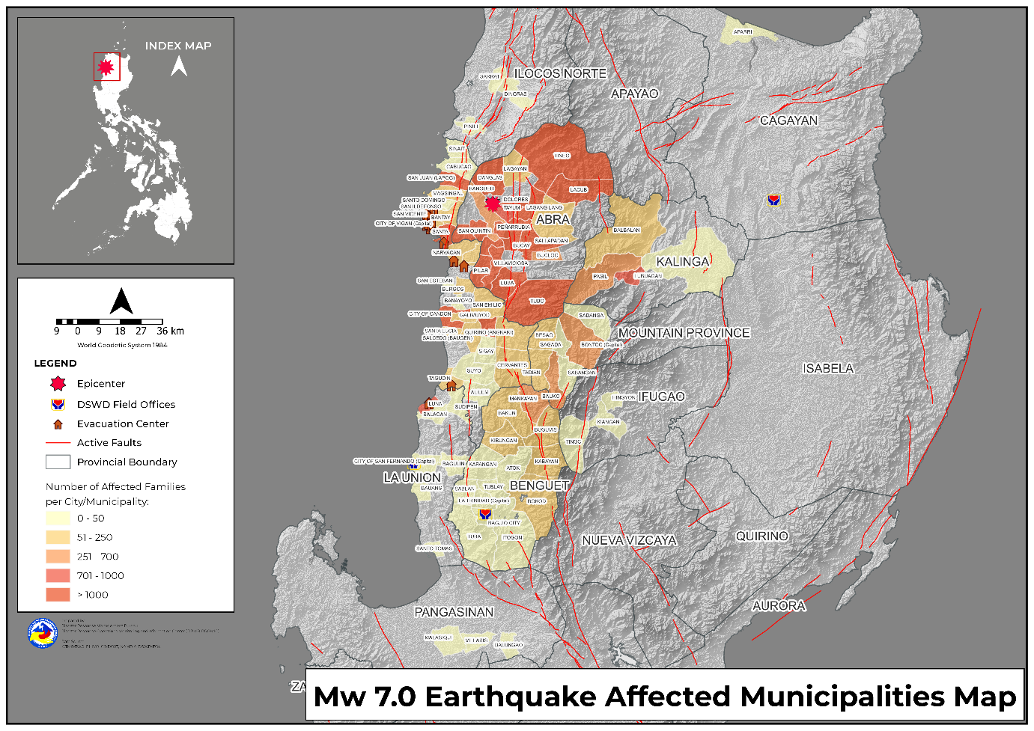

- Status of Displaced Population

- Inside Evacuation Center
There are 1,707 families or 5,472 persons currently taking temporary shelter in 47 evacuation centers in Region I and CAR (see Table 2).

Table 2. Number of Displaced Families / Persons Inside Evacuation Center

REGION / PROVINCE / MUNICIPALITY |  | NUMBER OF EVACUATION CENTERS (ECs) |  | NUMBER OF DISPLACED
 |  |  |  | INSIDE ECs
 |  |  |  | Families |  | Persons
 |  | CUM | NOW | CUM | NOW | CUM | NOW
GRAND TOTAL |  | 85 | 47 | 3,929 | 1,707 | 14,156 | 5,472
REGION I |  | 35 | 8 | 1,222 | 220 | 4,791 | 780
Ilocos Sur |  | 28 | 6 | 851 | 199 | 3,330 | 708
 | Bantay | 1 | 1 | 12 | 12 | 60 | 60
 | Burgos | 1 | 1 | 100 | 100 | 152 | 152
 | Caoayan | 1 | - | 65 | - | 331 | -
 | Galimuyod | 7 | - | 99 | - | 465 | -
 | Nagbukel | 1 | - | 63 | - | 231 | -
 | Narvacan | 3 | 3 | 82 | 82 | 474 | 474
 | San Ildefonso | 1 | - | 21 | - | 74 | -
 | San Juan (Lapog) | 1 | 1 | 5 | 5 | 22 | 22
 | San Vicente | 3 | - | 52 | - | 249 | -
 | Santa | 1 | - | 215 | - | 762 | -
 | Santo Domingo | 1 | - | 27 | - | 123 | -
 | Tagudin | 4 | - | 56 | - | 176 | -
 | CITY OF VIGAN (Capital) | 3 | - | 54 | - | 211 | -
La Union |  | 7 | 2 | 371 | 21 | 1,461 | 72
 | Bagulin | 1 | - | 23 | - | 80 | -
 | Bauang | 2 | - | 4 | - | 25 | -
 | Luna | 4 | 2 | 344 | 21 | 1,356 | 72
CAR |  | 50 | 39 | 2,707 | 1,487 | 9,365 | 4,692
Abra |  | 32 | 27 | 2,198 | 1,233 | 7,205 | 3,753
 | Bangued (capital) | 9 | 9 | 95 | 95 | 526 | 526
 | Bucay | 11 | 6 | 1,494 | 529 | 4,883 | 1,431
 | Bucloc | 4 | 4 | 415 | 415 | 1,195 | 1,195
 | Danglas | 2 | 2 | 22 | 22 | 76 | 76
 | Lacub | 1 | 1 | 73 | 73 | 231 | 231
 | Licuan-Baay (Licuan) | 1 | 1 | 6 | 6 | 30 | 30
 | Tubo | 1 | 1 | 26 | 26 | 50 | 50
 | Villaviciosa | 3 | 3 | 67 | 67 | 214 | 214
Benguet |  | 4 | 3 | 31 | 17 | 107 | 52
 | Atok | 2 | 2 | 14 | 8 | 47 | 24
 | Bakun | 1 | - | 8 | - | 32 | -
 | Kabayan | 1 | 1 | 9 | 9 | 28 | 28
Kalinga |  | 9 | 7 | 428 | 199 | 1,904 | 754
 | Lubuagan | 5 | 5 | 91 | 91 | 435 | 435
 | Pasil | 4 | 2 | 337 | 108 | 1,469 | 319
Mountain Province |  | 5 | 2 | 50 | 38 | 149 | 133
 | Bontoc (capital) | 2 | - | 2 | - | 6 | -
 | Bauko | 1 | 1 | 10 | 10 | 14 | 14
 | Besao | 1 | 1 | 28 | 28 | 119 | 119
 | Tadian | 1 | - | 10 | - | 10 | -
Note: Ongoing assessment and validation being conducted.
Source: DSWD FOs

- Outside Evacuation Center
There are 6,486 families or 27,198 persons temporarily staying with their relatives and/or friends (see Table 3).

Table 3. Number of Displaced Families / Persons Outside Evacuation Center
REGION / PROVINCE / MUNICIPALITY |  | NUMBER OF DISPLACED
 |  | OUTSIDE ECs
 |  | Families |  | Persons
 |  | CUM | NOW | CUM | NOW
GRAND TOTAL |  | 6,962 | 6,486 | 29,102 | 27,198
REGION I |  | 505 | 90 | 2,110 | 452
Ilocos Sur |  | 94 | 89 | 459 | 446
 | Caoayan | 4 | 4 | 21 | 21
 | San Emilio | 85 | 85 | 425 | 425
 | Tagudin | 5 | - | 13 | -
La Union |  | 410 | - | 1,645 | -
 | Luna | 400 | - | 1,600 | -
 | CITY OF SAN FERNANDO (Capital) | 4 | - | 9 | -
 | Sudipen | 6 | - | 36 | -
Pangasinan |  | 1 | 1 | 6 | 6
 | Malasiqui | 1 | 1 | 6 | 6
CAR |  | 6,457 | 6,396 | 26,992 | 26,746
Abra |  | 5,834 | 5,773 | 24,238 | 23,992
 | Bucay | 262 | 204 | 1,069 | 830
 | Dolores | 19 | 16 | 81 | 74
 | Lacub | 8 | 8 | 32 | 32
 | Lagangilang | 1,592 | 1,592 | 5,787 | 5,787
 | Lagayan | 102 | 102 | 603 | 603
 | Luba | 52 | 52 | 213 | 213
 | Pilar | 141 | 141 | 532 | 532
 | San Isidro | 1,577 | 1,577 | 5,478 | 5,478
 | San Quintin | 213 | 213 | 622 | 622
 | Tayum | 796 | 796 | 4,034 | 4,034
 | Tineg | 1,031 | 1,031 | 5,646 | 5,646
 | Tubo | 6 | 6 | 27 | 27
 | Villaviciosa | 35 | 35 | 114 | 114
Benguet |  | 48 | 48 | 253 | 253
 | Atok | 2 | 2 | 7 | 7
 | Baguio City | 3 | 3 | 18 | 18
 | Bakun | 4 | 4 | 17 | 17
 | Kapangan | 1 | 1 | 4 | 4
 | Mankayan | 15 | 15 | 75 | 75
 | Tuba | 23 | 23 | 132 | 132
Ifugao |  | 2 | 2 | 4 | 4
 | Hingyon | 2 | 2 | 4 | 4
Kalinga |  | 550 | 550 | 2,403 | 2,403
 | Balbalan | 73 | 73 | 260 | 260
 | Lubuagan | 474 | 474 | 2,133 | 2,133
 | City of Tabuk (capital) | 3 | 3 | 10 | 10
Mountain Province |  | 23 | 23 | 94 | 94
 | Bontoc (capital) | 4 | 4 | 14 | 14
 | Bauko | 8 | 8 | 42 | 42
 | Besao | 5 | 5 | 15 | 15
 | Sagada | 4 | 4 | 15 | 15
 | Tadian | 2 | 2 | 8 | 8
Note: Ongoing assessment and validation being conducted.
Source: DSWD FOs

- Total Displaced Population
There are 8,193 families or 32,670 persons taking temporary shelter either in evacuation centers or with their relatives and/or friends (see Table 4).

Table 4. Total Number of Displaced Families / Persons

REGION / PROVINCE / MUNICIPALITY |  | TOTAL DISPLACED SERVED
 |  | Families |  | Persons
 |  | Total Families |  | Total Persons
 |  | CUM | NOW | CUM | NOW
GRAND TOTAL |  | 10,891 | 8,193 | 43,258 | 32,670
REGION I |  | 1,727 | 310 | 6,901 | 1,232
Ilocos Sur |  | 945 | 288 | 3,789 | 1,154
 | Bantay | 12 | 12 | 60 | 60
 | Burgos | 100 | 100 | 152 | 152
 | Caoayan | 69 | 4 | 352 | 21
 | Galimuyod | 99 | - | 465 | -
 | Nagbukel | 63 | - | 231 | -
 | Narvacan | 82 | 82 | 474 | 474
 | San Emilio | 85 | 85 | 425 | 425
 | San Ildefonso | 21 | - | 74 | -
 | San Juan (Lapog) | 5 | 5 | 22 | 22
 | San Vicente | 52 | - | 249 | -
 | Santa | 215 | - | 762 | -
 | Santo Domingo | 27 | - | 123 | -
 | Tagudin | 61 | - | 189 | -
 | CITY OF VIGAN (Capital) | 54 | - | 211 | -
La Union |  | 781 | 21 | 3,106 | 72
 | Bagulin | 23 | - | 80 | -
 | Bauang | 4 | - | 25 | -
 | Luna | 744 | 21 | 2,956 | 72
 | CITY OF SAN FERNANDO (Capital) | 4 | - | 9 | -
 | Sudipen | 6 | - | 36 | -
Pangasinan |  | 1 | 1 | 6 | 6
 | Malasiqui | 1 | 1 | 6 | 6
CAR |  | 9,164 | 7,883 | 36,357 | 31,438
Abra |  | 8,032 | 7,006 | 31,443 | 27,745
 | Bangued (capital) | 95 | 95 | 526 | 526
 | Bucay | 1,756 | 733 | 5,952 | 2,261
 | Bucloc | 415 | 415 | 1,195 | 1,195
 | Danglas | 22 | 22 | 76 | 76
 | Dolores | 19 | 16 | 81 | 74
 | Lacub | 81 | 81 | 263 | 263
 | Lagangilang | 1,592 | 1,592 | 5,787 | 5,787
 | Lagayan | 102 | 102 | 603 | 603
 | Licuan-Baay (Licuan) | 6 | 6 | 30 | 30
 | Luba | 52 | 52 | 213 | 213
 | Pilar | 141 | 141 | 532 | 532
 | San Isidro | 1,577 | 1,577 | 5,478 | 5,478
 | San Quintin | 213 | 213 | 622 | 622
 | Tayum | 796 | 796 | 4,034 | 4,034
 | Tineg | 1,031 | 1,031 | 5,646 | 5,646
 | Tubo | 32 | 32 | 77 | 77
 | Villaviciosa | 102 | 102 | 328 | 328
Benguet |  | 79 | 65 | 360 | 305
 | Atok | 16 | 10 | 54 | 31
 | Baguio City | 3 | 3 | 18 | 18
 | Bakun | 12 | 4 | 49 | 17
 | Kabayan | 9 | 9 | 28 | 28
 | Kapangan | 1 | 1 | 4 | 4
 | Mankayan | 15 | 15 | 75 | 75
 | Tuba | 23 | 23 | 132 | 132
Ifugao |  | 2 | 2 | 4 | 4
 | Hingyon | 2 | 2 | 4 | 4
Kalinga |  | 978 | 749 | 4,307 | 3,157
 | Balbalan | 73 | 73 | 260 | 260
 | Lubuagan | 565 | 565 | 2,568 | 2,568
 | Pasil | 337 | 108 | 1,469 | 319
 | City of Tabuk (capital) | 3 | 3 | 10 | 10
Mountain Province |  | 73 | 61 | 243 | 227
 | Bontoc (capital) | 6 | 4 | 20 | 14
 | Bauko | 18 | 18 | 56 | 56
 | Besao | 33 | 33 | 134 | 134
 | Sagada | 4 | 4 | 15 | 15
 | Tadian | 12 | 2 | 18 | 8
Note: Ongoing assessment and validation being conducted.
Source: DSWD FOs

- Damaged Houses

A total of 12,082 houses were damaged; of which, 193 are totally damaged and 11,889 are partially damaged in Regions I, II, and CAR (see Table 5).

Table 5. Number of Damaged Houses

REGION / PROVINCE / MUNICIPALITY |  | NO. OF DAMAGED HOUSES
 |  | Total | Totally | Partially
GRAND TOTAL |  | 12,082 | 193 | 11,889
REGION I |  | 1,340 | 45 | 1,295
Ilocos Norte |  | 9 | - | 9
 | Dingras | 2 | - | 2
 | Pinili | 6 | - | 6
 | Sarrat | 1 | - | 1
Ilocos Sur |  | 1,270 | 45 | 1,225
 | Alilem | 4 | - | 4
 | Banayoyo | 3 | - | 3
 | Bantay | 133 | 1 | 132
 | Burgos | 23 | - | 23
 | Cabugao | 3 | - | 3
 | Cervantes | 87 | - | 87
 | Galimuyod | 12 | - | 12
 | Gregorio del Pilar (Concepcion) | 175 | - | 175
 | Magsingal | 173 | 5 | 168
 | Nagbukel | 166 | 32 | 134
 | Quirino (Angkaki) | 237 | 1 | 236
 | Salcedo (Baugen) | 164 | - | 164
 | San Esteban | 14 | - | 14
 | San Juan (Lapog) | 47 | 1 | 46
 | Sigay | 9 | - | 9
 | Sinait | 14 | 2 | 12
 | CITY OF VIGAN (Capital) | 6 | 3 | 3
La Union |  | 57 | - | 57
 | Balaoan | 1 | - | 1
 | Bauang | 29 | - | 29
 | Luna | 23 | - | 23
 | CITY OF SAN FERNANDO (Capital) | 4 | - | 4
Pangasinan |  | 4 | - | 4
 | Balungao | 2 | - | 2
 | Malasiqui | 1 | - | 1
 | Villasis | 1 | - | 1
REGION II |  | 1 | - | 1
Cagayan |  | 1 | - | 1
 | Aparri | 1 | - | 1
CAR |  | 10,741 | 148 | 10,593
Abra |  | 9,405 | 132 | 9,273
 | Bangued (capital) | 367 | 24 | 343
 | Bucay | 2,625 | 38 | 2,587
 | Bucloc | 76 | - | 76
 | Danglas | 158 | - | 158
 | Dolores | 322 | 7 | 315
 | Lacub | 94 | - | 94
 | Lagangilang | 1,639 | - | 1,639
 | Lagayan | 102 | 5 | 97
 | Licuan-Baay (Licuan) | 131 | - | 131
 | Luba | 369 | - | 369
 | Penarrubia | 701 | - | 701
 | Pidigan | 1,333 | 33 | 1,300
 | Pilar | 190 | - | 190
 | Sallapadan | 470 | 15 | 455
 | San Isidro | 314 | - | 314
 | San Quintin | 309 | 4 | 305
 | Tayum | 40 | 2 | 38
 | Tineg | 4 | - | 4
 | Villaviciosa | 161 | 4 | 157
Benguet |  | 145 | 2 | 143
 | Baguio City | 3 | - | 3
 | Bakun | 63 | - | 63
 | Itogon | 15 | 1 | 14
 | Kapangan | 1 | - | 1
 | Mankayan | 55 | - | 55
 | Sablan | 1 | 1 | -
 | Tublay | 7 | - | 7
Ifugao |  | 33 | 2 | 31
 | Hingyon | 2 | 2 | -
 | Kiangan | 20 | - | 20
 | Tinoc | 11 | - | 11
Kalinga |  | 166 | 3 | 163
 | Balbalan | 23 | - | 23
 | Lubuagan | 13 | 1 | 12
 | Pasil | 128 | 2 | 126
 | City of Tabuk (capital) | 2 | - | 2
Mountain Province |  | 992 | 9 | 983
 | Bontoc (capital) | 60 | - | 60
 | Sadanga | 10 | - | 10
 | Bauko | 576 | 5 | 571
 | Besao | 78 | - | 78
 | Sabangan | 8 | - | 8
 | Sagada | 22 | - | 22
 | Tadian | 238 | 4 | 234
Note: This version reflects the actual number of affected families and persons in Regions I, II and CAR after data validation on 29 July 2022, 2PM. Hence, changes in figures are based on the ongoing assessment and validation that are continuously being conducted.
Source: DSWD FOs

- Cost of Humanitarian Assistance Provided

A total of ₱5,046,030.23 worth of assistance was provided to the affected families; of which, ₱4,740,632.23 from the DSWD and ₱305,398.00 was provided by the Local Government Units (LGUs) (see Table 6).

Table 6. Cost of Assistance Provided to Affected Families / Persons
REGION / PROVINCE / MUNICIPALITY |  | COST OF ASSISTANCE
 |  | DSWD | LGUs | NGOs | OTHERS | GRAND TOTAL
GRAND TOTAL |  | 4,740,632.23 | 305,398.00 | - | - | 5,046,030.23
REGION I |  | - | 22,988.00 | - | - | 22,988.00
Ilocos Norte |  | - | 5,520.00 | - | - | 5,520.00
 | Dingras | - | 2,000.00 | - | - | 2,000.00
 | Pinili | - | 3,120.00 | - | - | 3,120.00
 | Sarrat | - | 400.00 | - | - | 400.00
La Union |  | - | 16,208.00 | - | - | 16,208.00
 | Luna | - | 13,000.00 | - | - | 13,000.00
 | CITY OF SAN FERNANDO (Capital) | - | 3,208.00 | - | - | 3,208.00
Pangasinan |  | - | 1,260.00 | - | - | 1,260.00
 | Malasiqui | - | 1,260.00 | - | - | 1,260.00
REGION II |  | 5,853.50 | - | - | - | 5,853.50
Cagayan |  | 5,853.50 | - | - | - | 5,853.50
 | Aparri | 5,853.50 | - | - | - | 5,853.50
CAR |  | 4,734,778.73 | 282,410.00 | - | - | 5,017,188.73
Abra |  | 4,734,778.73 | 173,100.00 | - | - | 4,907,878.73
 | Bangued (capital) | 713,025.00 | - | - | - | 713,025.00
 | Bucay | 2,010,592.08 | 4,900.00 | - | - | 2,015,492.08
 | Bucloc | - | 80,000.00 | - | - | 80,000.00
 | Danglas | - | 9,600.00 | - | - | 9,600.00
 | Lagangilang | 1,087,985.00 | - | - | - | 1,087,985.00
 | Lagayan | - | 72,760.00 | - | - | 72,760.00
 | Penarrubia | - | 5,840.00 | - | - | 5,840.00
 | Villaviciosa | 923,176.65 | - | - | - | 923,176.65
Kalinga |  | - | 108,510.00 | - | - | 108,510.00
 | Balbalan | - | 15,640.00 | - | - | 15,640.00
 | Lubuagan | - | 29,100.00 | - | - | 29,100.00
 | Pasil | - | 63,770.00 | - | - | 63,770.00
Mountain Province |  | - | 800.00 | - | - | 800.00
 | Tadian | - | 800.00 | - | - | 800.00
Source: DSWD FOs

Response Actions and Interventions

The DSWD Central Office (CO), FOs, National Resource Operations Center (NROC), and Visayas Disaster Resource Center (VDRC) have stockpiles and standby funds amounting to ₱1,331,816,960.26 with breakdown as follows:

Standby Funds
A total of ₱315,354,198.70 standby funds in the CO and FOs. Of the said amount, ₱247,530,257.39 is the available Quick Response Fund (QRF) in the CO.

Stockpiles
A total of 518,954 family food packs (FFPs) amounting to ₱319,238,874.49, other food items amounting to ₱211,913,580.23, and non-food items (FNIs) amounting to ₱485,310,306.84 are available.

OFFICE | STANDBY FUNDS | STOCKPILE |  |  |  | TOTAL STANDBY FUNDS & STOCKPILE
 |  | FAMILY FOOD PACKS |  | OTHER FOOD ITEMS | NON-FOOD RELIEF ITEMS
 |  | QUANTITY | TOTAL COST | TOTAL COST | TOTAL COST
TOTAL | 315,354,198.70 | 518,954 | 319,238,874.49 | 211,913,580.23 | 485,310,306.84 | 1,331,816,960.26
DSWD-CO | 247,530,257.39 | - | - | - | - | 247,530,257.39
NRLMB-NROC | - | 83,564 | 56,172,065.00 | 44,339,295.10 | 42,516,509.79 | 143,027,869.89
NRLMB-VDRC | - | 51,729 | 32,811,910.00 | 48,986,195.80 | 72,010.00 | 81,870,115.80
DSWD-FO I | 5,039,900.00 | 17,244 | 10,247,222.25 | 15,899,295.75 | 17,285,991.65 | 48,472,409.65
DSWD-FO II | 2,407,392.08 | 36,329 | 21,922,875.00 | 3,663,486.00 | 26,974,066.50 | 54,967,819.58
DSWD-FO III | 5,253,797.79 | 23,740 | 11,594,385.04 | 2,292,781.09 | 22,346,971.00 | 41,487,934.92
DSWD-FO CALABARZON | 5,000,000.47 | 14,501 | 8,841,710.90 | 3,282,202.00 | 62,144,179.16 | 79,268,092.53
DSWD-FO MIMAROPA | 5,661,519.78 | 41,866 | 29,573,099.32 | 9,984,849.00 | 18,525,527.34 | 63,744,995.44
DSWD-FO V | 5,000,000.00 | 33,395 | 17,434,743.56 | 6,279,587.05 | 42,302,110.90 | 71,016,441.51
DSWD-FO VI | 5,000,000.00 | 31,035 | 13,264,910.00 | 2,066,330.00 | 29,761,565.64 | 50,092,805.64
DSWD-FO VII | 5,000,000.00 | 17,667 | 10,070,190.00 | 15,338,793.32 | 40,883,200.65 | 71,292,183.97
DSWD-FO VIII | 5,000,000.00 | 21,052 | 13,226,152.93 | 4,957,038.50 | 32,895,114.37 | 56,078,305.80
DSWD-FO IX | 5,000,000.00 | 15,268 | 8,343,809.32 | 15,483,562.44 | 13,783,910.52 | 42,611,282.28
DSWD-FO X | 243,500.50 | 20,606 | 14,340,274.50 | 19,263,732.03 | 27,254,580.50 | 61,102,087.53
DSWD-FO XI | 5,090,000.00 | 22,954 | 14,468,214.20 | 6,870,149.00 | 27,634,405.80 | 54,062,769.00
DSWD-FO XII | 5,000,969.85 | 33,055 | 19,886,800.00 | 7,638,855.00 | 31,310,331.08 | 63,836,955.93
DSWD-FO CARAGA | 4,126,401.00 | 26,994 | 18,733,836.00 | 334,307.51 | 14,433,138.60 | 37,627,683.11
DSWD-FO NCR | 5,000,000.00 | 2,144 | 1,337,345.96 | 2,542,113.95 | 5,545,413.21 | 14,424,873.12
DSWD-FO CAR | 459.84 | 25,811 | 16,969,330.51 | 2,691,006.69 | 29,641,280.13 | 49,302,077.17
Note: The Inventory Summary is as of 29 July 2022, 4PM. Replenishment of standby funds for DSWD FOs II, X, and CAR is on process.
Sources: DRMB and NRLMB

Food and Non-food Items

DSWD-FO CAR
DATE | SITUATIONS / ACTIONS UNDERTAKEN
28 July 2022 | - DSWD FO CAR monitored the arrival of the 3,900 FFPs, 10 Family Tents, and 132 Modular Tents as an immediate augmentation to Abra.  - DSWD FO CAR facilitated the delivery of non-food items from the DSWD warehouse bound to Abra.
27 July 2022 | - DSWD FO CAR facilitated the loading of 3,900 FFPs, 10 family tents and 130 modular tents bound to Abra for prepositioning.

DSWD-FO II
DATE | SITUATIONS / ACTIONS UNDERTAKEN
28 July 2022 | - 1,500 FFPs from DSWD FO II and 50 modular tents from Office of Civil Defense Regional Office 02 (OCD RO2) ferried by the four (4) cargo trucks provided by the Province of Cagayan were already delivered to Bangued, Abra.

Camp Coordination and Camp Management

DSWD-FO CAR
DATE | SITUATIONS / ACTIONS UNDERTAKEN
27 July 2022 | - DSWD FO CAR provided technical assistance to the partner LGUs.

Internally Displaced Person (IDP) Protection

DSWD-FO CAR
DATE | SITUATIONS / ACTIONS UNDERTAKEN
29 July 2022 | - A Psychological First Aid (PFA) Team was deployed to conduct stress debriefing to victims of the Mw 7.0 earthquake. Several groups such as Saint Louis University (SLU) Sunflower, University of the Philippines (UP) Baguio, and Psychological Association of the Philippines-North Luzon Chapter signified their intention to provide PFA to families and individuals affected by the earthquake.

Other Activities

DSWD-DRMB
DATE | SITUATIONS / ACTIONS UNDERTAKEN
29 July 2022 | - The DRMB Operations Center (OpCen) is in 24/7 virtual operation to closely monitor and coordinate with the National Resource and Logistics Management Bureau (NRLMB) and DSWD FOs for significant updates on the Mw 7.0 Earthquake Incident in Tayum, Abra  - DSWD-DRMB is on standby response support assets from non-affected DSWD-FOs.  - DSWD-DRMB posted a “Call for Donations” on its official social media accounts to provide information on how to donate in-kind items or cash.
28 July 2022 | - DSWD-DRMB facilitated the signing of the DSWD Secretary on the request for replenishment of the standby funds amounting to ₱662,500,000.00 for onward approval and action of the Department of Budget and Management (DBM).
27 July 2022 | - DSWD-DRMB facilitates the delivery of the following FNIs from the National Resource Operations Center (NROC) scheduled on 28 July 2022 for Regions I and CAR:  - 5,000 FFPs/region  - 2,000 Hygiene Kits/region  - 1,000 Sleeping Kits/region  - 1,000 Kitchen Kits/region  - 1,000 Family Tents/region (sourced from DSWD FO CALABARZON)  - DSWD-DRMB facilitates the P15 million fund augmentation to DSWD-FO I and CAR for urgent food and NFI relief requirements.

DSWD-NRLMB
DATE | SITUATIONS / ACTIONS UNDERTAKEN
29 July 2022 | - DSWD-NRLMB continuously repacks relief goods for possible augmentation.  - DSWD-NRLMB provides logistical augmentation to FOs on delivering FFPs to LGUs.
27 July 2022 | - Augmentation of 2,500 FFPs were delivered by NRLMB to DSWD FO I.  - Additional augmentation from NRLMB of 5,000 FFPs, 2,000 hygiene kits, 1,000 sleeping kits, 1,000 kitchen kits and 1,000 family tents were scheduled for delivery to DSWD FO I.

DSWD-FO NCR
DATE | SITUATIONS / ACTIONS UNDERTAKEN
27 July 2022 | - Ongoing coordination with concerned offices for updates regarding damages and affected population.

DSWD-CAR
DATE | SITUATIONS / ACTIONS UNDERTAKEN
29 July 2022 | - DSWD FO CAR is continuously coordinating with the Response Clusters and its Quick Response Teams (QRTs) in Abra, Benguet, Kalinga, Ifugao, and Mountain Province.  - DSWD FO CAR coordinated with the Aviation Regiment of the Philippine Army to airlift the FFPs intended for the three (3) isolated Barangays in Pasil, Kalinga.
28 July 2022 | - DSWD FO CAR monitored the series of aftershocks felt in various places in Luzon from 12:00AM to 6:00AM.  - DSWD FO CAR through the Crisis Intervention Section (CIS) provided cash assistance worth ₱10,000 and burial assistance worth ₱25,000 to the affected family.
27 July 2022 | - DSWD FO CAR activated Quick Response Team #35.  - DSWD FO CAR activated Quick Response Team in the PAT- Abra, Benguet, Kalinga and Mountain Province.  - Psychosocial Support Processing (PSP) Team is on standby for possible deployment.  - DSWD FO CAR Public Service Continuity Plan is activated.  - DSWD FO CAR is continuously coordinating with partner agencies on significant updates.

DSWD-FO I
DATE | SITUATIONS / ACTIONS UNDERTAKEN
29 July 2022 | - DSWD FO I is closely coordinating with the Department of Science and Technology – Philippine Institute of Volcanology and Seismology (DOST-PHIVOLCS) and Regional Disaster Risk Reduction and Management Council 1 (RDRRMC1) for updates, and its Provincial Action Teams to monitor and gather updates on the affected population and damages brought by the earthquake incident.
28 July 2022 | - DSWD FO I is on Red Alert Status.  - DSWD FO I staff are on standby for possible augmentation. Likewise, the field office ensures availability and readiness of resources.  - Donation and Help Desks are available at the DSWD Regional warehouse in Binday, City of San Fernando, La Union to accommodate clients.  - DSWD FO I Regional Director Marie Angela S. Gopalan served as guest during an interview with the DZTP Radyo Tirad Pass where updates regarding the DSWD’s augmentation process and the possible assistance that could be provided were discussed and shared.  - DSWD FO I Assistant Regional Director for Operations (ARDO) Marlene Febes D. Peralta together with other DSWD FO I staff attended the virtual press briefing in collaboration with the RDRRMC1 member-agencies to discuss disaster response related questions from the media.  - DSWD FO I spearheaded the Response Cluster Meeting conducted via Zoom to discuss situation updates from Response Cluster Member Agencies relative to the earthquake incident
27 July 2022 | - DSWD FO I attended the Response Cluster Meeting spearheaded by Regional Director Marie Angela S. Gopalan and Assistant Regional Director (ARD) for Operations Marlene Febes D. Peralta to discuss the situation updates from Response Cluster Member Agencies relative to the Magnitude 7.0 earthquake on 27 July 2022, 3PM.

DSWD-FO II
DATE | SITUATIONS / ACTIONS UNDERTAKEN
28 July 2022 | - DSWD FO II requested the Office of Civil Defense Regional Office 02 (OCD RO2) for manpower to load the remaining FNIs as augmentation support for CAR; to which, staff from Bureau of Fire Protection (BFP), Philippine National Police (PNP), and Philippine Coast Guard (PCG) responded and helped in loading the FFPs at the DSWD FO II Regional warehouse in Tuguegarao City.  - The Province of Cagayan provided three (3) cargo trucks in coordination with the OCD RO2 that would ferry the FFPs to Bangued, Abra.  - Additional seven (7) trucks from the City of Ilagan, Isabela were in transit to load FFPs for delivery to Bangued, Abra.
27 July 2022 | - DSWD FO II released an advisory for the information of the Social Welfare and Development Teams (SWADTs) and Municipal Action Teams (MATs) on monitoring of damaged houses and affected families relative to the 7.0 magnitude earthquake.  - DSWD FO II is in close coordination with the SWADTs and MATs in their area of responsibility for updates.  - DSWD FO II is in close coordination with the status of MAGAT Dam through its SWADTs.  - DSWD FO II ensures ready logistics and family food packs to be extended in case there are families affected.  - DSWD FO II already arranged two (2) teams ready for deployment in case FOs CAR and I need human resource augmentation.

DSWD-FO CALABARZON
DATE | SITUATIONS / ACTIONS UNDERTAKEN
27 July 2022 | - DSWD FO CALABARZON is continuously monitoring and coordinating with RDDRMC CALABARZON, Batangas PDRRMO, PSWDO and LGUs for updates relative to the earthquake situation and with the Office of the Civil Defense IV-A and NRLMB for logistics support and workforce.

DSWD-FO MIMAROPA
DATE | SITUATIONS / ACTIONS UNDERTAKEN
27 July 2022 | - Ongoing coordination with concerned offices for updates regarding damages and affected population.

DSWD-FO V
DATE | SITUATIONS / ACTIONS UNDERTAKEN
27 July 2022 | - Ongoing coordination with concerned offices for updates regarding damages and affected population.

Photo Documentation

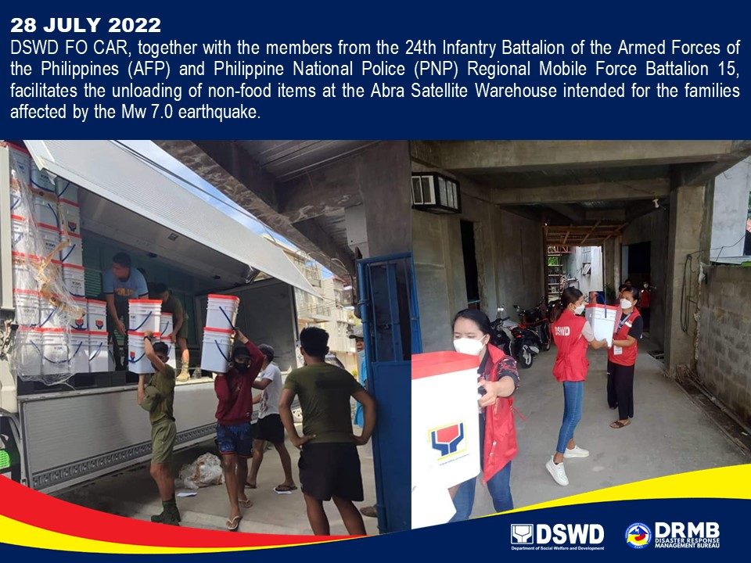

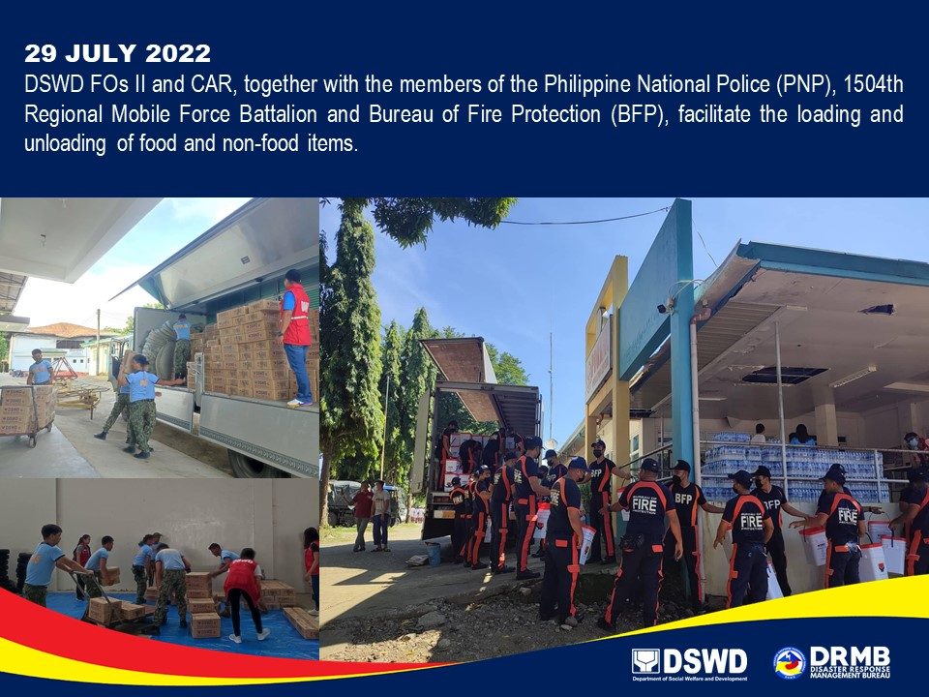

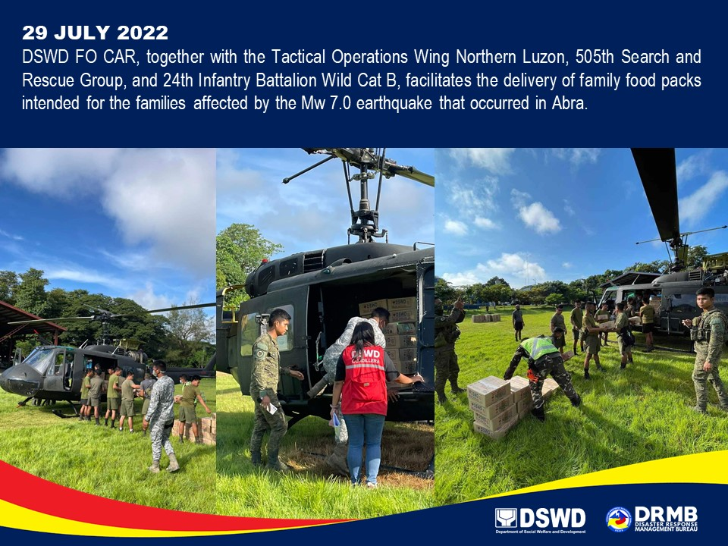

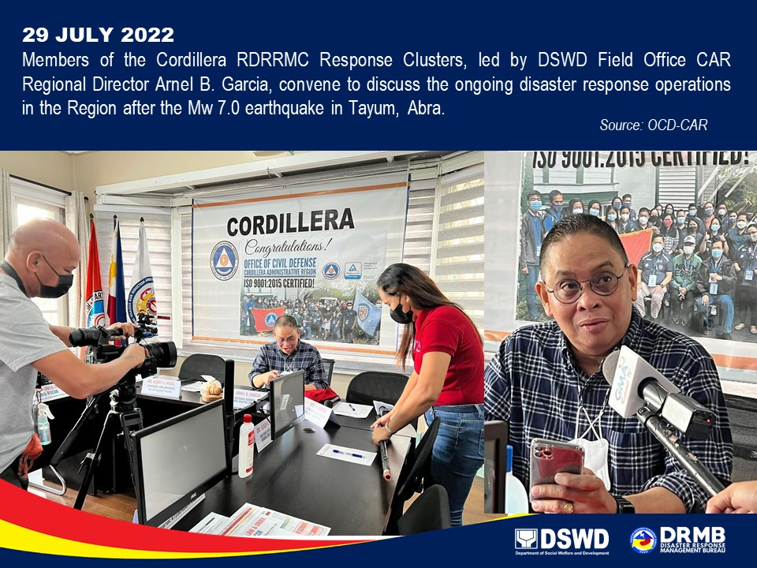

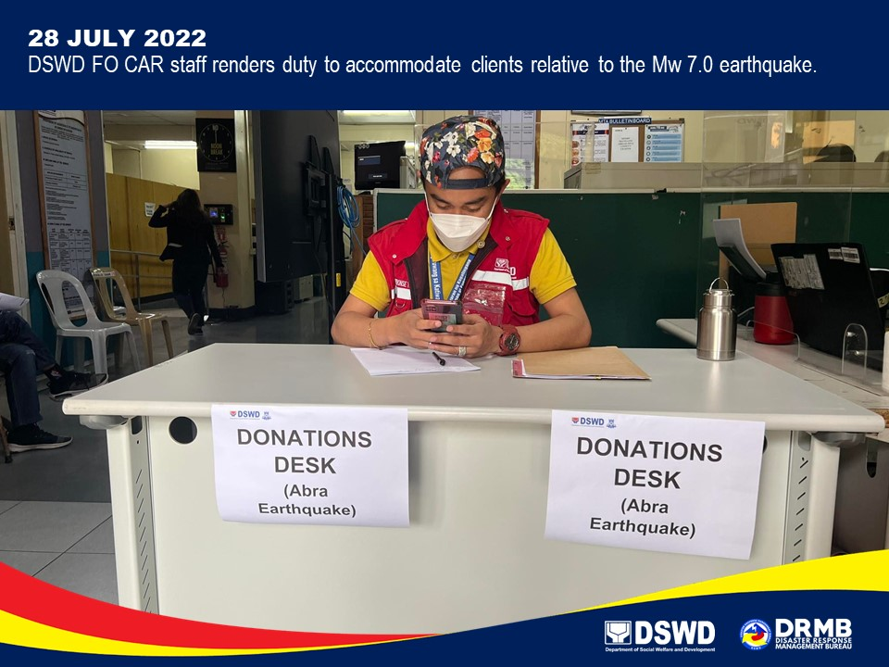

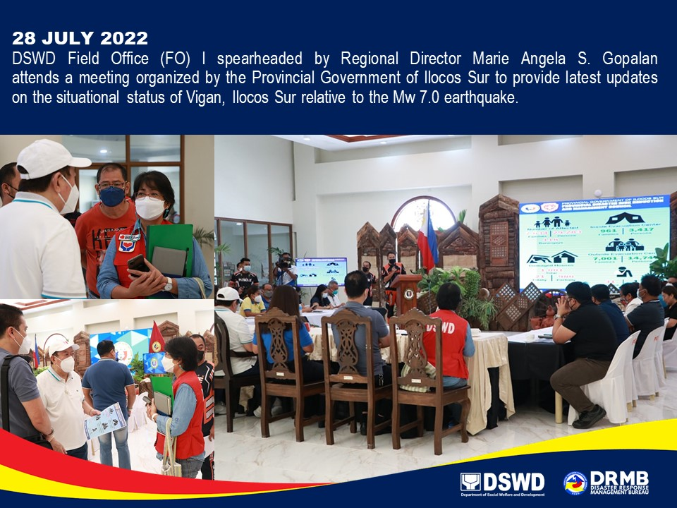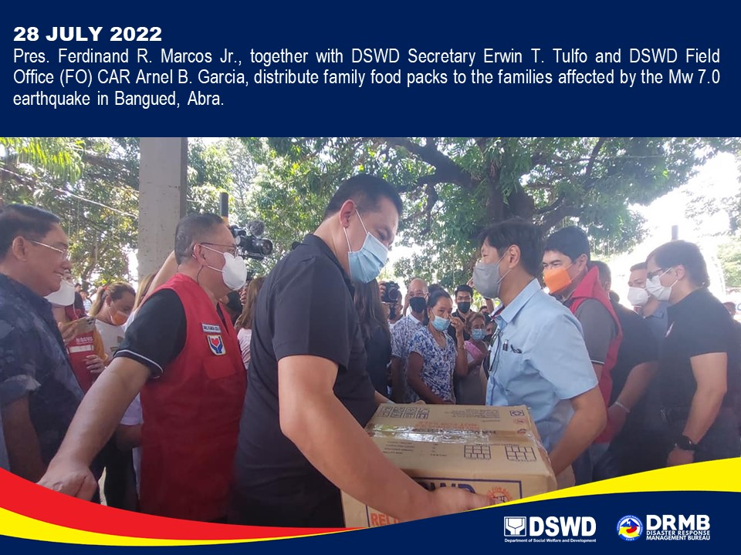

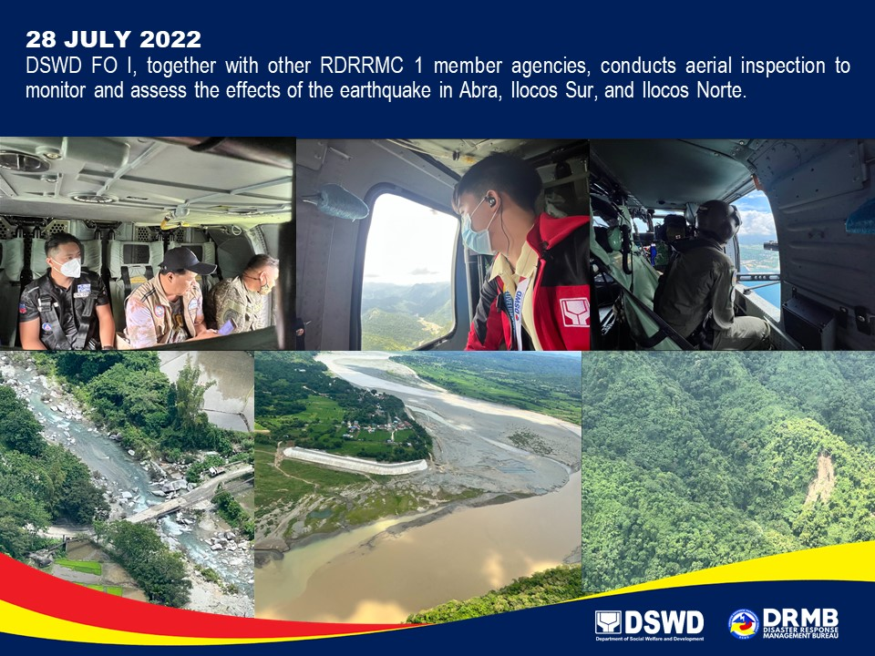

*****
The Disaster Response Operations Monitoring and Information Center (DROMIC) of the DSWD-DRMB is closely coordinating with the concerned DSWD-FOs for any significant updates and actions taken relative to the Earthquake Incident.

Prepared by: Releasing Officer:

DIANE C. PELEGRINO MARC LEO L. BUTAC
AARON JOHN B. PASCUA
MARIE JOYCE G. RAFANAN

