DSWD DROMIC Report #7 on the
Mw 7.0 Earthquake Incident in Tayum, Abra
as of 30 July 2022, 6AM

Situation Overview

On 27 July 2022 at 8:43 AM, a 7.0-magnitude earthquake jolted the Municipality of Tayum, Abra (17.64°N, 120.63°E - 003 km N 45°W) with a tectonic origin and a depth of focus of 017 km. The earthquake was also felt in the neighboring municipalities.

Date/Time: | 27 Jul 2022 - 8:43:24 AM
Reported Intensities: | Intensity VII - Bucloc and Manabo, Abra  Intensity VI - Vigan City, Sinait, Bantay, San Esteban, Ilocos Sur; Laoac, Pangasinan; Baguio City;  Intensity V - Magsingal and San Juan, Ilocos Sur, Alaminos City and Labrador, Pangasinan; Bambang, Nueva Vizcaya; Mexico, Pampanga; Concepcion, and Tarlac City, Tarlac; City of Manila; City of Malabon  Intensity IV - City of Marikina; Quezon City; City of Pasig; City of Valenzuela; City of Tabuk, Kalinga; Bautista and Malasiqui, Pangasinan; Bayombong and Diadi, Nueva Vizcaya; Guiguinto, Obando, and San Rafael, Bulacan; San Mateo, Rizal  Intensity III - Bolinao, Pangasinan; Bulakan, Bulacan; Tanay, Rizal  Intensity II - General Trias City, Cavite; Santa Rosa City, Laguna  Instrumental Intensities:  Intensity VII - Vigan City  Intensity V - Laoag City, Ilocos Norte; Peñablanca, Cagayan; Dagupan City, Pangasinan;  Sinait, Ilocos Sur; Baguio City  Intensity IV - Gonzaga, Cagayan; Baler, Aurora; Bayombong, Nueva Vizcaya; Ramos, Tarlac;  Ilagan, Isabela; Basista, Pangasinan; Claveria, Cagayan; San Jose, Palayan City and Cabanatuan City, Nueva Ecija; Madella, Quirino; Tabuk, Kalinga; Santiago City, Isabela  Intensity III - Quezon City; Iba, Zambales; Navotas City, Malabon City, Metro Manila; Magalang & Guagua Pampanga; Bolinao, Sison & Infanta, Pangasinan; Bulakan, San Ildefonso, Guiguinto, Plaridel, and Malolos City, Bulacan; Tarlac City, Tarlac  Intensity II - Dona Remedios Trinidad, Angat & Santa Maria, Bulacan; Tagaytay City, Cavite; Pasig City Metro Manila; Polillo, Gumaca & Infanta, Quezon  Intensity I - Tanay, Taytay, Morong, Antipolo City, Rizal; Marilao,Bulacan; San Juan City, Las Pinas City, Metro Manila; Lucban, Quezon; Subic, Zambales; Mercedes,Camarines Norte; Olongapo City, Zambales; Carmona, Cavite
Expecting Damage: | YES
Expecting Aftershocks: | YES
Source: DOST-PHIVOLCS Earthquake Bulletin

- Status of Affected Areas and Population

A total of 54,504 families or 215,313 persons are affected in 815 barangays in Regions I, II and CAR (see Table 1).

Table 1. Number of Affected Families / Persons

REGION / PROVINCE / MUNICIPALITY |  | NUMBER OF AFFECTED
 |  | Barangays | Families | Persons
GRAND TOTAL |  | 815 | 54,504 | 215,313
REGION I |  | 377 | 11,356 | 50,138
Ilocos Norte |  | 8 | 9 | 33
 | Dingras | 2 | 2 | 2
 | Pinili | 5 | 6 | 27
 | Sarrat | 1 | 1 | 4
Ilocos Sur |  | 305 | 9,708 | 44,238
 | Alilem | 2 | 4 | 23
 | Banayoyo | 4 | 4 | 17
 | Bantay | 16 | 145 | 725
 | Burgos | 16 | 309 | 1197
 | Cabugao | 7 | 61 | 305
 | CITY OF CANDON | 28 | 3092 | 13942
 | Caoayan | 3 | 69 | 352
 | Cervantes | 13 | 195 | 815
 | Galimuyod | 9 | 144 | 661
 | Gregorio del Pilar (Concepcion) | 7 | 1247 | 6235
 | Magsingal | 22 | 241 | 993
 | Nagbukel | 8 | 228 | 851
 | Narvacan | 3 | 82 | 474
 | Quirino (Angkaki) | 9 | 239 | 911
 | Salcedo (Baugen) | 1 | 164 | 825
 | San Emilio | 6 | 274 | 1375
 | San Esteban | 4 | 27 | 77
 | San Ildefonso | 4 | 41 | 133
 | San Juan (Lapog) | 22 | 370 | 1223
 | San Vicente | 2 | 66 | 307
 | Santa | 9 | 1413 | 7145
 | Santa Lucia | 13 | 172 | 576
 | Santa Maria | 23 | 281 | 1405
 | Santo Domingo | 15 | 184 | 894
 | Sigay | 3 | 9 | 50
 | Sinait | 1 | 15 | 60
 | Suyo | 1 | 21 | 96
 | Tagudin | 25 | 372 | 1456
 | CITY OF VIGAN (Capital) | 29 | 239 | 1115
La Union |  | 58 | 1,632 | 5,836
 | Agoo | 1 | 2 | 7
 | Bacnotan | 1 | 1 | 1
 | Bagulin | 1 | 23 | 80
 | Balaoan | 5 | 7 | 31
 | Bangar | 10 | 770 | 2,436
 | Bauang | 13 | 49 | 172
 | Luna | 19 | 767 | 3,048
 | Rosario | 1 | 1 | 5
 | CITY OF SAN FERNANDO (Capital) | 4 | 4 | 9
 | Santo Tomas | 2 | 2 | 11
 | Sudipen | 1 | 6 | 36
Pangasinan |  | 6 | 7 | 31
 | Balungao | 3 | 4 | 20
 | Malasiqui | 1 | 1 | 6
 | Sison | 1 | 1 | 4
 | Villasis | 1 | 1 | 1
REGION II |  | 1 | 1 | 4
Cagayan |  | 1 | 1 | 4
 | Aparri | 1 | 1 | 4
CAR |  | 437 | 43,147 | 165,171
Abra |  | 231 | 38,757 | 146,986
 | Bangued (capital) | 22 | 659 | 2,793
 | Bucay | 21 | 5,718 | 28,924
 | Bucloc | 4 | 687 | 2,614
 | Danglas | 7 | 1,342 | 4,026
 | Dolores | 15 | 3,734 | 12,373
 | La Paz | 12 | 1,275 | 4,433
 | Lacub | 6 | 1,168 | 5,687
 | Lagangilang | 17 | 4,381 | 12,511
 | Lagayan | 5 | 102 | 603
 | Licuan-Baay (Licuan) | 9 | 170 | 595
 | Luba | 8 | 1,835 | 6,451
 | Penarrubia | 9 | 2,081 | 7,660
 | Pidigan | 15 | 1,531 | 5,964
 | Pilar | 19 | 3,344 | 10,914
 | Sallapadan | 9 | 2,039 | 7,823
 | San Isidro | 9 | 1,577 | 5,478
 | San Quintin | 6 | 1,880 | 5,640
 | Tayum | 10 | 947 | 4,696
 | Tineg | 10 | 1,031 | 5,646
 | Tubo | 10 | 1,451 | 5,845
 | Villaviciosa | 8 | 1,805 | 6,310
Apayao |  | 2 | 11 | 36
 | Conner | 2 | 11 | 36
Benguet |  | 85 | 1,441 | 5,785
 | Atok | 3 | 16 | 54
 | Baguio City | 4 | 5 | 20
 | Bakun | 7 | 155 | 605
 | Bokod | 10 | 177 | 801
 | Buguias | 12 | 199 | 830
 | Itogon | 3 | 16 | 72
 | Kabayan | 11 | 158 | 647
 | Kapangan | 6 | 42 | 169
 | Kibungan | 6 | 216 | 951
 | La Trinidad (capital) | 4 | 8 | 14
 | Mankayan | 11 | 381 | 1,316
 | Sablan | 1 | 1 | 7
 | Tuba | 3 | 25 | 139
 | Tublay | 4 | 42 | 160
Ifugao |  | 14 | 52 | 222
 | Hingyon | 2 | 2 | 4
 | Kiangan | 6 | 38 | 157
 | Tinoc | 6 | 12 | 61
Kalinga |  | 26 | 1,362 | 5,685
 | Balbalan | 6 | 114 | 448
 | Lubuagan | 6 | 818 | 3,458
 | Pasil | 12 | 427 | 1,769
 | City of Tabuk (capital) | 2 | 3 | 10
Mountain Province |  | 79 | 1,524 | 6,457
 | Bontoc (capital) | 11 | 384 | 2,113
 | Sadanga | 2 | 10 | 28
 | Bauko | 19 | 685 | 2,876
 | Besao | 12 | 131 | 237
 | Sabangan | 6 | 9 | 37
 | Sagada | 11 | 43 | 153
 | Tadian | 18 | 262 | 1,013

Note: This version reflects the actual number of affected families and persons in Region I after data validation on 29 July 2022, 8PM. The decrease in the number of affected families in Sigay and San Juan in Ilocos Sur are based on the validated report of the LGUs. Ongoing assessment and validation that are continuously being conducted.
Source: DSWD Field Offices (FOs)

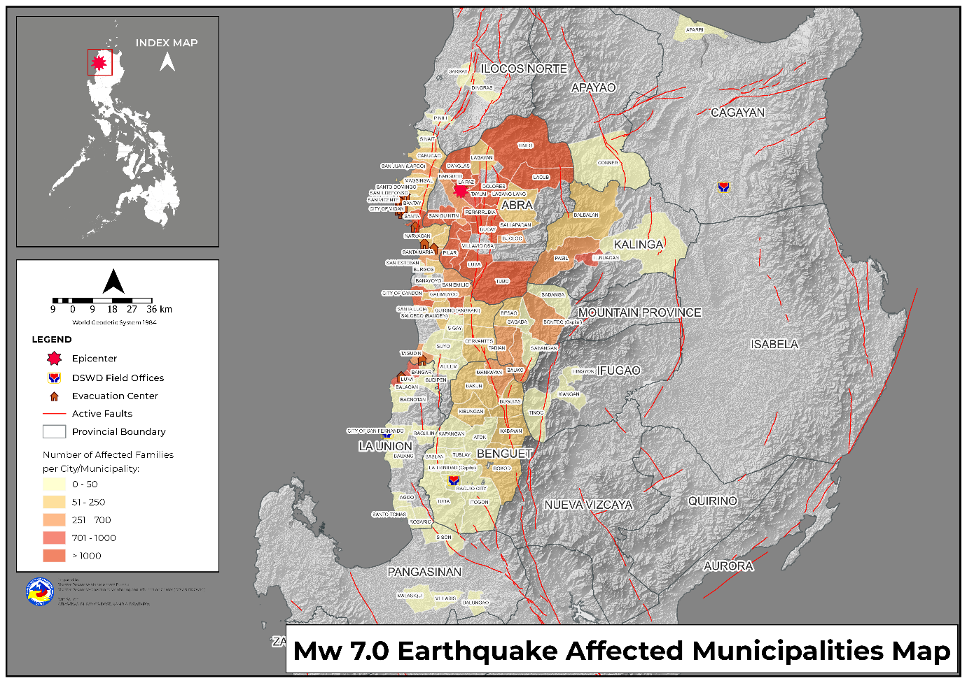

- Status of Displaced Population

- Inside Evacuation Center
There are 1,581 families or 5,226 persons currently taking temporary shelter in 43 evacuation centers in Region I and CAR (see Table 2).

Table 2. Number of Displaced Families / Persons Inside Evacuation Center

REGION / PROVINCE / MUNICIPALITY |  | NUMBER OF EVACUATION CENTERS (ECs) |  | NUMBER OF DISPLACED
 |  |  |  | INSIDE ECs
 |  |  |  | Families |  | Persons
 |  | CUM | NOW | CUM | NOW | CUM | NOW
GRAND TOTAL |  | 86 | 43 | 3,982 | 1,581 | 14,369 | 5,226
REGION I |  | 36 | 4 | 1,275 | 94 | 5,004 | 534
Ilocos Sur |  | 29 | 4 | 904 | 94 | 3,543 | 534
 | Bantay | 1 | 1 | 12 | 12 | 60 | 60
 | Burgos | 1 | - | 100 | - | 152 | -
 | Caoayan | 1 | - | 65 | - | 331 | -
 | Galimuyod | 7 | - | 99 | - | 465 | -
 | Nagbukel | 1 | - | 63 | - | 231 | -
 | Narvacan | 3 | 3 | 82 | 82 | 474 | 474
 | San Ildefonso | 1 | - | 21 | - | 74 | -
 | San Juan (Lapog) | 1 | - | 5 | - | 22 | -
 | San Vicente | 3 | - | 52 | - | 249 | -
 | Santa | 1 | - | 215 | - | 762 | -
 | Santo Domingo | 1 | - | 27 | - | 123 | -
 | Tagudin | 5 | - | 109 | - | 389 | -
 | CITY OF VIGAN (Capital) | 3 | - | 54 | - | 211 | -
La Union |  | 7 | - | 371 | - | 1,461 | -
 | Bagulin | 1 | - | 23 | - | 80 | -
 | Bauang | 2 | - | 4 | - | 25 | -
 | Luna | 4 | - | 344 | - | 1,356 | -
CAR |  | 50 | 39 | 2,707 | 1,487 | 9,365 | 4,692
Abra |  | 32 | 27 | 2,198 | 1,233 | 7,205 | 3,753
 | Bangued (capital) | 9 | 9 | 95 | 95 | 526 | 526
 | Bucay | 11 | 6 | 1,494 | 529 | 4,883 | 1,431
 | Bucloc | 4 | 4 | 415 | 415 | 1,195 | 1,195
 | Danglas | 2 | 2 | 22 | 22 | 76 | 76
 | Lacub | 1 | 1 | 73 | 73 | 231 | 231
 | Licuan-Baay (Licuan) | 1 | 1 | 6 | 6 | 30 | 30
 | Tubo | 1 | 1 | 26 | 26 | 50 | 50
 | Villaviciosa | 3 | 3 | 67 | 67 | 214 | 214
Benguet |  | 4 | 3 | 31 | 17 | 107 | 52
 | Atok | 2 | 2 | 14 | 8 | 47 | 24
 | Bakun | 1 | - | 8 | - | 32 | -
 | Kabayan | 1 | 1 | 9 | 9 | 28 | 28
Kalinga |  | 9 | 7 | 428 | 199 | 1,904 | 754
 | Lubuagan | 5 | 5 | 91 | 91 | 435 | 435
 | Pasil | 4 | 2 | 337 | 108 | 1,469 | 319
Mountain Province |  | 5 | 2 | 50 | 38 | 149 | 133
 | Bontoc (capital) | 2 | - | 2 | - | 6 | -
 | Bauko | 1 | 1 | 10 | 10 | 14 | 14
 | Besao | 1 | 1 | 28 | 28 | 119 | 119
 | Tadian | 1 | - | 10 | - | 10 | -
Note: This version reflects the actual number of displaced families and persons in Region I after data validation on 29 July
2022, 8PM. Ongoing assessment and validation being conducted.
Source: DSWD FOs

- Outside Evacuation Center
There are 6,490 families or 27,213 persons temporarily staying with their relatives and/or friends (see Table 3).

Table 3. Number of Displaced Families / Persons Outside Evacuation Center
REGION / PROVINCE / MUNICIPALITY |  | NUMBER OF DISPLACED
 |  | OUTSIDE ECs
 |  | Families |  | Persons
 |  | CUM | NOW | CUM | NOW
GRAND TOTAL |  | 7,062 | 6,490 | 29,473 | 27,213
REGION I |  | 604 | 94 | 2,479 | 467
Ilocos Sur |  | 185 | 85 | 792 | 425
 | Caoayan | 4 | - | 21 | -
 | San Emilio | 85 | 85 | 425 | 425
 | Tagudin | 96 | - | 346 | -
La Union |  | 417 | 7 | 1,676 | 31
 | Balaoan | 7 | 7 | 31 | 31
 | Luna | 400 | - | 1,600 | -
 | CITY OF SAN FERNANDO (Capital) | 4 | - | 9 | -
 | Sudipen | 6 | - | 36 | -
Pangasinan |  | 2 | 2 | 11 | 11
 | Balungao | 1 | 1 | 5 | 5
 | Malasiqui | 1 | 1 | 6 | 6
CAR |  | 6,458 | 6,396 | 26,994 | 26,746
Abra |  | 5,834 | 5,773 | 24,238 | 23,992
 | Bucay | 262 | 204 | 1,069 | 830
 | Dolores | 19 | 16 | 81 | 74
 | Lacub | 8 | 8 | 32 | 32
 | Lagangilang | 1,592 | 1,592 | 5,787 | 5,787
 | Lagayan | 102 | 102 | 603 | 603
 | Luba | 52 | 52 | 213 | 213
 | Pilar | 141 | 141 | 532 | 532
 | San Isidro | 1,577 | 1,577 | 5,478 | 5,478
 | San Quintin | 213 | 213 | 622 | 622
 | Tayum | 796 | 796 | 4,034 | 4,034
 | Tineg | 1,031 | 1,031 | 5,646 | 5,646
 | Tubo | 6 | 6 | 27 | 27
 | Villaviciosa | 35 | 35 | 114 | 114
Apayao |  | 1 | - | 2 | -
 | Conner | 1 | - | 2 | -
Benguet |  | 48 | 48 | 253 | 253
 | Atok | 2 | 2 | 7 | 7
 | Baguio City | 3 | 3 | 18 | 18
 | Bakun | 4 | 4 | 17 | 17
 | Kapangan | 1 | 1 | 4 | 4
 | Mankayan | 15 | 15 | 75 | 75
 | Tuba | 23 | 23 | 132 | 132
Ifugao |  | 2 | 2 | 4 | 4
 | Hingyon | 2 | 2 | 4 | 4
Kalinga |  | 550 | 550 | 2,403 | 2,403
 | Balbalan | 73 | 73 | 260 | 260
 | Lubuagan | 474 | 474 | 2,133 | 2,133
 | City of Tabuk (capital) | 3 | 3 | 10 | 10
Mountain Province |  | 23 | 23 | 94 | 94
 | Bontoc (capital) | 4 | 4 | 14 | 14
 | Bauko | 8 | 8 | 42 | 42
 | Besao | 5 | 5 | 15 | 15
 | Sagada | 4 | 4 | 15 | 15
 | Tadian | 2 | 2 | 8 | 8
Note: Ongoing assessment and validation being conducted.
Source: DSWD FOs

- Total Displaced Population
There are 8,071 families or 32,439 persons taking temporary shelter either in evacuation centers or with their relatives and/or friends (see Table 4).

Table 4. Total Number of Displaced Families / Persons

REGION / PROVINCE / MUNICIPALITY |  | TOTAL DISPLACED SERVED
 |  | Families |  | Persons
 |  | Total Families |  | Total Persons
 |  | CUM | NOW | CUM | NOW
GRAND TOTAL |  | 11,044 | 8,071 | 43,842 | 32,439
REGION I |  | 1,879 | 188 | 7,483 | 1,001
Ilocos Sur |  | 1,089 | 179 | 4,335 | 959
 | Bantay | 12 | 12 | 60 | 60
 | Burgos | 100 | - | 152 | -
 | Caoayan | 69 | - | 352 | -
 | Galimuyod | 99 | - | 465 | -
 | Nagbukel | 63 | - | 231 | -
 | Narvacan | 82 | 82 | 474 | 474
 | San Emilio | 85 | 85 | 425 | 425
 | San Ildefonso | 21 | - | 74 | -
 | San Juan (Lapog) | 5 | - | 22 | -
 | San Vicente | 52 | - | 249 | -
 | Santa | 215 | - | 762 | -
 | Santo Domingo | 27 | - | 123 | -
 | Tagudin | 205 | - | 735 | -
 | CITY OF VIGAN (Capital) | 54 | - | 211 | -
La Union |  | 788 | 7 | 3,137 | 31
 | Bagulin | 23 | - | 80 | -
 | Balaoan | 7 | 7 | 31 | 31
 | Bauang | 4 | - | 25 | -
 | Luna | 744 | - | 2,956 | -
 | CITY OF SAN FERNANDO (Capital) | 4 | - | 9 | -
 | Sudipen | 6 | - | 36 | -
Pangasinan |  | 2 | 2 | 11 | 11
 | Balungao | 1 | 1 | 5 | 5
 | Malasiqui | 1 | 1 | 6 | 6
CAR |  | 9,165 | 7,883 | 36,359 | 31,438
Abra |  | 8,032 | 7,006 | 31,443 | 27,745
 | Bangued (capital) | 95 | 95 | 526 | 526
 | Bucay | 1,756 | 733 | 5,952 | 2,261
 | Bucloc | 415 | 415 | 1,195 | 1,195
 | Danglas | 22 | 22 | 76 | 76
 | Dolores | 19 | 16 | 81 | 74
 | Lacub | 81 | 81 | 263 | 263
 | Lagangilang | 1,592 | 1,592 | 5,787 | 5,787
 | Lagayan | 102 | 102 | 603 | 603
 | Licuan-Baay (Licuan) | 6 | 6 | 30 | 30
 | Luba | 52 | 52 | 213 | 213
 | Pilar | 141 | 141 | 532 | 532
 | San Isidro | 1,577 | 1,577 | 5,478 | 5,478
 | San Quintin | 213 | 213 | 622 | 622
 | Tayum | 796 | 796 | 4,034 | 4,034
 | Tineg | 1,031 | 1,031 | 5,646 | 5,646
 | Tubo | 32 | 32 | 77 | 77
 | Villaviciosa | 102 | 102 | 328 | 328
Apayao |  | 1 | - | 2 | -
 | Conner | 1 | - | 2 | -
Benguet |  | 79 | 65 | 360 | 305
 | Atok | 16 | 10 | 54 | 31
 | Baguio City | 3 | 3 | 18 | 18
 | Bakun | 12 | 4 | 49 | 17
 | Kabayan | 9 | 9 | 28 | 28
 | Kapangan | 1 | 1 | 4 | 4
 | Mankayan | 15 | 15 | 75 | 75
 | Tuba | 23 | 23 | 132 | 132
Ifugao |  | 2 | 2 | 4 | 4
 | Hingyon | 2 | 2 | 4 | 4
Kalinga |  | 978 | 749 | 4,307 | 3,157
 | Balbalan | 73 | 73 | 260 | 260
 | Lubuagan | 565 | 565 | 2,568 | 2,568
 | Pasil | 337 | 108 | 1,469 | 319
 | City of Tabuk (capital) | 3 | 3 | 10 | 10
Mountain Province |  | 73 | 61 | 243 | 227
 | Bontoc (capital) | 6 | 4 | 20 | 14
 | Bauko | 18 | 18 | 56 | 56
 | Besao | 33 | 33 | 134 | 134
 | Sagada | 4 | 4 | 15 | 15
 | Tadian | 12 | 2 | 18 | 8
Note: Ongoing assessment and validation being conducted.
Source: DSWD FOs

- Damaged Houses

A total of 14,798 houses were damaged; of which, 216 are totally damaged and 14,582 are partially damaged in Regions I, II, and CAR (see Table 5).

Table 5. Number of Damaged Houses

REGION / PROVINCE / MUNICIPALITY |  | NO. OF DAMAGED HOUSES
 |  | Total | Totally | Partially
GRAND TOTAL |  | 14,798 | 216 | 14,582
REGION I |  | 2,738 | 66 | 2,672
Ilocos Norte |  | 9 | - | 9
 | Dingras | 2 | - | 2
 | Pinili | 6 | - | 6
 | Sarrat | 1 | - | 1
Ilocos Sur |  | 2,629 | 66 | 2,563
 | Alilem | 4 | - | 4
 | Banayoyo | 3 | - | 3
 | Bantay | 133 | 1 | 132
 | Burgos | 232 | - | 232
 | Cabugao | 61 | - | 61
 | CITY OF CANDON | 87 | 5 | 82
 | Cervantes | 195 | - | 195
 | Galimuyod | 12 | - | 12
 | Gregorio del Pilar (Concepcion) | 175 | - | 175
 | Magsingal | 190 | 5 | 185
 | Nagbukel | 166 | 32 | 134
 | Quirino (Angkaki) | 237 | 1 | 236
 | Salcedo (Baugen) | 164 | - | 164
 | San Emilio | 248 | 3 | 245
 | San Esteban | 14 | - | 14
 | San Ildefonso | 17 | 1 | 16
 | San Juan (Lapog) | 112 | 2 | 110
 | Santa Maria | 279 | - | 279
 | Santo Domingo | 143 | 9 | 134
 | Sigay | 9 | - | 9
 | Sinait | 14 | 2 | 12
 | Tagudin | 128 | 2 | 126
 | CITY OF VIGAN (Capital) | 6 | 3 | 3
La Union |  | 93 | - | 93
 | Agoo | 2 | - | 2
 | Balaoan | 6 | - | 6
 | Bauang | 49 | - | 49
 | Luna | 23 | - | 23
 | Rosario | 1 | - | 1
 | CITY OF SAN FERNANDO (Capital) | 4 | - | 4
 | Santo Tomas | 2 | - | 2
 | Sudipen | 6 | - | 6
Pangasinan |  | 7 | - | 7
 | Balungao | 4 | - | 4
 | Malasiqui | 1 | - | 1
 | Sison | 1 | - | 1
 | Villasis | 1 | - | 1
REGION II |  | 1 | - | 1
Cagayan |  | 1 | - | 1
 | Aparri | 1 | - | 1
CAR |  | 12,059 | 150 | 11,909
Abra |  | 10,453 | 132 | 10,321
 | Bangued (capital) | 367 | 24 | 343
 | Bucay | 2,625 | 38 | 2,587
 | Bucloc | 76 | - | 76
 | Danglas | 158 | - | 158
 | Dolores | 322 | 7 | 315
 | La Paz | 1,048 | - | 1,048
 | Lacub | 94 | - | 94
 | Lagangilang | 1,639 | - | 1,639
 | Lagayan | 102 | 5 | 97
 | Licuan-Baay (Licuan) | 131 | - | 131
 | Luba | 369 | - | 369
 | Penarrubia | 701 | - | 701
 | Pidigan | 1,333 | 33 | 1,300
 | Pilar | 190 | - | 190
 | Sallapadan | 470 | 15 | 455
 | San Isidro | 314 | - | 314
 | San Quintin | 309 | 4 | 305
 | Tayum | 40 | 2 | 38
 | Tineg | 4 | - | 4
 | Villaviciosa | 161 | 4 | 157
Apayao |  | 11 | - | 11
 | Conner | 11 | - | 11
Benguet |  | 247 | 2 | 245
 | Baguio City | 3 | - | 3
 | Bakun | 63 | - | 63
 | Itogon | 15 | 1 | 14
 | Kabayan | 102 | - | 102
 | Kapangan | 1 | - | 1
 | Mankayan | 55 | - | 55
 | Sablan | 1 | 1 | -
 | Tublay | 7 | - | 7
Ifugao |  | 51 | 2 | 49
 | Hingyon | 2 | 2 | -
 | Kiangan | 38 | - | 38
 | Tinoc | 11 | - | 11
Kalinga |  | 166 | 3 | 163
 | Balbalan | 23 | - | 23
 | Lubuagan | 13 | 1 | 12
 | Pasil | 128 | 2 | 126
 | City of Tabuk (capital) | 2 | - | 2
Mountain Province |  | 1,131 | 11 | 1,120
 | Bontoc (capital) | 68 | - | 68
 | Sadanga | 10 | - | 10
 | Bauko | 667 | 7 | 660
 | Besao | 91 | - | 91
 | Sabangan | 8 | - | 8
 | Sagada | 37 | - | 37
 | Tadian | 250 | 4 | 246
Note: This version reflects the actual number of damaged houses in Regions I, II, and CAR after data validation on 29 July 2022, 8PM. Hence, changes in figures are based on the ongoing assessment and validation that are continuously being conducted.
Source: DSWD FOs

- Cost of Humanitarian Assistance Provided

A total of ₱5,094,800.23 worth of assistance was provided to the affected families; of which, ₱4,740,632.23 from the DSWD and ₱354,168.00 was provided by the Local Government Units (LGUs) (see Table 6).

Table 6. Cost of Assistance Provided to Affected Families / Persons
REGION / PROVINCE / MUNICIPALITY |  | COST OF ASSISTANCE
 |  | DSWD | LGU | NGOs | OTHERS | GRAND TOTAL
GRAND TOTAL |  | 4,740,632.23 | 354,168.00 | - | - | 5,094,800.23
REGION I |  | - | 24,708.00 | - | - | 24,708.00
Ilocos Norte |  | - | 5,520.00 | - | - | 5,520.00
 | Dingras | - | 2,000.00 | - | - | 2,000.00
 | Pinili | - | 3,120.00 | - | - | 3,120.00
 | Sarrat | - | 400.00 | - | - | 400.00
La Union |  | - | 16,708.00 | - | - | 16,708.00
 | Luna | - | 13,000.00 | - | - | 13,000.00
 | Rosario | - | 500.00 | - | - | 500.00
 | CITY OF SAN FERNANDO (Capital) | - | 3,208.00 | - | - | 3,208.00
Pangasinan |  | - | 2,480.00 | - | - | 2,480.00
 | Malasiqui | - | 1,260.00 | - | - | 1,260.00
 | Villasis | - | 1,220.00 | - | - | 1,220.00
REGION II |  | 5,853.50 | - | - | - | 5,853.50
Cagayan |  | 5,853.50 | - | - | - | 5,853.50
 | Aparri | 5,853.50 | - | - | - | 5,853.50
CAR |  | 4,734,778.73 | 329,460.00 | - | - | 5,064,238.73
Abra |  | 4,734,778.73 | 173,100.00 | - | - | 4,907,878.73
 | Bangued (capital) | 713,025.00 | - | - | - | 713,025.00
 | Bucay | 2,010,592.08 | 4,900.00 | - | - | 2,015,492.08
 | Bucloc | - | 80,000.00 | - | - | 80,000.00
 | Danglas | - | 9,600.00 | - | - | 9,600.00
 | Lagangilang | 1,087,985.00 | - | - | - | 1,087,985.00
 | Lagayan | - | 72,760.00 | - | - | 72,760.00
 | Penarrubia | - | 5,840.00 | - | - | 5,840.00
 | Villaviciosa | 923,176.65 | - | - | - | 923,176.65
Apayao |  | - | 17,820.00 | - | - | 17,820.00
 | Conner | - | 17,820.00 | - | - | 17,820.00
Kalinga |  | - | 108,510.00 | - | - | 108,510.00
 | Balbalan | - | 15,640.00 | - | - | 15,640.00
 | Lubuagan | - | 29,100.00 | - | - | 29,100.00
 | Pasil | - | 63,770.00 | - | - | 63,770.00
Mountain Province |  | - | 30,030.00 | - | - | 30,030.00
 | Besao | - | 25,830.00 | - | - | 25,830.00
 | Sagada | - | 3,400.00 | - | - | 3,400.00
 | Tadian | - | 800.00 | - | - | 800.00
Source: DSWD FOs

Response Actions and Interventions

The DSWD Central Office (CO), FOs, National Resource Operations Center (NROC), and Visayas Disaster Resource Center (VDRC) have stockpiles and standby funds amounting to ₱1,335,909,070.26 with breakdown as follows:

Standby Funds
A total of ₱315,354,198.70 standby funds in the CO and FOs. Of the said amount, ₱247,530,257.39 is the available Quick Response Fund (QRF) in the CO.

Stockpiles
A total of 516,345 family food packs (FFPs) amounting to ₱317,471,484.49, other food items amounting to ₱211,913,580.23, and non-food items (FNIs) amounting to ₱491,169,806.84 are available.

OFFICE | STANDBY FUNDS | STOCKPILE |  |  |  | TOTAL STANDBY FUNDS & STOCKPILE
 |  | FAMILY FOOD PACKS |  | OTHER FOOD ITEMS | NON-FOOD RELIEF ITEMS
 |  | QUANTITY | TOTAL COST | TOTAL COST | TOTAL COST
TOTAL | 315,354,198.70 | 516,345 | 317,471,484.49 | 211,913,580.23 | 491,169,806.84 | 1,335,909,070.26
DSWD-CO | 247,530,257.39 | - | - | - | - | 247,530,257.39
NRLMB-NROC | - | 80,964 | 54,409,265.00 | 44,339,295.10 | 42,516,509.79 | 141,265,069.89
NRLMB-VDRC | - | 51,729 | 32,811,910.00 | 48,986,195.80 | 72,010.00 | 81,870,115.80
DSWD-FO I | 5,039,900.00 | 17,235 | 10,242,632.25 | 15,899,295.75 | 23,145,491.65 | 54,327,319.65
DSWD-FO II | 2,407,392.08 | 36,329 | 21,922,875.00 | 3,663,486.00 | 26,974,066.50 | 54,967,819.58
DSWD-FO III | 5,253,797.79 | 23,740 | 11,594,385.04 | 2,292,781.09 | 22,346,971.00 | 41,487,934.92
DSWD-FO CALABARZON | 5,000,000.47 | 14,501 | 8,841,710.90 | 3,282,202.00 | 62,144,179.16 | 79,268,092.53
DSWD-FO MIMAROPA | 5,661,519.78 | 41,866 | 29,573,099.32 | 9,984,849.00 | 18,525,527.34 | 63,744,995.44
DSWD-FO V | 5,000,000.00 | 33,395 | 17,434,743.56 | 6,279,587.05 | 42,302,110.90 | 71,016,441.51
DSWD-FO VI | 5,000,000.00 | 31,035 | 13,264,910.00 | 2,066,330.00 | 29,761,565.64 | 50,092,805.64
DSWD-FO VII | 5,000,000.00 | 17,667 | 10,070,190.00 | 15,338,793.32 | 40,883,200.65 | 71,292,183.97
DSWD-FO VIII | 5,000,000.00 | 21,052 | 13,226,152.93 | 4,957,038.50 | 32,895,114.37 | 56,078,305.80
DSWD-FO IX | 5,000,000.00 | 15,268 | 8,343,809.32 | 15,483,562.44 | 13,783,910.52 | 42,611,282.28
DSWD-FO X | 243,500.50 | 20,606 | 14,340,274.50 | 19,263,732.03 | 27,254,580.50 | 61,102,087.53
DSWD-FO XI | 5,090,000.00 | 22,954 | 14,468,214.20 | 6,870,149.00 | 27,634,405.80 | 54,062,769.00
DSWD-FO XII | 5,000,969.85 | 33,055 | 19,886,800.00 | 7,638,855.00 | 31,310,331.08 | 63,836,955.93
DSWD-FO CARAGA | 4,126,401.00 | 26,994 | 18,733,836.00 | 334,307.51 | 14,433,138.60 | 37,627,683.11
DSWD-FO NCR | 5,000,000.00 | 2,144 | 1,337,345.96 | 2,542,113.95 | 5,545,413.21 | 14,424,873.12
DSWD-FO CAR | 459.84 | 25,811 | 16,969,330.51 | 2,691,006.69 | 29,641,280.13 | 49,302,077.17
Note: The Inventory Summary is as of 29 July 2022, 8PM. Replenishment of standby funds for DSWD FOs II, X, and CAR is on process.
Sources: DRMB and NRLMB

Food and Non-food Items (FNIs)

DSWD-FO CAR
DATE | SITUATIONS / ACTIONS UNDERTAKEN
29 July 2022 | - DSWD FO CAR delivered NFIs to the Municipalities of Boliney, Daguioman, Lacub, and Bucloc in Abra via airlift.
28 July 2022 | - DSWD FO CAR monitored the arrival of the 3,900 FFPs, 10 family tents, and 132 modular tents as an immediate augmentation to the Province of Abra.  - DSWD FO CAR facilitated the delivery of NFIs from the DSWD warehouse bound for Abra.
27 July 2022 | - DSWD FO CAR facilitated the loading of 3,900 FFPs, 10 family tents, and 130 modular tents bound for Abra for prepositioning.

DSWD-FO II
DATE | SITUATIONS / ACTIONS UNDERTAKEN
29 July 2022 | - The additional nine (9) cargo trucks of the Provincial Government of Isabela and 501st Infantry Brigade of Philippine Army hauled 5,300 FFPs from the DSWD FO II’s warehouse in Tuguegarao City for delivery to Bangued, Abra.  - The seven (7) trucks of the Provincial Government of Isabela left the DSWD FO II’s warehouse in Tuguegarao City carrying 4,600 FFPs bound for Bangued, Abra.  - Two (2) Army trucks with 700 FFPs are also bound for Bangued, Abra.
28 July 2022 | - 1,500 FFPs from DSWD FO II and 50 modular tents from Office of Civil Defense Regional Office 02 (OCD RO2) ferried by the four (4) cargo trucks provided by the Province of Cagayan were delivered to Bangued, Abra.

Camp Coordination and Camp Management

DSWD-FO CAR
DATE | SITUATIONS / ACTIONS UNDERTAKEN
27 July 2022 | - DSWD FO CAR provided technical assistance to partner LGUs.

Internally Displaced Person (IDP) Protection

DSWD-FO CAR
DATE | SITUATIONS / ACTIONS UNDERTAKEN
29 July 2022 | - A Psychological First Aid (PFA) Team was deployed to conduct stress debriefing to victims of the Mw 7.0 earthquake. Several groups such as Saint Louis University (SLU) Sunflower, University of the Philippines (UP) Baguio, and Psychological Association of the Philippines-North Luzon Chapter signified their intention to provide PFA to families and individuals affected by the earthquake.

Other Activities

DSWD-DRMB
DATE | SITUATIONS / ACTIONS UNDERTAKEN
29 July 2022 | - The DRMB Operations Center (OpCen) is in 24/7 virtual operation to closely monitor and coordinate with the National Resource and Logistics Management Bureau (NRLMB) and DSWD FOs for significant updates on the Mw 7.0 Earthquake Incident in Tayum, Abra  - DSWD-DRMB is on standby response support assets from non-affected DSWD-FOs.  - DSWD-DRMB posted a “Call for Donations” on its official social media accounts to provide information on how to donate in-kind items or cash.
28 July 2022 | - DSWD-DRMB facilitated the signing of the DSWD Secretary on the request for replenishment of the standby funds amounting to ₱662,500,000.00 for onward approval and action of the Department of Budget and Management (DBM).
27 July 2022 | - DSWD-DRMB facilitated the delivery of the following FNIs from the National Resource Operations Center (NROC) scheduled on 28 July 2022 for Regions I and CAR:  - 5,000 FFPs/region  - 2,000 Hygiene Kits/region  - 1,000 Sleeping Kits/region  - 1,000 Kitchen Kits/region  - 1,000 Family Tents/region (sourced from DSWD FO CALABARZON)  - DSWD-DRMB facilitates the P15 million fund augmentation to DSWD-FO I and CAR for urgent food and NFI relief requirements.

DSWD-NRLMB
DATE | SITUATIONS / ACTIONS UNDERTAKEN
29 July 2022 | - DSWD-NRLMB continuously repacks relief goods for possible augmentation.  - DSWD-NRLMB provides logistical augmentation to FOs on delivering FFPs to LGUs.
27 July 2022 | - Augmentation of 2,500 FFPs were delivered by NRLMB to DSWD FO I.  - Additional augmentation from NRLMB including 5,000 FFPs, 2,000 hygiene kits, 1,000 sleeping kits, 1,000 kitchen kits, and 1,000 family tents were scheduled for delivery to DSWD FO I.

DSWD-FO NCR
DATE | SITUATIONS / ACTIONS UNDERTAKEN
27 July 2022 | - DSWD FO NCR coordinated with concerned offices for updates regarding damages and affected population.

DSWD-CAR
DATE | SITUATIONS / ACTIONS UNDERTAKEN
29 July 2022 | - DSWD FO CAR continuously coordinates with the Response Clusters and its Quick Response Teams (QRTs) in Abra, Benguet, Kalinga, Ifugao, and Mountain Province.  - DSWD FO CAR coordinated with the Aviation Regiment of the Philippine Army to airlift the FFPs intended for the three (3) isolated Barangays in Pasil, Kalinga.  - DSWD FO CAR requested augmentation of NFIs from DSWD FO I.  - DSWD FO CAR picked up 7,000 pieces of sando bags from DSWD FO I.
28 July 2022 | - DSWD FO CAR through the Crisis Intervention Section (CIS) provided cash assistance worth ₱10,000.00 and burial assistance worth ₱25,000.00 to the affected family.
27 July 2022 | - DSWD FO CAR activated its Quick Response Team in Abra, Benguet, Kalinga, and Mountain Province.  - Psychosocial Support Processing (PSP) Team was on standby for possible deployment.  - DSWD FO CAR Public Service Continuity Plan was activated.  - DSWD FO CAR coordinated with partner agencies on significant updates.

DSWD-FO I
DATE | SITUATIONS / ACTIONS UNDERTAKEN
29 July 2022 | - DSWD FO I closely coordinates with the Department of Science and Technology – Philippine Institute of Volcanology and Seismology (DOST-PHIVOLCS) and Regional Disaster Risk Reduction and Management Council 1 (RDRRMC1) for updates, and its Provincial Action Teams to monitor and gather updates on the affected population and damages brought by the earthquake incident.  - DSWD FO I Incident Management Team (IMT) is activated and on duty while the other staff are on standby for possible augmentation.  - DSWD FO I ensures availability and readiness of its resources.  - Donations and Help Desks are available at the DSWD Regional warehouse in Binday, City of San Fernando, La Union to accommodate clients.
28 July 2022 | - DSWD FO I raised the alert level status to RED.  - DSWD FO I Regional Director Marie Angela S. Gopalan served as guest during an interview with the DZTP Radyo Tirad Pass where updates regarding the DSWD’s augmentation process and the possible assistance that could be provided were discussed and shared.  - DSWD FO I Assistant Regional Director for Operations (ARDO) Marlene Febes D. Peralta together with other DSWD FO I staff attended the virtual press briefing in collaboration with the RDRRMC1 member agencies to discuss disaster response related questions from the media.  - DSWD FO I spearheaded the Response Cluster Meeting conducted via Zoom to discuss situation updates from Response Cluster member agencies relative to the earthquake incident
27 July 2022 | - The Response Cluster Meeting, spearheaded by DSWD FO I Regional Director Marie Angela S. Gopalan and ARDO Marlene Febes D. Peralta, was conducted to discuss the situation updates from the Response Cluster member agencies relative to the Mw 7.0 earthquake.

DSWD-FO II
DATE | SITUATIONS / ACTIONS UNDERTAKEN
28 July 2022 | - DSWD FO II requested the OCD RO2 for manpower to load the remaining FNIs as augmentation support for CAR; to which, staff from Bureau of Fire Protection (BFP), Philippine National Police (PNP), and Philippine Coast Guard (PCG) responded and helped in loading the FFPs at the DSWD FO II Regional warehouse in Tuguegarao City.  - The Province of Cagayan provided three (3) cargo trucks in coordination with the OCD RO2 that would ferry the FFPs to Bangued, Abra.  - Additional seven (7) trucks from the City of Ilagan, Isabela were in transit to load FFPs for delivery to Bangued, Abra.
27 July 2022 | - DSWD FO II released an advisory for the information of the Social Welfare and Development Teams (SWADTs) and Municipal Action Teams (MATs) on monitoring of damaged houses and affected families relative to the Mw 7.0 earthquake.  - DSWD FO II closely coordinated with the SWADTs and MATs for updates and status of the Magat Dam.  - DSWD FO II ensured that FFPs and other logistical needs are ready to be extended as augmentation support.  - DSWD FO II had arranged two (2) teams ready for deployment in case FOs CAR and I would need for human resource augmentation.

DSWD-FO CALABARZON
DATE | SITUATIONS / ACTIONS UNDERTAKEN
27 July 2022 | - DSWD FO CALABARZON continuously monitored and coordinated with RDDRMC CALABARZON, Batangas Provincial Disaster Risk Reduction and Management Office (PDRRMO), Provincial Social Welfare and Development Office (PSWDO), and LGUs for updates relative to the earthquake incident and with the OCD IV-A and NRLMB for logistics support and workforce.

DSWD-FO MIMAROPA
DATE | SITUATIONS / ACTIONS UNDERTAKEN
27 July 2022 | - DSWD FO MIMAROPA coordinated with the concerned offices for updates regarding damages and affected population.

DSWD-FO V
DATE | SITUATIONS / ACTIONS UNDERTAKEN
27 July 2022 | - DSWD FO V coordinated with the concerned offices for updates regarding damages and affected population.

Photo Documentation

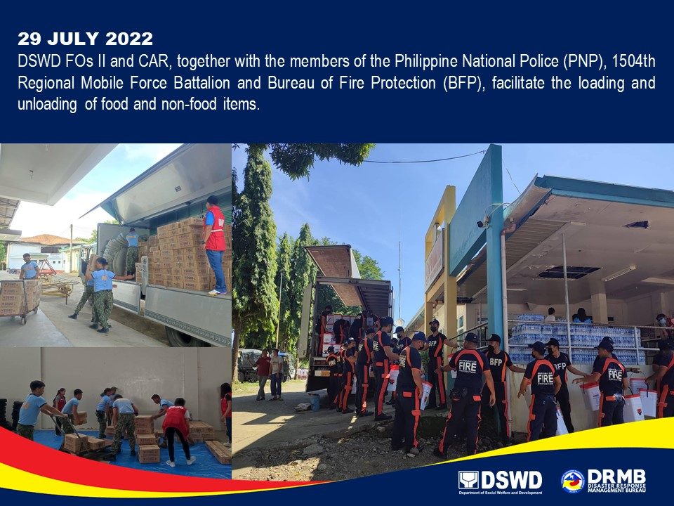

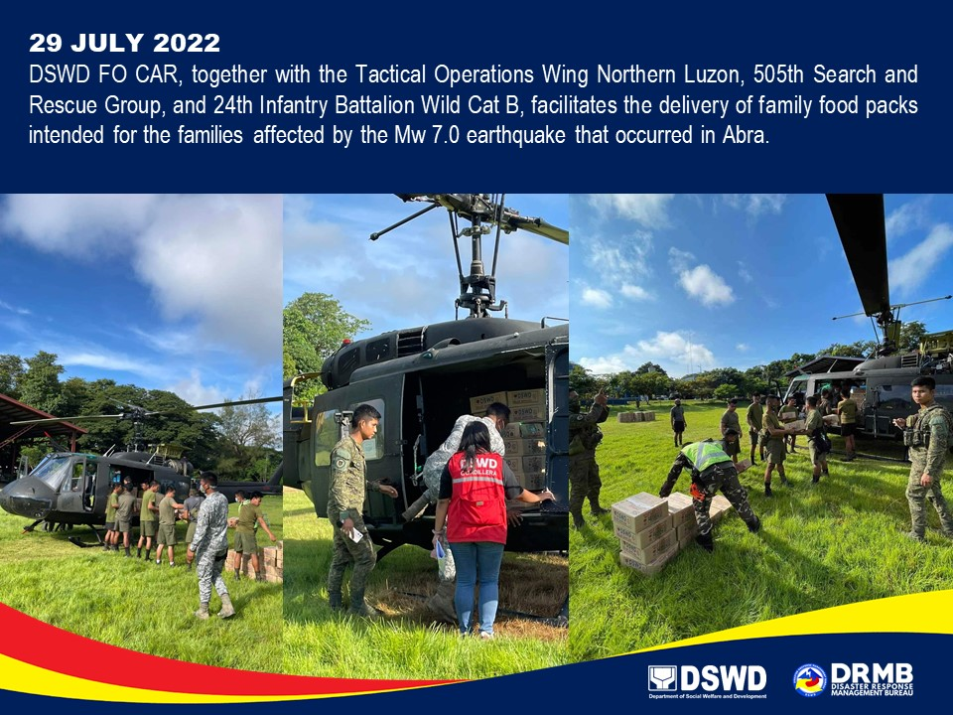

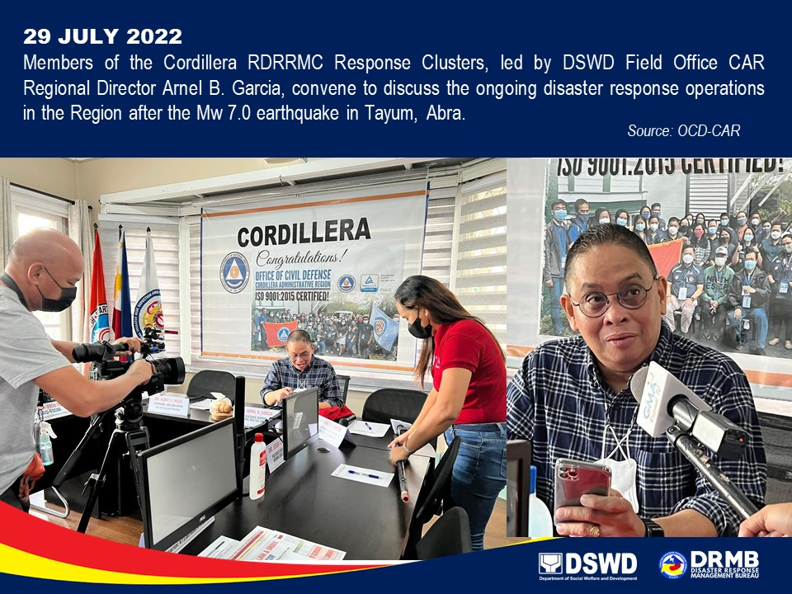

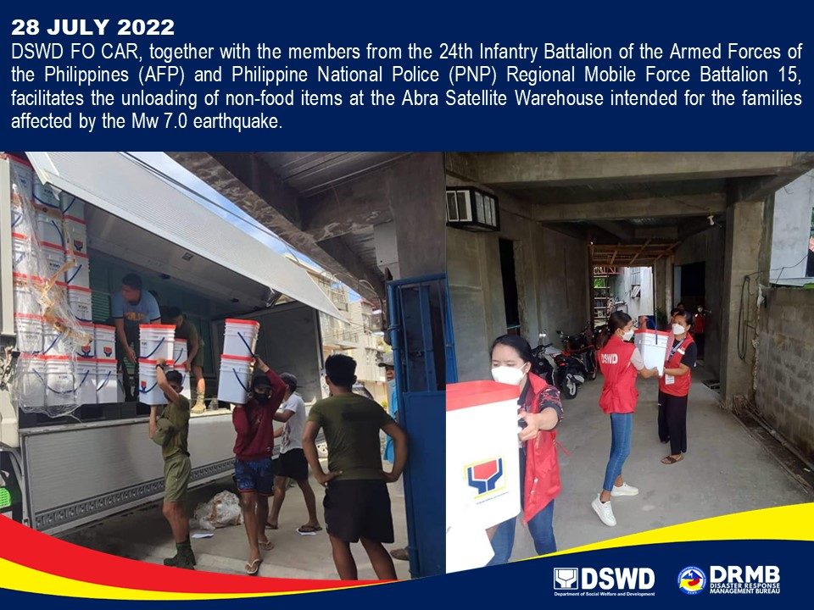
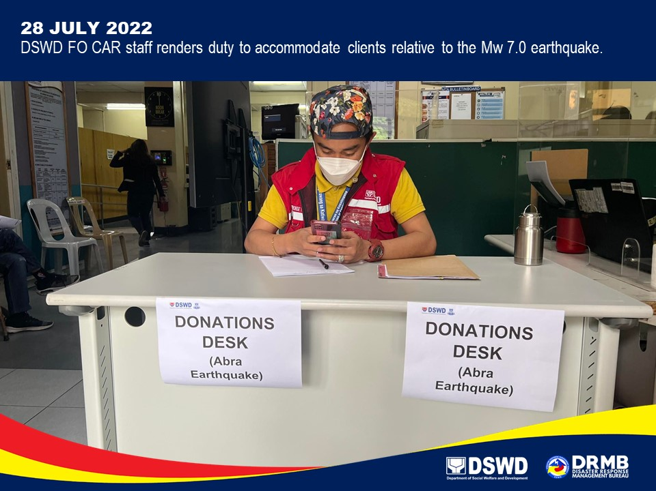

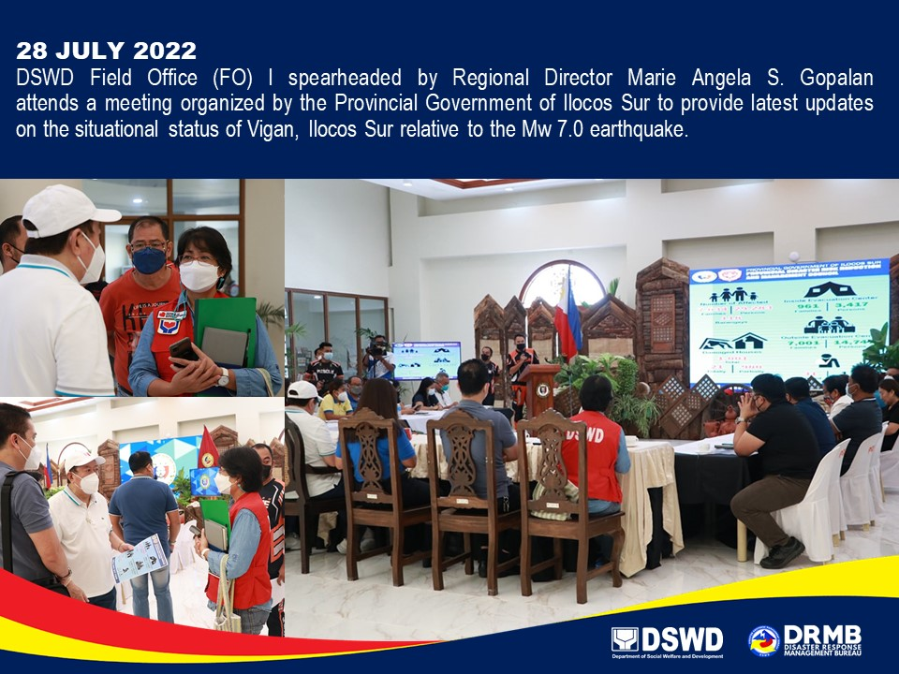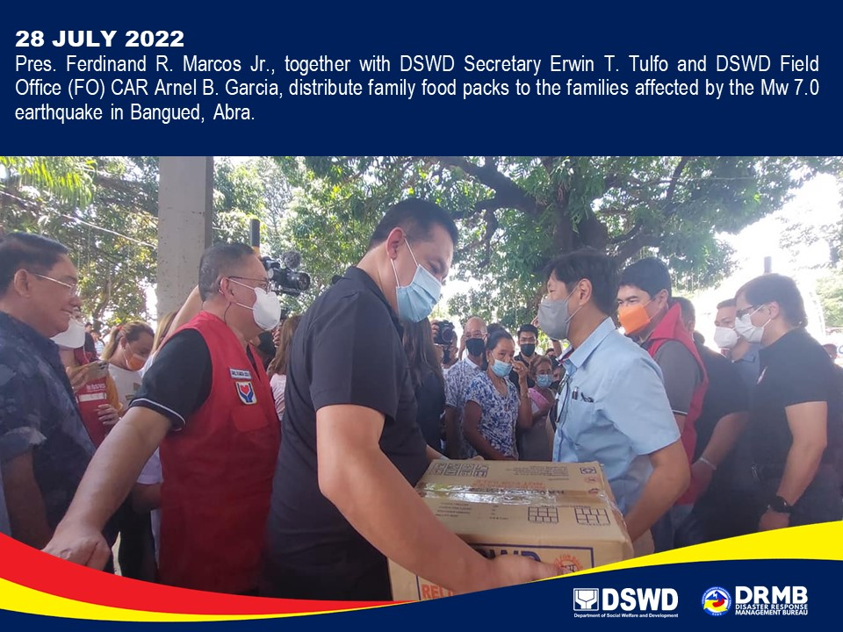

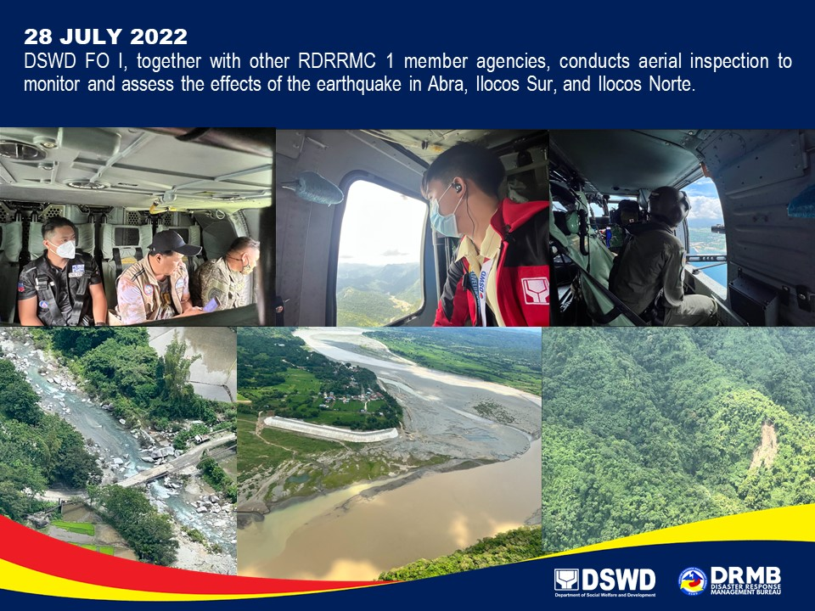

*****
The Disaster Response Operations Monitoring and Information Center (DROMIC) of the DSWD-DRMB is closely coordinating with the concerned DSWD-FOs for any significant updates and actions taken relative to the Earthquake Incident.

Prepared by: Releasing Officer:

DIANE C. PELEGRINO MARC LEO L. BUTAC
AARON JOHN B. PASCUA
MARIE JOYCE G. RAFANAN
JEM ERIC F. FAMORCAN
PHIL JOBERT A. ZALDIVAR

