DSWD DROMIC Terminal Report on the Flashflood Incident
in Tangcal, Lanao del Norte
07 September 2022, 6PM
- Situation Overview

On 03 July 2022 at 2:12 AM, heavy rains resulted to a flashflood incident in Brgy. Lindongan, Tangcal, Lanao del Norte.
Source: DSWD Field Office (FO) X

- Status of Affected Areas and Population

There are 76 families or 417 persons affected in Brgy. Lindongan, Tangcal, Lanao del Norte (see Table 1).

Table 1. Number of Affected Families / Persons
REGION / PROVINCE / MUNICIPALITY |  | NUMBER OF AFFECTED
 |  | Barangays | Families | Persons
GRAND TOTAL |  | 1 | 76 | 417
REGION X |  | 1 | 76 | 417
Lanao del Norte |  | 1 | 76 | 417
 | Tangcal | 1 | 76 | 417
Source: DSWD FO X

- Status of Displaced Population

- Inside Evacuation Center
A total of 25 families or 125 persons took temporary shelter at a Madrasah in the neighboring Barangay of Somiorang (see Table 2).

Table 2. Number of Displaced Families / Persons Inside Evacuation Center
REGION / PROVINCE / MUNICIPALITY |  | NUMBER OF EVACUATION CENTERS (ECs) |  | NUMBER OF DISPLACED
 |  |  |  | INSIDE ECs
 |  |  |  | Families |  | Persons
 |  | CUM | NOW | CUM | NOW | CUM | NOW
GRAND TOTAL |  | 1 | - | 25 | - | 125 | -
REGION X |  | 1 | - | 25 | - | 125 | -
Lanao del Norte |  | 1 | - | 25 | - | 125 | -
 | Tangcal | 1 | - | 25 | - | 125 | -
Source: DSWD FO X

- Damaged Houses

A total of 25 houses were partially damaged in Brgy. Lindongan, Tangcal, Lanao del Norte (see Table 3).

Table 3. Number of Damaged Houses
REGION / PROVINCE / MUNICIPALITY |  | NO. OF DAMAGED HOUSES
 |  | Total | Totally | Partially
GRAND TOTAL |  | 25 | - | 25
REGION X |  | 25 | - | 25
Lanao del Norte |  | 25 | - | 25
 | Tangcal | 25 | - | 25
Source: DSWD FO X

- Cost of Humanitarian Assistance Provided

A total of ₱226,974.00 worth of assistance was provided to the affected families; of which, ₱167,428.00 from the DSWD and ₱59,546.00 from the Local Government Unit (LGU) (see Table 4).

Table 4. Cost of Assistance Provided to Affected Families / Persons
REGION / PROVINCE / MUNICIPALITY |  | COST OF ASSISTANCE
 |  | DSWD | LGU | NGOs | OTHERS | GRAND TOTAL
GRAND TOTAL |  | 167,428.00 | 59,546.00 | - | - | 226,974.00
REGION X |  | 167,428.00 | 59,546.00 | - | - | 226,974.00
Lanao del Norte |  | 167,428.00 | 59,546.00 | - | - | 226,974.00
 | Tangcal | 167,428.00 | 59,546.00 | - | - | 226,974.00
Source: DSWD FO X

- PHOTO DOCUMENTATION

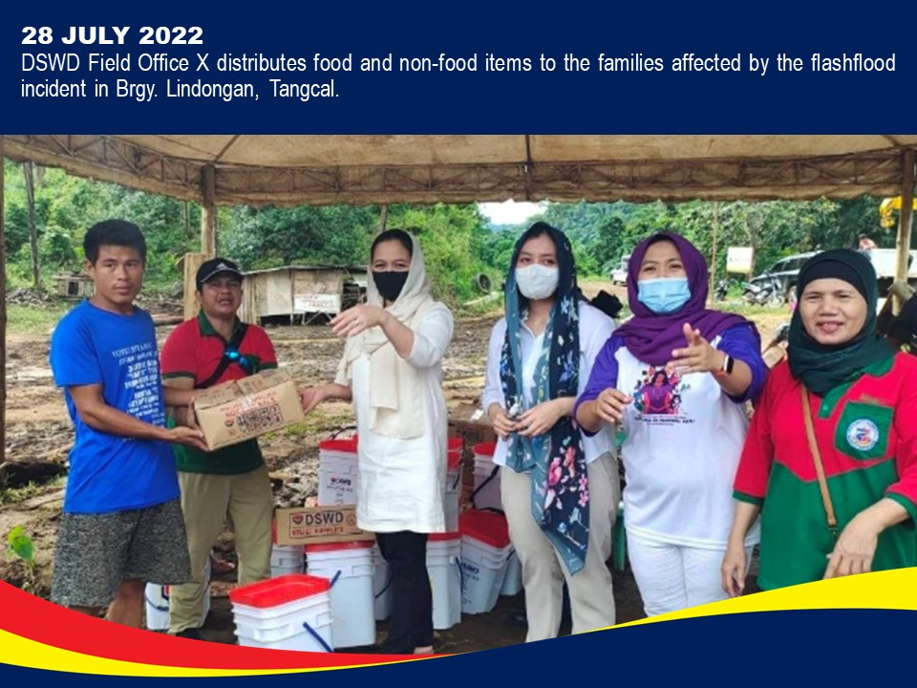

*****
This terminal report is based on the final report submitted by DSWD FO X on 11 August 2022. The Disaster Response Operations Monitoring and Information Center (DROMIC) of DSWD-DRMB is closely coordinating with DSWD FO X for any request of Technical Assistance and Resource Augmentation (TARA).

Prepared by:  JOANNA CAMILLE R. JACINTO-LIZARDO | Released by:  RODEL V. CABADDU

