DSWD DROMIC Preparedness for Response Report #1 on Tropical Depression “FLORITA”
as of 22 August 2022, 6AM

Situation Overview

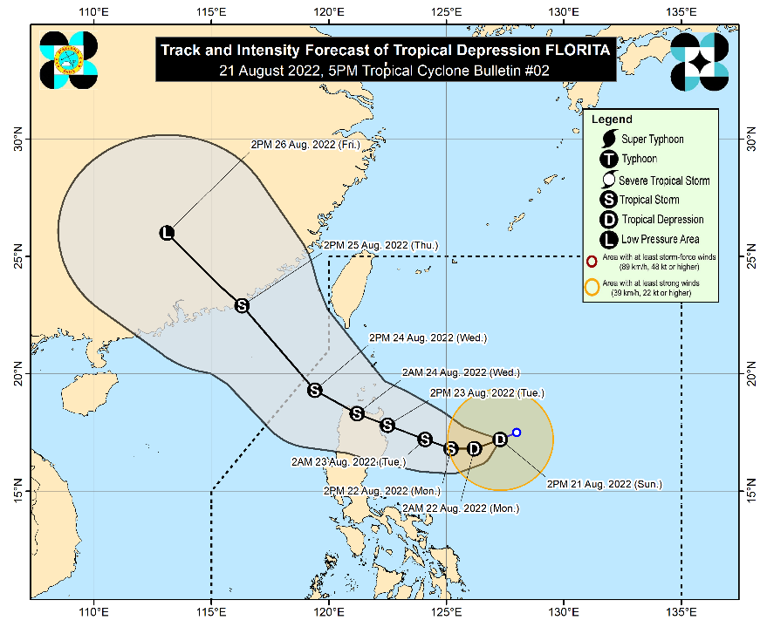
Issued at 5:00 PM, 21 August 2022, FLORITA SLIGHTLY INTENSIFIES WHILE MOVING WEST SOUTHWESTWARD OVER THE PHILIPPINE SEA EAST OF CAGAYAN.

Heavy Rainfall:
- Tomorrow early morning through afternoon, light to moderate with at times heavy rains may prevail over Cagayan, Isabela, Batanes, and Aurora.
- By tomorrow evening through Tuesday evening, heavy to intense with at times torrential rains over Batanes, Cagayan, Isabela, Cordillera Administrative Region, and Ilocos Region. Light to moderate with at times heavy rains over Central Luzon and the rest of Cagayan Valley.
- Under these conditions, scattered to widespread flooding (including flash floods) and rain-induced landslides are expected especially in areas that are highly or very highly susceptible to these hazard as identified in hazard maps, and in localities with significant antecedent rainfall.

Severe Winds:

- Strong winds (strong breeze to near gale conditions) will be experienced within any of the areas where Wind Signal no. 1 is currently in effect
- Areas under TCWS will be expanded in succeeding bulletins, while the hoisted wind signals in some localities of the country will be upgraded as “FLORITA” moves closer. Hoisting of TCWS #2 is likely in the localities situated in the eastern section of Northern Luzon as early as tomorrow morning.
Hazards affecting Coastal Waters:

- In the next 24 hours, the tropical depression will bring moderate to rough seas (1.2 to 2.8 m) over the eastern seaboards of Luzon. These conditions may be risky for those using small seacrafts. Mariners are advised to take precautionary measures when venturing out to sea and, if possible, avoid navigating in these conditions.

Track and Intensity Outlook:

- Tropical Depression “FLORITA” will continue moving generally west southwestward in the next 12 hours before turning westward tomorrow morning, then west northwestward by Tuesday towards Northern Luzon. On the forecast track, the center of this tropical cyclone is forecast to make landfall in the vicinity of Cagayan or northern portion of Isabela on Tuesday morning or afternoon. Afterwards, the center of “FLORITA” will move west northwestward and cross several provinces in Northern Luzon before emerging over the West Philippine Sea by Wednesday early morning.
- “FLORITA” is forecast to reach tropical storm category tomorrow morning or afternoon and may reach peak intensity of 75 km/h prior to making landfall on Tuesday morning or afternoon. Slight weakening is likely as it crosses the Northern Luzon, but it is forecast to remain within the tropical storm category.
The center of the eye was estimated based on all available data 540 km East of Tuguegarao City, Cagayan (17.1 °N, 126.8 °E)
Source: DOST-PAGASA Severe Weather Bulletin

Predictive Analytics for Humanitarian Response (PAHR)

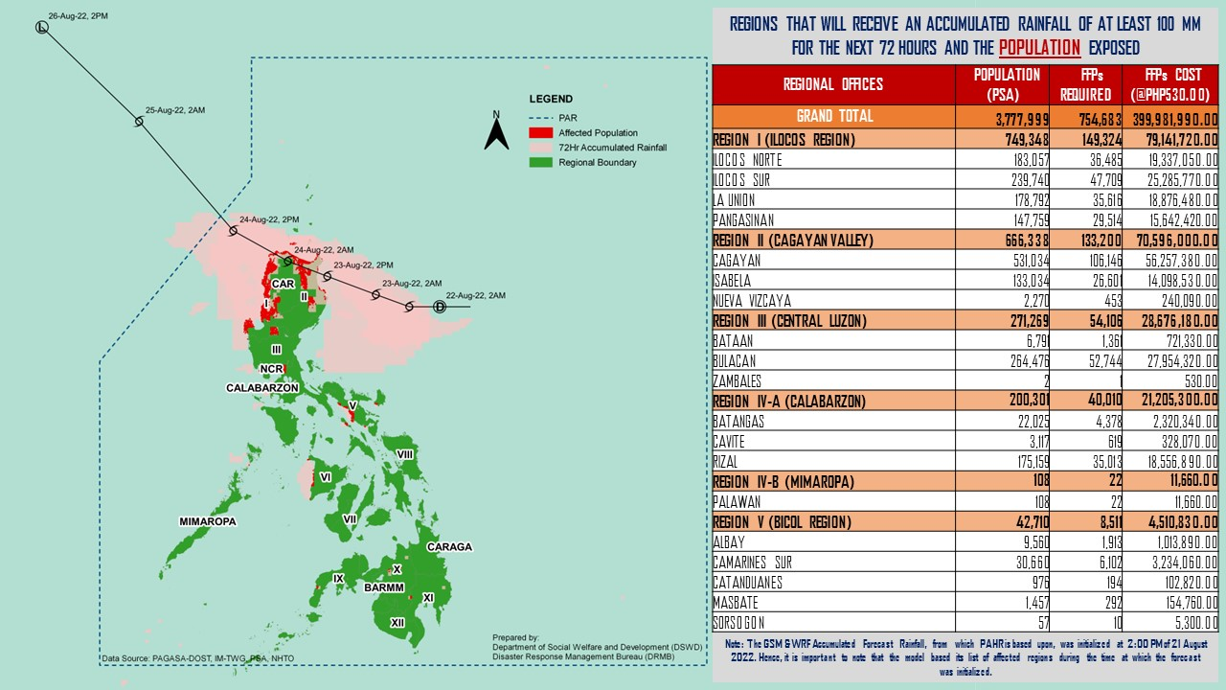

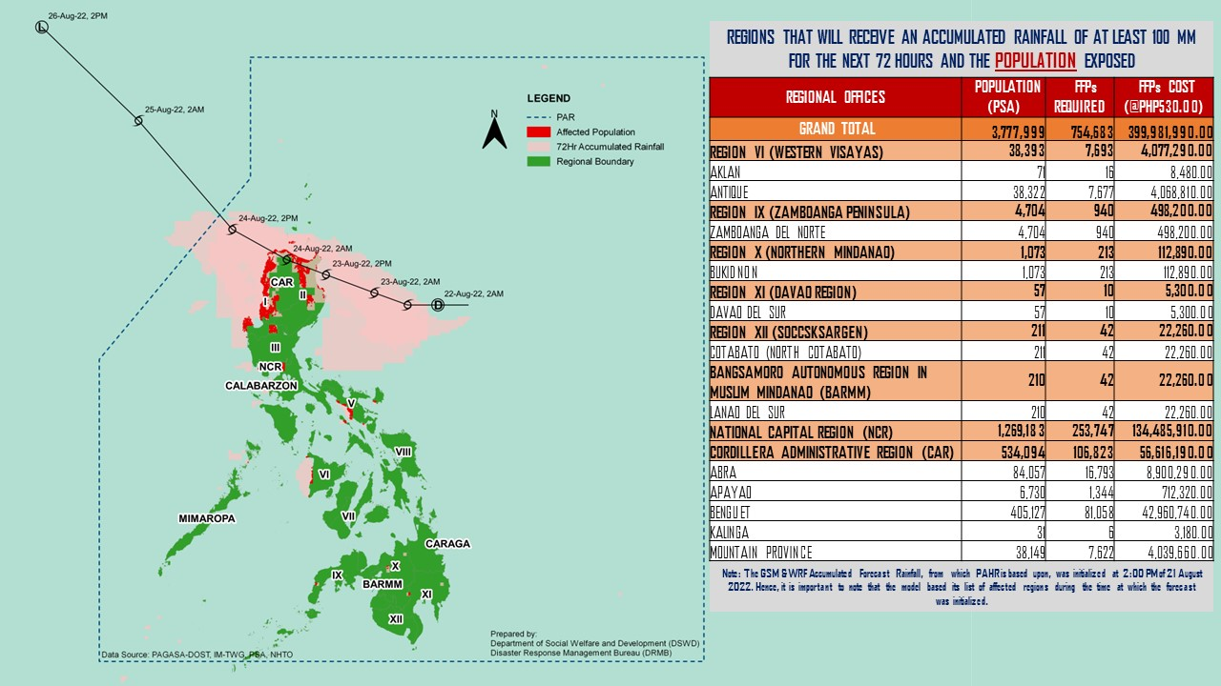

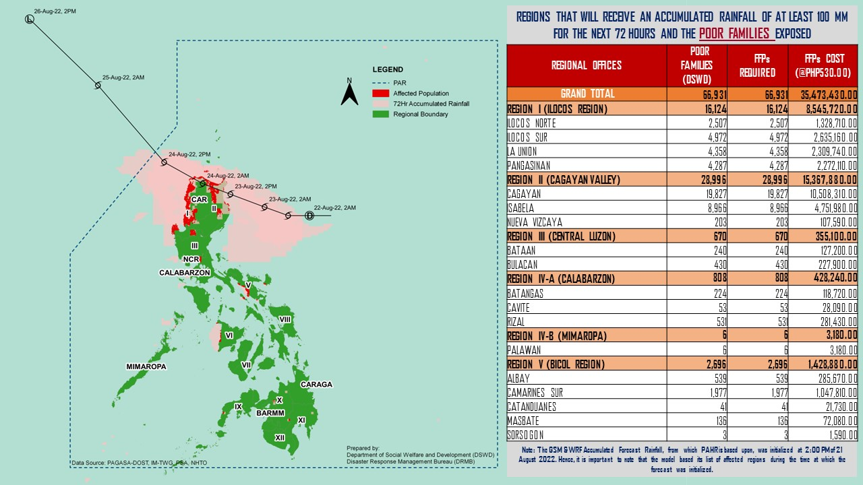

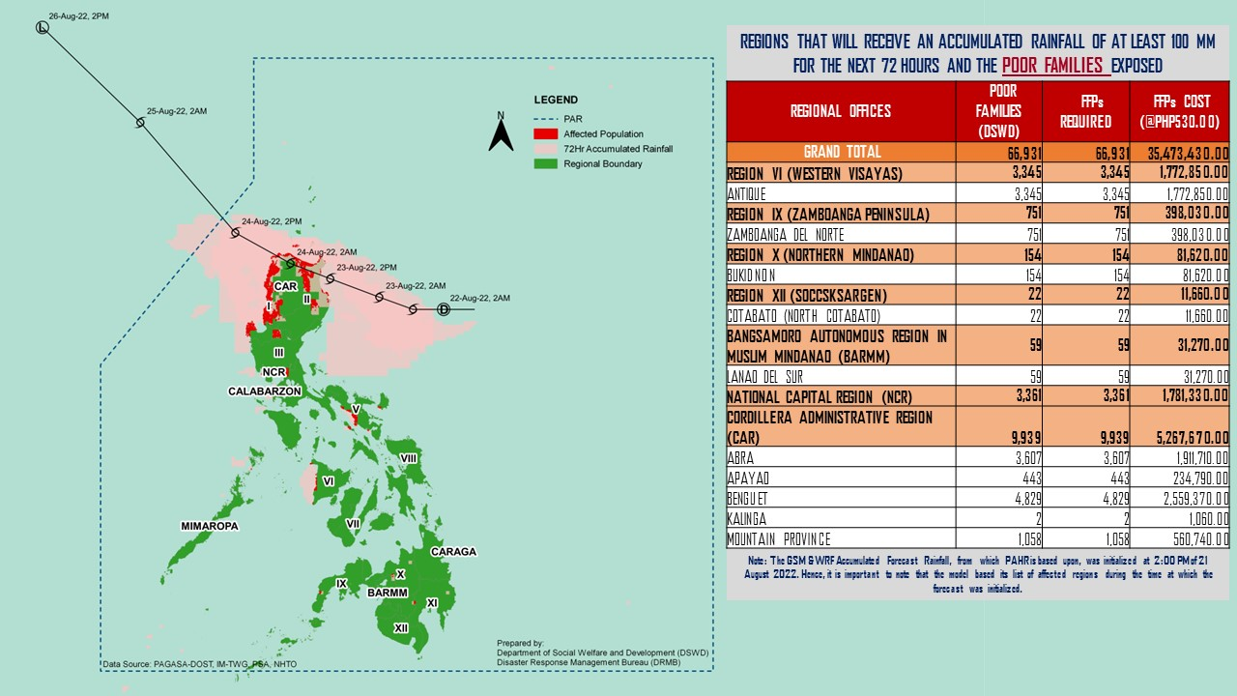

Status of Prepositioned Resources: Stockpile and Standby Funds

The DSWD Central Office (CO), Field Offices (FOs), and National Resource Operations Center (NROC) have stockpiles and standby funds amounting to ₱1,758,867,142.04 with breakdown as follows (see Table 2):

- Standby Funds
A total of ₱843,919,378.86 standby funds in the CO and FOs. Of the said amount, ₱765,504,390.12 is the available Quick Response Fund (QRF) in the CO.

- Stockpiles
A total of 481,054 family food packs (FFPs) amounting to ₱284,207,073.02, other food items amounting to ₱190,906,645.93 and non-food items (FNIs) amounting to ₱439,834,044.23 are available.

Table 1. Available Stockpiles and Standby Funds
REGIONAL / FIELD OFFICE | STANDBY FUNDS | FAMILY FOOD PACKS |  | OTHER FOOD ITEMS | NON-FOOD RELIEF ITEMS | TOTAL STANDBY FUNDS & STOCKPILE
 |  | QUANTITY | TOTAL COST | TOTAL COST | TOTAL COST
TOTAL | 843,919,378.86 | 481,054 | 284,207,073.02 | 190,906,645.93 | 439,834,044.23 | 1,758,867,142.04
Central Office | 765,504,390.12 | - | - | - | - | 765,504,390.12
NRLMB - NROC | - | 42,372 | 26,410,031.00 | 48,272,835.21 | 46,025,704.79 | 120,708,571.00
NRLMB - VDRC | - | 51,729 | 32,858,910.00 | 37,490,675.40 | 72,010.00 | 70,421,595.40
I | 5,082,232.51 | 20,179 | 12,628,858.75 | 12,645,524.80 | 23,145,491.65 | 53,502,107.71
II | 5,623,408.00 | 18,098 | 9,272,546.25 | 4,717,837.45 | 13,644,633.50 | 33,258,425.20
III | 5,253,797.79 | 16,654 | 8,284,342.40 | 2,292,781.09 | 22,536,586.35 | 38,367,507.63
CALABARZON | 5,000,000.47 | 13,824 | 8,333,707.75 | 3,159,406.00 | 30,707,579.16 | 47,200,693.38
MIMAROPA | 7,120,619.78 | 32,974 | 23,386,198.38 | 9,984,849.00 | 18,525,527.34 | 59,017,194.50
V | 5,000,000.00 | 65,615 | 34,119,427.32 | 6,279,587.05 | 41,474,054.40 | 86,873,068.77
VI | 5,000,000.00 | 21,667 | 10,976,333.00 | 1,892,695.00 | 27,842,048.64 | 45,711,076.64
VII | 5,000,000.00 | 22,573 | 12,866,610.00 | 12,469,084.58 | 35,608,076.14 | 65,943,770.72
VIII | 5,000,000.00 | 22,209 | 13,847,373.94 | 4,811,088.50 | 31,973,242.37 | 55,631,704.81
IX | 5,000,000.00 | 23,661 | 8,789,198.67 | 6,371,841.88 | 15,176,872.85 | 35,337,913.40
X | 5,243,500.50 | 20,248 | 14,114,182.50 | 15,586,510.83 | 26,928,425.50 | 61,872,619.33
XI | 5,090,000.00 | 22,768 | 14,393,819.00 | 12,713,303.75 | 27,325,263.80 | 59,522,386.55
XII | 5,000,969.85 | 22,799 | 13,476,800.00 | 7,638,855.00 | 23,560,363.98 | 49,676,988.83
CARAGA | - | 19,194 | 13,320,636.00 | 334,307.51 | 16,504,283.60 | 30,159,227.11
NCR | 5,000,000.00 | 11,106 | 5,278,572.00 | 1,832,534.15 | 5,561,838.21 | 17,672,944.36
CAR | 5,000,459.84 | 33,384 | 21,849,526.06 | 2,412,928.73 | 33,222,041.95 | 62,484,956.58
Note: The Inventory Summary is as of 21 August 2022, 4PM. Replenishment of standby funds for DSWD-FO CARAGA is currently being processed.
Source: DRMB and NRLMB

Situational Reports

DSWD-DRMB
DATE | SITUATIONS / ACTIONS UNDERTAKEN
21 August 2022 | - The Disaster Response Management Bureau (DRMB) is closely coordinating with the concerned field offices for significant disaster response updates.  - DRMB participated in the Online Pre-Disaster Risk Assessment (PDRA) Core Group Meeting on Tropical Depression “FLORITA” with other response cluster member agencies on 21 August 2022. Further meetings shall be conducted on the implementation of COVID-19 protocols during the response efforts on the Tropical Depression “FLORITA”.  - All DRMB Quick Response Team (QRT) members and emergency equipment are on standby and ready for deployment.

DSWD-NRLMB
DATE | SITUATIONS / ACTIONS UNDERTAKEN
21 August 2022 | - DSWD-NRLMB is continuously repacking goods for possible augmentation.  - DSWD-NRLMB provides logistical augmentation to FOs on delivering FFPs to LGUs.

DSWD-FO II
DATE | SITUATIONS / ACTIONS UNDERTAKEN
21 August 2022 | - DSWD FO II attended the Pre-Disaster Risk Assessment (PDRA) Core Group Meeting relative to the preparedness for response measures of every member council of Cagayan Valley Regional Disaster Risk Reduction Management Council (CVRDRRMC).  - DSWD FO II ensures that the Regional Quick Response Teams (RQRTs), Social Welfare and Development Teams and City / Municipal Action Teams (C/MATs) in the region are on a ON-CALL/STANDBY status and are advised to coordinate with the Local Disaster Risk Reduction and Management Councils (LDRRMCs) / Local Social Welfare and Development Offices (LSWDOs) if there are concerns needed to be addressed by the Field Office.  - DSWD FO II continuous to ensure availability of Food and Non-Food Items (FNIs) at any given time.  - DSWD FO II through the Disaster Response Management Division (DRMD) is continuously coordinating with the Provincial / City / Municipal Social Welfare and Development Offices (P/C/MSWDOs) and Provincial / City / Municipal Disaster Risk Reduction Management Offices (P/C/MDRRMOs) in the provinces of Cagayan, Isabela, Quirino, Nueva Vizcaya and Batanes for significant disaster response updates.

*****
The Disaster Response Operations Monitoring and Information Center (DROMIC) of the DSWD-DRMB is closely monitoring the effects of the Tropical Depression “FLORITA” and is coordinating with the concerned DSWD Field Offices for any significant updates.

Prepared by:  MARIE JOYCE G. RAFANAN | Released by:  LESLIE R. JAWILI

