DSWD DROMIC Preparedness for Response Report #43 on the
Kanlaon Volcano Seismic Activity
as of 04 August 2022, 6AM

- Brief Background on Kanlaon Volcano

- A stratovolcano (conical volcano built-up by many layers of hardened lava and tephra);

- Mount Kanlaon also known as Kanlaon Volcano covers 24,557.60 hectares of land area with rainforests and verdant vegetation cutting through the political boundaries of cities of Bago, La Carlota, San Carlos, and Canlaon and the towns of Murcia and La Castellana within the park and having 169 hectares as Buffer Zone. Mt. Kanlaon is a complex and active volcano surrounded by several craters and volcanic peaks. Volcanic features in the area include the cinder cone of the active center and craters at the summit. It is underlain by tropical volcanic materials composed of sheeted lava flows, lahar deposits, airfall tephra and apron pyroclastic materials;

- Its last eruption was reported on 20 December 2017 characterized by small volcanic earthquakes with moderate emissions of white steam-laden plumes that rose to 400 meters from the summit; and,

- Areas under the four (4) - kilometer permanent danger zones are 13 barangays of Canlaon City (Lumapao, Malaiba, Masulog and Pula), La Castellana (Biaknabato, Cabagnaan, Mansalanao, and Sag-Ang), La Carlota City (Ara-al and Yubo), Bago City (Ilijan and Mailum), and San Carlos City with a combined population count of 76,656. A massive eruption may directly affect a total of 528,838 persons covering all barangays of the said one (1) municipality and four (4) cities.

- Situation Overview

- Kanlaon Volcano is at Alert Level 1, which means that it is at low-level volcanic unrest;

- Alert Level 1 indicates slight increase in volcanic earthquake and steam / gas activity. Sporadic explosions from the summit crater or new vents. Notable increase in the temperature, acidity and volcanic gas concentrations of monitored springs and fumaroles. Slight inflation or swelling of the edifice;

- The local government units (LGUs) and the public are strongly reminded that entry into the 4-kilometer radius Permanent Danger Zone (PDZ) is strictly prohibited due to the further possibilities of sudden and hazardous steam-driven or phreatic eruptions;

- Civil aviation authorities must also advise pilots to avoid flying close to the volcano’s summit as ejecta from any sudden phreatic eruption can be hazardous to aircraft; and,

- DOST-PHIVOLCS is closely monitoring Kanlaon Volcano’s activity and any new development will be relayed to all concerned.

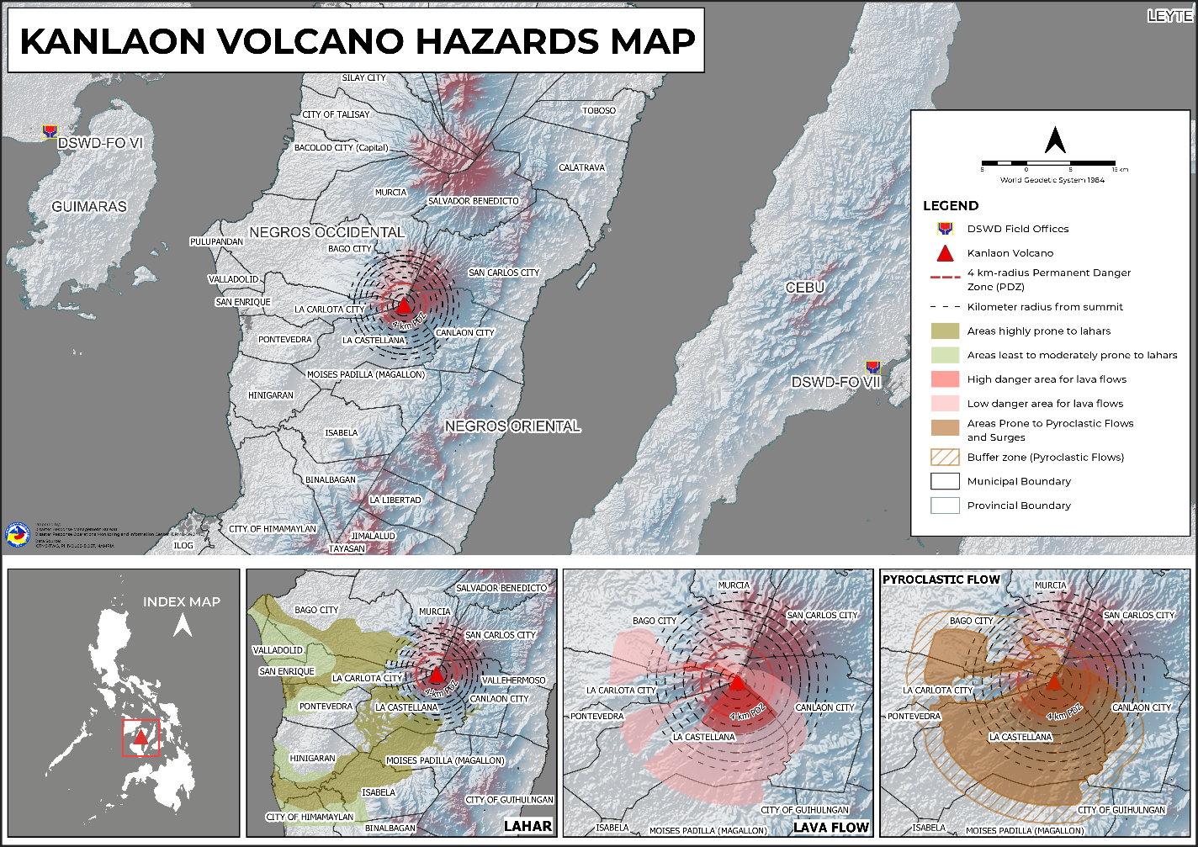

- Predictive Analytics for Humanitarian Response (PAHR)

A total of 15,331 families or 76,656 persons in 13 barangays in Regions VI and VII lying within the 4-kilometer (km) Permanent Danger Zone (PDZ) are at high risk on Kanlaon’s eruption. A massive eruption would directly affect 105,767 families or 528,838 persons spanning one (1) town and four (4) cities in Negros Occidental and Negros Oriental (see Table 1).

Table 1. Projected Affected Population
Affected Areas | 4-km PDZ |  |  | Total Population
 | Barangays | Families | Persons | Barangays | Families | Persons
TOTAL | 13 | 15,331 | 76,656 | 149 | 105,767 | 528,838
Region VI  (Negros Occidental) | 9 | 11,513 | 57,565 | 137 | 94,003 | 470,016
Bago City | 2 | 2,683 | 13,416 | 24 | 38,242 | 191,210
La Castellana | 4 | 4,914 | 24,570 | 13 | 15,898 | 79,492
La Carlota City | 2 | 1,069 | 5,345 | 14 | 13,333 | 66,664
San Carlos City | 1 | 2,847 | 14,234 | 86 | 26,530 | 132,650
Region VII  (Negros Oriental) | 4 | 3,818 | 19,091 | 12 | 11,764 | 58,822
Canlaon City | 4 | 3,818 | 19,091 | 12 | 11,764 | 58,822

A total of ₱9,965,150.00 worth of family food packs (FFPs) is projected to be provided to 15,331 families in Regions VI and VII based on the 4-km PDZ. A massive eruption would require 105,767 FFPs for the same number of families that would be directly affected, costing ₱68,748,550.00 for a two (2)-day food requirement for a family of five (5) members (see Table 2).

Table 2. Projected FFPs Requirement
Affected Areas | 4-km PDZ |  | PSA 2020
 | Families | FFP Cost | Families | FFP Cost
TOTAL | 15,331 | 9,965,150.00 | 105,767 | 68,748,550.00
Region VI  (Negros Occidental) | 11,513 | 7,483,450.00 | 94,003 | 61,101,950.00
Bago City | 2,683 | 1,743,950.00 | 38,242 | 24,857,300.00
La Castellana | 4,914 | 3,194,100.00 | 15,898 | 10,333,700.00
La Carlota City | 1,069 | 694,850.00 | 13,333 | 8,666,450.00
San Carlos City | 2,847 | 1,850,550.00 | 26,530 | 17,244,500.00
Region VII  (Negros Oriental) | 3,818 | 2,481,700.00 | 11,764 | 7,646,600.00
Canlaon City | 3,818 | 2,481,700.00 | 11,764 | 7,646,600.00

- Response Actions and Interventions

        - Standby Funds and Prepositioned Relief Stockpile

OFFICE | STANDBY FUNDS | STOCKPILE |  |  | TOTAL STANDBY FUNDS & STOCKPILE
 |  | FAMILY FOOD PACKS |  | OTHER FOOD AND NON-FOOD ITEMS (FNIs)
 |  | QUANTITY | TOTAL COST
TOTAL | 321,813,298.70 | 450,482 | 272,092,292.82 | 681,269,652.20 | 1,275,175,243.72
DSWD CO | 247,530,257.39 | - | - | - | 247,530,257.39
NRLMB NROC | - | 43,474 | 28,294,645.00 | 98,252,171.77 | 126,546,816.77
NRLMB VDRC | - | 51,729 | 32,818,910.00 | 49,058,205.80 | 81,877,115.80
DSWD FO VI | 5,000,000.00 | 31,035 | 13,264,910.00 | 31,827,895.64 | 50,092,805.64
DSWD FO VII | 5,000,000.00 | 17,667 | 10,070,190.00 | 56,221,993.97 | 71,292,183.97
Other FOs | 64,283,041.31 | 306,577 | 187,643,637.82 | 445,909,385.02 | 697,836,064.15
Note: The Inventory Summary is as of 03 August 2022, 8PM.
Sources: DSWD-DRMB and DSWD-NRLMB

  - Standby Funds
    - ₱247.53 million Quick Response Fund (QRF) at the DSWD Central Office.
    - ₱10 million available at DSWD FOs VI and VII.
    - ₱64.28 million in other DSWD FOs which may support the relief needs through inter-FO augmentation.
  - Prepositioned FFPs and Other Relief Items
    - 95,203 FFPs available in Disaster Response Centers; of which, 43,474 FFPs are at the National Resource Operations Center (NROC), Pasay City and 51,729 FFPs are at the Visayas Disaster Resource Center (VDRC), Mandaue City.
    - 48,702 FFPs available at DSWD FOs VI and VII.
    - 306,577 FFPs in other DSWD FOs which may support the relief needs through inter-FO augmentation.
    - ₱681.27 million worth of other FNIs at NROC, VDRC, and DSWD FO warehouses.

        - Other Activities

DSWD-DRMB
DATE | SITUATIONS / ACTIONS UNDERTAKEN
04 August 2022 | - The Disaster Response Operations Monitoring and Information Center (DROMIC) of the DSWD-DRMB monitors and closely coordinates with concerned DSWD Field Offices for significant updates on preparedness measures and actions taken.

DSWD FO VI
DATE | SITUATIONS / ACTIONS UNDERTAKEN
03 July 2022 | - DSWD FO VI coordinated with the City Social Welfare and Development Office (CSWDO) of Himamaylan, Talisay and Bago City for additional prepositioning of goods.  - DSWD FO VI closely monitored the situation through coordination with PHIVOLCs and concerned local government units (LGUs) for any reports on displacement of families and relief needs through the Quick Response Teams (QRTs) and Action Teams deployed at the local level.

DSWD FO VII
DATE | SITUATIONS / ACTIONS UNDERTAKEN
12 July 2022 | - DSWD FO VII personnel facilitated the ongoing five (5)-day Camp Coordination and Camp Management (CCCM) and Internally Displaced Persons (IDP) Training to 33 participants from the Local Social Welfare and Development Office (LSWDO), Local Disaster Risk Reduction and Management Office (LDRRMO), Department of Education (DepEd) and Philippine National Police (PNP) in Canlaon City, Negros Oriental on 11 July 2022.  - DSWD FO VII ensures continuous inspection and assessment of possible storage facilities for the prepositioning of Food and Non-Food Items (FNFIs) in the LGUs of Canlaon City, Vallehermoso, La Libertad, Guihulngan City and Jimalalud, Negros Oriental.  - DSWD FO VII is currently finalizing the Memorandum of Agreement (MOA) for the prepositioning of FNFIs to Canlaon City. On-going coordination, discussion and consultation meetings with the DSWD Legal Team are being conducted.  - At least 5,000 FFPs, hygiene kits, and family kits will be prepositioned in Canlaon City as initial preparations.
08 July 2022 | - DSWD FO VII coordinated with the LDRRMO and LSWDO of Canlaon City. The NRLMB VDRC committed to provide technical assistance to Canlaon City in the assessment of identified warehouses and storage facilities, and in the identification of other facilities as option for secondary storage.  - DSWD FO VII and concerned stakeholders reviewed the provisions and roles of each party in the Memorandum of Agreement (MOA) relative to the prepositioning of FFPs, and the LGU of Canlaon City has to enter into a MOA with DSWD prior to the delivery of the projected 5,000 FFPs as prepositioned relief goods in the area.
07 July 2022 | - The LDRRM Operations Center continuously monitored the behavior and activities of the Kanlaon Volcano.  - The LDRRMO of Canlaon City conducted assessment in the barangays of Pula and Masulog. The team visited the Sitios located at the foot of the volcano where five (5) manifestations of felt earthquakes were recorded.
06 July 2022 | - DSWD FO VII convened a meeting with the member agencies of the Regional Disaster Risk Reduction and Management Council (RDRRMC)-7 Response Cluster at the Office of Civil Defense (OCD) VII in Lapu-Lapu City, Cebu to discuss the Contingency Plan for the Kanlaon Volcano seismic activity in line with the disaster preparedness of the RDRRMC-7.
05 July 2022 | - DSWD FO VII coordinated with the Local Disaster Risk Reduction and Management (LDRRM) Officer of Canlaon City. There was no significant rumbling or explosion in the area and unusual behavior observed on Mt. Kanlaon other than the earthquakes recorded by DOST-PHIVOLCS.  - DSWD FO VII through its Disaster Response Management Division conducted a meeting together with the Social Welfare and Development (SWAD) Team and warehouse personnel in Negros Oriental for the crafting of the Pre-Disaster and Preparedness Implementation Plan.  - The Regional Resource Operations Section (RROS) of DSWD FO VII would deploy its Provincial Warehouse Manager to Canlaon City to discuss preparations, check/inspect storage areas for the planned prepositioning of FNIs as well as check on evacuation camps’ capacity for the deployment of tents. He would also be visiting the adjacent Municipality of Vallehermoso for the same purpose.  - DSWD FO VII would attend the Disaster Response Cluster meeting organized by the Office of Civil Defense (OCD) VII to discuss the Central Visayas Contingency Plan for Mt. Kanlaon.
03 July 2022 | - DSWD FO VII closely monitored the situation through coordination with PHIVOLCS and concerned Local Disaster Risk Reduction and Management Councils (LDRRMCs) for any reports on displacement of families and relief needs through the QRTs and Negros Oriental Provincial and Canlaon City Action Teams.

*****
The Disaster Response Operations Monitoring and Information Center (DROMIC) of DSWD-DRMB is closely coordinating with DSWD FOs VI and VII for significant preparedness for response updates and technical assistance needed.

Prepared by:  AARON JOHN B. PASCUA  MARIE JOYCE G. RAFANAN | Released by:  MARC LEO L. BUTAC

Canlaon City Official website (www.canlaoncity.gov.ph)
Department of Science and Technology - Philippine Institute of Volcanology and Seismology (DOST-PHIVOLCS)
Philippine Statistics Authority (PSA), May 2020
Based on the latest DOST-PHIVOLCS Advisory issued on 03 August 2022, 5AM

