DSWD DROMIC Report #1 on the
Fire Incident in Brgy. Subangdaku, Mandaue City
as of 1 August 2022, 6PM
- Situation Overview

On 30 July 2022, the Mandaue City Fire Office received a second alarm fire along H. Cortes St., Brgy. Subangdaku, Mandaue City, Cebu.

Source: DSWD-Field Office (FO) VII

- Status of Affected Areas and Population

A total of 31 families or 109 persons are affected in one (1) barangay in Region VII (see Table 1).

Table 1. Number of Affected Families / Persons
REGION / PROVINCE / MUNICIPALITY |  | NUMBER OF AFFECTED
 |  | Barangays | Families | Persons
GRAND TOTAL |  | 1 | 31 | 109
REGION VII |  | 1 | 31 | 109
Cebu |  | 1 | 31 | 109
 | Mandaue City | 1 | 31 | 109
Note: Ongoing assessment and validation being conducted.
Source: DSWD FO VII

- Status of Displaced Population

- Inside Evacuation Center
There are 31 families or 109 persons currently taking temporary shelter at Subangdaku Elementary School in Mandaue City (see Table 2).

Table 2. Number of Displaced Families / Persons Inside Evacuation Center
REGION / PROVINCE / MUNICIPALITY |  | NUMBER OF EVACUATION CENTERS (ECs) |  | NUMBER OF DISPLACED
 |  |  |  | INSIDE ECs
 |  |  |  | Families |  | Persons
 |  | CUM | NOW | CUM | NOW | CUM | NOW
GRAND TOTAL |  | 1 | 1 | 31 | 31 | 109 | 109
REGION VII |  | 1 | 1 | 31 | 31 | 109 | 109
Cebu |  | 1 | 1 | 31 | 31 | 109 | 109
 | Mandaue City | 1 | 1 | 31 | 31 | 109 | 109
Note: Ongoing assessment and validation being conducted.
Source: DSWD FO VII

- Damaged Houses
A total of 16 houses were damaged by the fire; of which, 15 are totally damaged and one (1) is partially damaged (see Table 3).

Table 3. Number of Damaged Houses
REGION / PROVINCE / MUNICIPALITY |  | NO. OF DAMAGED HOUSES
 |  | Total | Totally | Partially
GRAND TOTAL |  | 16 | 15 | 1
REGION VII |  | 16 | 15 | 1
Cebu |  | 16 | 15 | 1
 | Mandaue City | 16 | 15 | 1
Source: DSWD-FO VII
- Response Actions and Interventions

- Standby Funds and Prepositioned Relief Stockpile
OFFICE | STANDBY FUNDS | STOCKPILE |  |  | TOTAL STANDBY FUNDS & STOCKPILE
 |  | FAMILY FOOD PACKS |  | OTHER FOOD AND NON-FOOD ITEMS (FNIs)
 |  | QUANTITY | TOTAL COST
TOTAL | 252,530,257.39 | 111,453 | 71,063,219.00 | 193,917,998.72 | 517,511,475.11
DSWD CO | 247,530,257.39 | - | - | - | 247,530,257.39
NRLMB NROC | - | 42,057 | 28,174,119.00 | 88,637,798.95 | 116,811,917.95
NRLMB VDRC | - | 51,729 | 32,818,910.00 | 49,058,205.80 | 81,877,115.80
DSWD FO VII | 5,000,000.00 | 17,667 | 10,070,190.00 | 56,221,993.97 | 71,292,183.97
Note: The Inventory Summary is as of 1 August 2022, 4PM.
Source: DSWD-DRMB and DSWD-NRLMB

  - Standby Funds
    - ₱247.53 million Quick Response Fund (QRF) at the DSWD Central Office.
    - ₱5 million available at DSWD FO VII.

  - Prepositioned FFPs and Other Relief Items
    - 93,786 FFPs available in Disaster Response Centers; of which, 42,057 FFPs are at the National Resource Operations Center (NROC), Pasay City and 51,729 FFPs are at the Visayas Disaster Resource Center (VDRC), Mandaue City.
    - 17,667 FFPs available at DSWD FO VII.
    - ₱193.92 million worth of other FNIs at NROC, VDRC, and DSWD FO VII warehouses.

- Other Activities

DATE | ACTIVITIES
1 August 2022 | - DSWD FO VII maintains coordination with the Mandaue City Government through the City Social Welfare Services Offices (CSWSO) for any relief augmentation support needed.
31 July 2022 | - DSWD-FO VII distributed a total of ₱140,000.00 financial assistance to the 28 affected families where each family received ₱5,000.00. The other three (3) families were advised to claim their assistance at the DSWD Regional Office.

- Photo Documentation

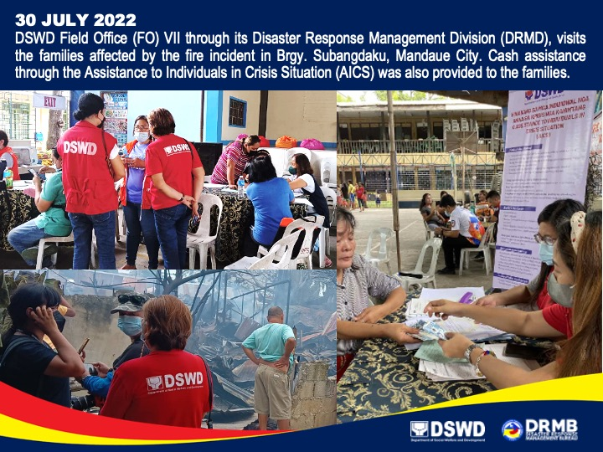

*****
The Disaster Response Operations Monitoring and Information Center (DROMIC) of DSWD-DRMB is closely coordinating with DSWD FO VII for significant disaster response updates and assistance provided.

Prepared by:  JAN ERWIN ANDREW ONTANILLAS  MARIE JOYCE G. RAFANAN | Released by:  MARC LEO L. BUTAC

