DSWD DROMIC Report #13 on the
Mw 7.0 Earthquake Incident in Tayum, Abra

as of 02 August 2022, 6AM

Situation Overview

On 27 July 2022 at 8:43 AM, a 7.0-magnitude earthquake jolted the Municipality of Tayum, Abra (17.64°N, 120.63°E - 003 km N 45°W) with a tectonic origin and a depth of focus of 017 km. The earthquake was also felt in the neighboring municipalities.

Date/Time: | 27 Jul 2022 - 8:43:24 AM
Reported Intensities: | Intensity VII - Bucloc and Manabo, Abra  Intensity VI - Vigan City, Sinait, Bantay, San Esteban, Ilocos Sur; Laoac, Pangasinan; Baguio City;  Intensity V - Magsingal and San Juan, Ilocos Sur, Alaminos City and Labrador, Pangasinan; Bambang, Nueva Vizcaya; Mexico, Pampanga; Concepcion, and Tarlac City, Tarlac; City of Manila; City of Malabon  Intensity IV - City of Marikina; Quezon City; City of Pasig; City of Valenzuela; City of Tabuk, Kalinga; Bautista and Malasiqui, Pangasinan; Bayombong and Diadi, Nueva Vizcaya; Guiguinto, Obando, and San Rafael, Bulacan; San Mateo, Rizal  Intensity III - Bolinao, Pangasinan; Bulakan, Bulacan; Tanay, Rizal  Intensity II - General Trias City, Cavite; Santa Rosa City, Laguna  Instrumental Intensities:  Intensity VII - Vigan City  Intensity V - Laoag City, Ilocos Norte; Peñablanca, Cagayan; Dagupan City, Pangasinan;  Sinait, Ilocos Sur; Baguio City  Intensity IV - Gonzaga, Cagayan; Baler, Aurora; Bayombong, Nueva Vizcaya; Ramos, Tarlac;  Ilagan, Isabela; Basista, Pangasinan; Claveria, Cagayan; San Jose, Palayan City and Cabanatuan City, Nueva Ecija; Madella, Quirino; Tabuk, Kalinga; Santiago City, Isabela  Intensity III - Quezon City; Iba, Zambales; Navotas City, Malabon City, Metro Manila; Magalang & Guagua Pampanga; Bolinao, Sison & Infanta, Pangasinan; Bulakan, San Ildefonso, Guiguinto, Plaridel, and Malolos City, Bulacan; Tarlac City, Tarlac  Intensity II - Dona Remedios Trinidad, Angat & Santa Maria, Bulacan; Tagaytay City, Cavite; Pasig City Metro Manila; Polillo, Gumaca & Infanta, Quezon  Intensity I - Tanay, Taytay, Morong, Antipolo City, Rizal; Marilao,Bulacan; San Juan City, Las Pinas City, Metro Manila; Lucban, Quezon; Subic, Zambales; Mercedes,Camarines Norte; Olongapo City, Zambales; Carmona, Cavite
Expecting Damage: | YES
Expecting Aftershocks: | YES
Source: DOST-PHIVOLCS Earthquake Bulletin

- Status of Affected Areas and Population

A total of 103,549 families or 394,407 persons are affected in 1,135 barangays in Regions I, II, and CAR (see Table 1).

Table 1. Number of Affected Families / Persons

REGION / PROVINCE / MUNICIPALITY |  | NUMBER OF AFFECTED
 |  | Barangays | Families | Persons
GRAND TOTAL |  | 1,135 | 103,549 | 394,407
REGION I |  | 591 | 28,668 | 120,452
Ilocos Norte |  | 12 | 13 | 49
 | Dingras | 2 | 2 | 2
 | Pinili | 9 | 10 | 43
 | Sarrat | 1 | 1 | 4
Ilocos Sur |  | 437 | 25,606 | 108,538
 | Alilem | 2 | 4 | 23
 | Banayoyo | 4 | 4 | 17
 | Bantay | 17 | 172 | 856
 | Burgos | 16 | 309 | 1321
 | Cabugao | 7 | 61 | 305
 | CITY OF CANDON | 35 | 4861 | 17179
 | Caoayan | 17 | 7329 | 36340
 | Cervantes | 13 | 250 | 1054
 | Galimuyod | 9 | 144 | 661
 | Gregorio del Pilar (Concepcion) | 7 | 1247 | 6235
 | Lidlidda | 8 | 72 | 247
 | Magsingal | 24 | 303 | 1009
 | Nagbukel | 8 | 228 | 851
 | Narvacan | 12 | 230 | 1009
 | Quirino (Angkaki) | 9 | 239 | 911
 | Salcedo (Baugen) | 21 | 3377 | 12453
 | San Emilio | 7 | 334 | 1514
 | San Esteban | 6 | 51 | 167
 | San Ildefonso | 4 | 41 | 133
 | San Juan (Lapog) | 22 | 370 | 1223
 | San Vicente | 2 | 66 | 307
 | Santa | 9 | 1413 | 7145
 | Santa Catalina | 7 | 482 | 1885
 | Santa Cruz | 5 | 914 | 2712
 | Santa Lucia | 34 | 774 | 3185
 | Santa Maria | 23 | 281 | 1405
 | Santiago | 21 | 961 | 3555
 | Santo Domingo | 15 | 184 | 894
 | Sigay | 3 | 9 | 50
 | Sinait | 1 | 15 | 60
 | Sugpon | 5 | 82 | 354
 | Suyo | 1 | 21 | 96
 | Tagudin | 25 | 372 | 1456
 | CITY OF VIGAN (Capital) | 38 | 406 | 1926
La Union |  | 136 | 3,042 | 11,834
 | Agoo | 1 | 2 | 7
 | Bacnotan | 1 | 1 | 1
 | Balaoan | 21 | 905 | 4,454
 | Bangar | 36 | 1,139 | 3,378
 | Bauang | 14 | 67 | 321
 | Luna | 19 | 767 | 3,048
 | Naguilian | 18 | 78 | 284
 | Pugo | 1 | 1 | 8
 | Rosario | 1 | 1 | 7
 | CITY OF SAN FERNANDO (Capital) | 9 | 13 | 45
 | San Juan | 7 | 49 | 198
 | Santo Tomas | 5 | 6 | 26
 | Santol | 2 | 7 | 21
 | Sudipen | 1 | 6 | 36
Pangasinan |  | 6 | 7 | 31
 | Balungao | 3 | 4 | 20
 | Malasiqui | 1 | 1 | 6
 | Sison | 1 | 1 | 4
 | Villasis | 1 | 1 | 1
REGION II |  | 1 | 1 | 4
Cagayan |  | 1 | 1 | 4
 | Aparri | 1 | 1 | 4
CAR |  | 543 | 74,880 | 273,951
Abra |  | 303 | 68,972 | 249,765
 | Bangued (capital) | 31 | 11,674 | 42,290
 | Boliney | 8 | 907 | 4,649
 | Bucay | 21 | 6,226 | 21,125
 | Bucloc | 4 | 687 | 2,614
 | Daguioman | 4 | 476 | 2,065
 | Danglas | 7 | 1,342 | 4,026
 | Dolores | 15 | 3,634 | 12,373
 | La Paz | 12 | 4,946 | 19,784
 | Lacub | 6 | 1,168 | 5,687
 | Lagangilang | 17 | 4,633 | 14,941
 | Lagayan | 5 | 1,582 | 4,488
 | Langiden | 6 | 1,257 | 3,752
 | Licuan-Baay (Licuan) | 11 | 1,631 | 6,145
 | Luba | 8 | 1,828 | 6,964
 | Malibcong | 12 | 1,145 | 4,534
 | Manabo | 11 | 1,322 | 5,407
 | Penarrubia | 9 | 2,081 | 7,660
 | Pidigan | 15 | 1,936 | 7,744
 | Pilar | 19 | 3,595 | 11,675
 | Sallapadan | 9 | 2,039 | 7,823
 | San Isidro | 9 | 1,695 | 5,478
 | San Juan | 19 | 1,779 | 6,586
 | San Quintin | 6 | 1,880 | 5,640
 | Tayum | 11 | 5,262 | 18,514
 | Tineg | 10 | 1,031 | 5,646
 | Tubo | 10 | 1,451 | 5,845
 | Villaviciosa | 8 | 1,765 | 6,310
Apayao |  | 2 | 11 | 36
 | Conner | 2 | 11 | 36
Benguet |  | 92 | 2,042 | 9,130
 | Atok | 3 | 16 | 54
 | Baguio City | 5 | 7 | 34
 | Bakun | 7 | 181 | 735
 | Bokod | 10 | 177 | 801
 | Buguias | 14 | 415 | 2,227
 | Itogon | 3 | 16 | 72
 | Kabayan | 11 | 158 | 650
 | Kapangan | 7 | 52 | 211
 | Kibungan | 6 | 216 | 951
 | La Trinidad (capital) | 7 | 21 | 60
 | Mankayan | 11 | 715 | 3,029
 | Sablan | 1 | 1 | 7
 | Tuba | 3 | 25 | 139
 | Tublay | 4 | 42 | 160
Ifugao |  | 20 | 86 | 368
 | Hingyon | 3 | 3 | 7
 | Kiangan | 7 | 39 | 162
 | Lagawe (capital) | 3 | 3 | 8
 | Tinoc | 7 | 41 | 191
Kalinga |  | 28 | 1,512 | 6,210
 | Balbalan | 6 | 114 | 448
 | Lubuagan | 6 | 818 | 3,458
 | Pasil | 14 | 577 | 2,294
 | City of Tabuk (capital) | 2 | 3 | 10
Mountain Province |  | 98 | 2,257 | 8,442
 | Bontoc (capital) | 13 | 486 | 2,524
 | Sadanga | 5 | 20 | 93
 | Bauko | 20 | 746 | 3,245
 | Besao | 12 | 131 | 237
 | Sabangan | 15 | 364 | 364
 | Sagada | 14 | 111 | 280
 | Tadian | 19 | 399 | 1,699
Note: This version reflects the actual number of affected families and persons in Region I after data validation on 01 August 2022, 8PM. Ongoing assessment and validation that are continuously being conducted.
Source: DSWD Field Offices (FOs)

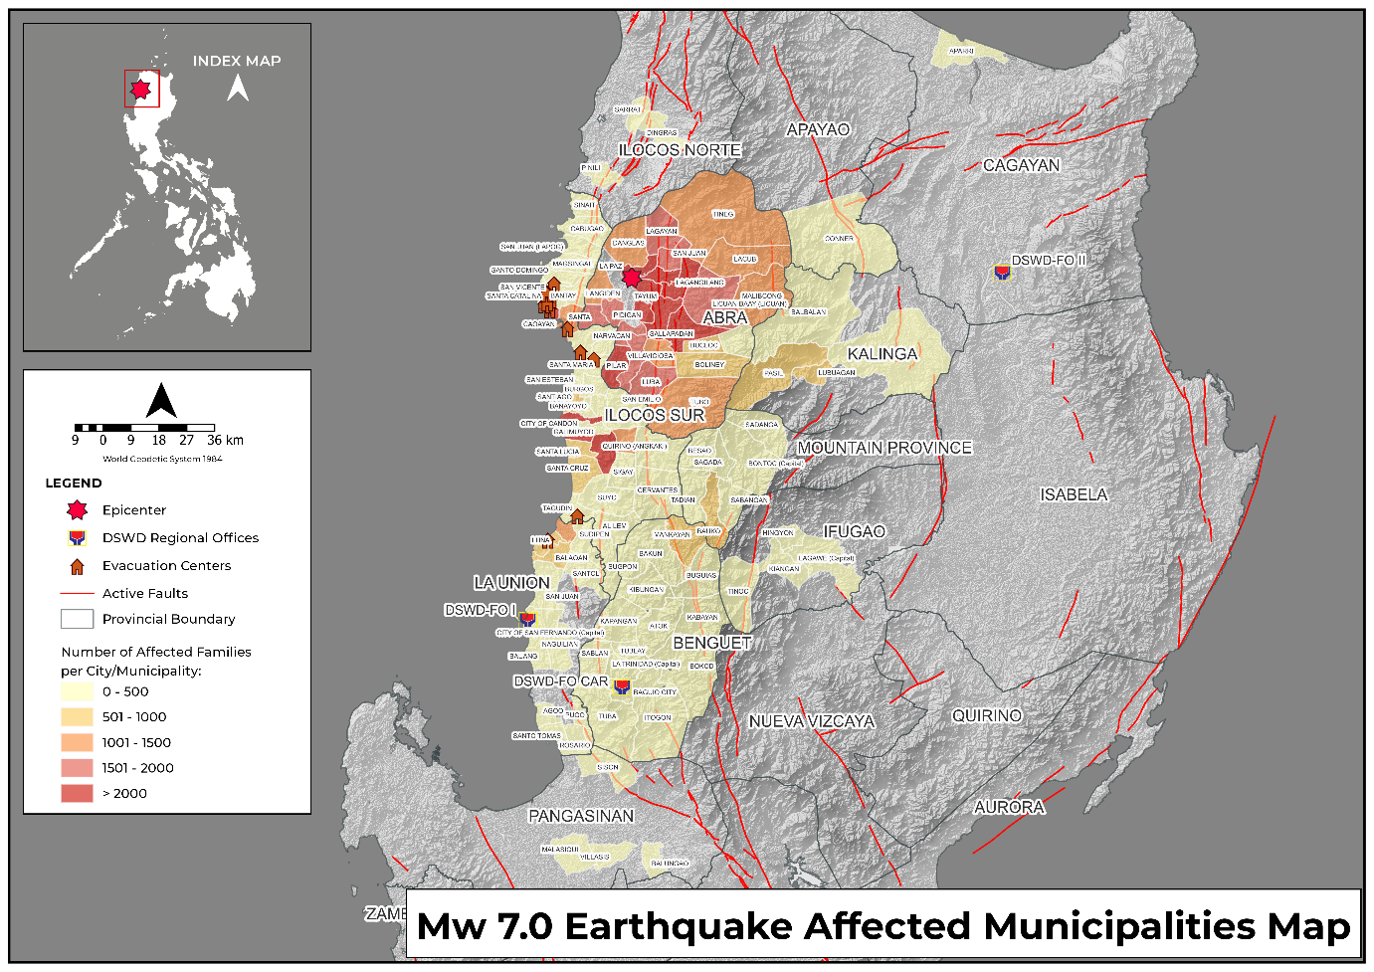

- Status of Displaced Population

- Inside Evacuation Center
There are 956 families or 3,054 persons currently taking temporary shelter in 30 evacuation centers in Region I and CAR (see Table 2).

Table 2. Number of Displaced Families / Persons Inside Evacuation Center

REGION / PROVINCE / MUNICIPALITY |  | NUMBER OF EVACUATION CENTERS (ECs) |  | NUMBER OF DISPLACED
 |  |  |  | INSIDE ECs
 |  |  |  | Families |  | Persons
 |  | CUM | NOW | CUM | NOW | CUM | NOW
GRAND TOTAL |  | 111 | 30 | 6,574 | 956 | 24,900 | 3,054
REGION I |  | 48 | 2 | 3,693 | 62 | 14,834 | 210
Ilocos Sur |  | 40 | 2 | 1,786 | 62 | 7,018 | 210
 | Bantay | 2 | 1 | 12 | 10 | 60 | 50
 | Burgos | 1 | - | 82 | - | 233 | -
 | Caoayan | 3 | - | 203 | - | 806 | -
 | Galimuyod | 7 | - | 99 | - | 465 | -
 | Nagbukel | 1 | - | 63 | - | 231 | -
 | Narvacan | 3 | - | 82 | - | 474 | -
 | San Emilio | 1 | 1 | 87 | 52 | 376 | 160
 | San Esteban | 1 | - | 13 | - | 38 | -
 | San Ildefonso | 1 | - | 21 | - | 74 | -
 | San Juan (Lapog) | 1 | - | 5 | - | 22 | -
 | San Vicente | 3 | - | 52 | - | 249 | -
 | Santa | 1 | - | 215 | - | 762 | -
 | Santa Catalina | 1 | - | 445 | - | 1785 | -
 | Santa Cruz | 1 | - | 13 | - | 65 | -
 | Santiago | 4 | - | 204 | - | 655 | -
 | Santo Domingo | 1 | - | 27 | - | 123 | -
 | Tagudin | 5 | - | 109 | - | 389 | -
 | CITY OF VIGAN (Capital) | 3 | - | 54 | - | 211 | -
La Union |  | 8 | - | 1,907 | - | 7,816 | -
 | Balaoan | 3 | - | 873 | - | 4,330 | -
 | Bangar | 1 | - | 690 | - | 2,130 | -
 | Luna | 4 | - | 344 | - | 1,356 | -
CAR |  | 63 | 28 | 2,881 | 894 | 10,066 | 2,844
Abra |  | 40 | 16 | 2,349 | 674 | 7,855 | 2,009
 | Bangued (capital) | 10 | 1 | 97 | 2 | 532 | 6
 | Boliney | 4 | 4 | 26 | 26 | 70 | 70
 | Bucay | 13 | - | 1,548 | - | 5,240 | -
 | Bucloc | 4 | 4 | 415 | 415 | 1,195 | 1,195
 | Danglas | 2 | 2 | 22 | 22 | 76 | 76
 | Lacub | 2 | 2 | 142 | 142 | 448 | 448
 | Licuan-Baay (Licuan) | 1 | - | 6 | - | 30 | -
 | Tubo | 1 | - | 26 | - | 50 | -
 | Villaviciosa | 3 | 3 | 67 | 67 | 214 | 214
Benguet |  | 6 | 3 | 41 | 10 | 145 | 38
 | Atok | 2 | - | 14 | - | 47 | -
 | Bakun | 1 | 1 | 14 | 6 | 49 | 17
 | Buguias | 2 | 2 | 4 | 4 | 21 | 21
 | Kabayan | 1 | - | 9 | - | 28 | -
Kalinga |  | 12 | 7 | 441 | 172 | 1,917 | 664
 | Lubuagan | 6 | 6 | 94 | 94 | 430 | 430
 | Pasil | 6 | 1 | 347 | 78 | 1,487 | 234
Mountain Province |  | 5 | 2 | 50 | 38 | 149 | 133
 | Bontoc (capital) | 2 | - | 2 | - | 6 | -
 | Bauko | 1 | 1 | 10 | 10 | 14 | 14
 | Besao | 1 | 1 | 28 | 28 | 119 | 119
 | Tadian | 1 | - | 10 | - | 10 | -
Note: This version reflects the actual number of displaced families and persons in Region I after data validation on 01 August 2022, 8PM. Ongoing assessment and validation being conducted.
Source: DSWD FOs

- Outside Evacuation Center
There are 12,300 families or 45,023 persons temporarily staying with their relatives and/or friends (see Table 3).

Table 3. Number of Displaced Families / Persons Outside Evacuation Center
REGION / PROVINCE / MUNICIPALITY |  | NUMBER OF DISPLACED
 |  | OUTSIDE ECs
 |  | Families |  | Persons
 |  | CUM | NOW | CUM | NOW
GRAND TOTAL |  | 25,078 | 12,300 | 95,716 | 45,023
REGION I |  | 9,884 | 6 | 38,509 | 30
Ilocos Sur |  | 9,005 | 6 | 35,528 | 30
 | Burgos | 18 | - | 43 | -
 | CITY OF CANDON | 4778 | - | 16813 | -
 | Caoayan | 2596 | - | 12863 | -
 | Narvacan | 6 | 6 | 30 | 30
 | San Esteban | 38 | - | 129 | -
 | Santa Catalina | 36 | - | 107 | -
 | Santa Cruz | 887 | - | 3024 | -
 | Santiago | 550 | - | 2173 | -
 | Tagudin | 96 | - | 346 | -
La Union |  | 877 | - | 2,970 | -
 | Bangar | 449 | - | 1,248 | -
 | Luna | 400 | - | 1,600 | -
 | Naguilian | 2 | - | 8 | -
 | Rosario | 1 | - | 7 | -
 | CITY OF SAN FERNANDO (Capital) | 13 | - | 45 | -
 | Santo Tomas | 6 | - | 26 | -
 | Sudipen | 6 | - | 36 | -
Pangasinan |  | 2 | - | 11 | -
 | Balungao | 1 | - | 5 | -
 | Malasiqui | 1 | - | 6 | -
CAR |  | 15,194 | 12,294 | 57,207 | 44,993
Abra |  | 13,888 | 11,780 | 51,942 | 43,054
 | Bangued (capital) | 82 | - | 243 | -
 | Bucay | 378 | 34 | 1,554 | 242
 | Daguioman | 18 | 4 | 92 | 20
 | Dolores | 59 | 56 | 244 | 237
 | Lacub | 17 | 9 | 69 | 37
 | Lagangilang | 4,324 | 4,324 | 14,888 | 14,888
 | Lagayan | 1,582 | 1,582 | 4,488 | 4,488
 | Langiden | 619 | 619 | 1,786 | 1,786
 | Luba | 52 | 52 | 213 | 213
 | Malibcong | 33 | 5 | 152 | 20
 | Manabo | 45 | 45 | 229 | 229
 | Pilar | 214 | 12 | 793 | 68
 | San Isidro | 1,577 | 1,577 | 5,478 | 5,478
 | San Juan | 20 | 20 | 84 | 84
 | San Quintin | 213 | 213 | 622 | 622
 | Tayum | 3,568 | 2,145 | 15,178 | 8,830
 | Tineg | 1,031 | 1,031 | 5,646 | 5,646
 | Tubo | 21 | 17 | 69 | 52
 | Villaviciosa | 35 | 35 | 114 | 114
Apayao |  | 1 | - | 2 | -
 | Conner | 1 | - | 2 | -
Benguet |  | 181 | 86 | 818 | 438
 | Atok | 2 | 2 | 7 | 7
 | Baguio City | 3 | 3 | 18 | 18
 | Bakun | 5 | 5 | 21 | 21
 | Bokod | 111 | 23 | 465 | 103
 | Buguias | 10 | 10 | 62 | 62
 | Kabayan | 7 | - | 18 | -
 | Kapangan | 5 | 5 | 20 | 20
 | Mankayan | 15 | 15 | 75 | 75
 | Tuba | 23 | 23 | 132 | 132
Ifugao |  | 2 | 1 | 4 | 1
 | Hingyon | 2 | 1 | 4 | 1
Kalinga |  | 1,069 | 398 | 4,283 | 1,410
 | Balbalan | 114 | - | 448 | -
 | Lubuagan | 722 | 248 | 3,018 | 885
 | Pasil | 230 | 150 | 807 | 525
 | City of Tabuk (capital) | 3 | - | 10 | -
Mountain Province |  | 53 | 29 | 158 | 90
 | Bontoc (capital) | 5 | - | 16 | -
 | Bauko | 17 | 12 | 72 | 57
 | Besao | 14 | 5 | 30 | 15
 | Sagada | 4 | - | 18 | -
 | Tadian | 13 | 12 | 22 | 18
Note: This version reflects the actual number of displaced families and persons in Region I and CAR after data validation on 01 August 2022, 8PM. Ongoing assessment and validation being conducted.
Source: DSWD FOs

- Total Displaced Population
There are 13,256 families or 48,077 persons taking temporary shelter either in evacuation centers or with their relatives and/or friends (see Table 4).

Table 4. Total Number of Displaced Families / Persons

REGION / PROVINCE / MUNICIPALITY |  | TOTAL DISPLACED SERVED
 |  | Families |  | Persons
 |  | CUM | NOW | CUM | NOW
GRAND TOTAL |  | 31,652 | 13,256 | 120,616 | 48,077
REGION I |  | 13,577 | 68 | 53,343 | 240
Ilocos Sur |  | 10,791 | 68 | 42,546 | 240
 | Bantay | 12 | 10 | 60 | 50
 | Burgos | 100 | - | 276 | -
 | CITY OF CANDON | 4778 | - | 16813 | -
 | Caoayan | 2799 | - | 13669 | -
 | Galimuyod | 99 | - | 465 | -
 | Nagbukel | 63 | - | 231 | -
 | Narvacan | 88 | 6 | 504 | 30
 | San Emilio | 87 | 52 | 376 | 160
 | San Esteban | 51 | - | 167 | -
 | San Ildefonso | 21 | - | 74 | -
 | San Juan (Lapog) | 5 | - | 22 | -
 | San Vicente | 52 | - | 249 | -
 | Santa | 215 | - | 762 | -
 | Santa Catalina | 481 | - | 1892 | -
 | Santa Cruz | 900 | - | 3089 | -
 | Santiago | 754 | - | 2828 | -
 | Santo Domingo | 27 | - | 123 | -
 | Tagudin | 205 | - | 735 | -
 | CITY OF VIGAN (Capital) | 54 | - | 211 | -
La Union |  | 2,784 | - | 10,786 | -
 | Balaoan | 873 | - | 4,330 | -
 | Bangar | 1,139 | - | 3,378 | -
 | Luna | 744 | - | 2,956 | -
 | Naguilian | 2 | - | 8 | -
 | Rosario | 1 | - | 7 | -
 | CITY OF SAN FERNANDO (Capital) | 13 | - | 45 | -
 | Santo Tomas | 6 | - | 26 | -
 | Sudipen | 6 | - | 36 | -
Pangasinan |  | 2 | - | 11 | -
 | Balungao | 1 | - | 5 | -
 | Malasiqui | 1 | - | 6 | -
CAR |  | 18,075 | 13,188 | 67,273 | 47,837
Abra |  | 16,237 | 12,454 | 59,797 | 45,063
 | Bangued (capital) | 179 | 2 | 775 | 6
 | Boliney | 26 | 26 | 70 | 70
 | Bucay | 1,926 | 34 | 6,794 | 242
 | Bucloc | 415 | 415 | 1,195 | 1,195
 | Daguioman | 18 | 4 | 92 | 20
 | Danglas | 22 | 22 | 76 | 76
 | Dolores | 59 | 56 | 244 | 237
 | Lacub | 159 | 151 | 517 | 485
 | Lagangilang | 4,324 | 4,324 | 14,888 | 14,888
 | Lagayan | 1,582 | 1,582 | 4,488 | 4,488
 | Langiden | 619 | 619 | 1,786 | 1,786
 | Licuan-Baay (Licuan) | 6 | - | 30 | -
 | Luba | 52 | 52 | 213 | 213
 | Malibcong | 33 | 5 | 152 | 20
 | Manabo | 45 | 45 | 229 | 229
 | Pilar | 214 | 12 | 793 | 68
 | San Isidro | 1,577 | 1,577 | 5,478 | 5,478
 | San Juan | 20 | 20 | 84 | 84
 | San Quintin | 213 | 213 | 622 | 622
 | Tayum | 3,568 | 2,145 | 15,178 | 8,830
 | Tineg | 1,031 | 1,031 | 5,646 | 5,646
 | Tubo | 47 | 17 | 119 | 52
 | Villaviciosa | 102 | 102 | 328 | 328
Apayao |  | 1 | - | 2 | -
 | Conner | 1 | - | 2 | -
Benguet |  | 222 | 96 | 963 | 476
 | Atok | 16 | 2 | 54 | 7
 | Baguio City | 3 | 3 | 18 | 18
 | Bakun | 19 | 11 | 70 | 38
 | Bokod | 111 | 23 | 465 | 103
 | Buguias | 14 | 14 | 83 | 83
 | Kabayan | 16 | - | 46 | -
 | Kapangan | 5 | 5 | 20 | 20
 | Mankayan | 15 | 15 | 75 | 75
 | Tuba | 23 | 23 | 132 | 132
Ifugao |  | 2 | 1 | 4 | 1
 | Hingyon | 2 | 1 | 4 | 1
Kalinga |  | 1,510 | 570 | 6,200 | 2,074
 | Balbalan | 114 | - | 448 | -
 | Lubuagan | 816 | 342 | 3,448 | 1,315
 | Pasil | 577 | 228 | 2,294 | 759
 | City of Tabuk (capital) | 3 | - | 10 | -
Mountain Province |  | 103 | 67 | 307 | 223
 | Bontoc (capital) | 7 | - | 22 | -
 | Bauko | 27 | 22 | 86 | 71
 | Besao | 42 | 33 | 149 | 134
 | Sagada | 4 | - | 18 | -
 | Tadian | 23 | 12 | 32 | 18
Note: Ongoing assessment and validation being conducted.
Source: DSWD FOs

- Damaged Houses

A total of 29,049 houses were damaged; of which, 417 are totally damaged and 28,632 are partially damaged in Regions I, II, and CAR (see Table 5).

Table 5. Number of Damaged Houses

REGION / PROVINCE / MUNICIPALITY |  | NO. OF DAMAGED HOUSES
 |  | Total | Totally | Partially
GRAND TOTAL |  | 29,049 | 417 | 28,632
REGION I |  | 5,321 | 105 | 5,216
Ilocos Norte |  | 13 | - | 13
 | Dingras | 2 | - | 2
 | Pinili | 10 | - | 10
 | Sarrat | 1 | - | 1
Ilocos Sur |  | 4,930 | 97 | 4,833
 | Alilem | 4 | - | 4
 | Banayoyo | 3 | - | 3
 | Bantay | 160 | 1 | 159
 | Burgos | 232 | - | 232
 | Cabugao | 61 | - | 61
 | CITY OF CANDON | 223 | 5 | 218
 | Caoayan | 244 | 12 | 232
 | Cervantes | 248 | - | 248
 | Galimuyod | 12 | - | 12
 | Gregorio del Pilar (Concepcion) | 175 | - | 175
 | Lidlidda | 56 | - | 56
 | Magsingal | 240 | 10 | 230
 | Nagbukel | 166 | 32 | 134
 | Narvacan | 6 | - | 6
 | Quirino (Angkaki) | 237 | 1 | 236
 | Salcedo (Baugen) | 164 | - | 164
 | San Emilio | 325 | 3 | 322
 | San Esteban | 38 | - | 38
 | San Ildefonso | 17 | 1 | 16
 | San Juan (Lapog) | 112 | 2 | 110
 | Santa | 115 | - | 115
 | Santa Catalina | 5 | 5 | -
 | Santa Cruz | 21 | 2 | 19
 | Santa Lucia | 774 | 5 | 769
 | Santa Maria | 279 | - | 279
 | Santiago | 301 | 4 | 297
 | Santo Domingo | 143 | 9 | 134
 | Sigay | 9 | - | 9
 | Sinait | 14 | 2 | 12
 | Sugpon | 82 | - | 82
 | Tagudin | 128 | 2 | 126
 | CITY OF VIGAN (Capital) | 336 | 1 | 335
La Union |  | 371 | 8 | 363
 | Agoo | 2 | - | 2
 | Balaoan | 21 | 1 | 20
 | Bangar | 132 | - | 132
 | Bauang | 33 | 1 | 32
 | Luna | 23 | - | 23
 | Naguilian | 78 | 4 | 74
 | Rosario | 1 | - | 1
 | CITY OF SAN FERNANDO (Capital) | 13 | - | 13
 | San Juan | 49 | 2 | 47
 | Santo Tomas | 6 | - | 6
 | Santol | 7 | - | 7
 | Sudipen | 6 | - | 6
Pangasinan |  | 7 | - | 7
 | Balungao | 4 | - | 4
 | Malasiqui | 1 | - | 1
 | Sison | 1 | - | 1
 | Villasis | 1 | - | 1
REGION II |  | 1 | - | 1
Cagayan |  | 1 | - | 1
 | Aparri | 1 | - | 1
CAR |  | 23,727 | 312 | 23,415
Abra |  | 21,550 | 282 | 21,268
 | Bangued (capital) | 4,111 | 106 | 4,005
 | Boliney | 106 | 1 | 105
 | Bucay | 2,644 | 57 | 2,587
 | Bucloc | 76 | - | 76
 | Daguioman | 61 | - | 61
 | Danglas | 158 | - | 158
 | Dolores | 805 | 11 | 794
 | La Paz | 1,048 | 9 | 1,039
 | Lacub | 162 | - | 162
 | Lagangilang | 1,592 | - | 1,592
 | Lagayan | 309 | 5 | 304
 | Langiden | 400 | 9 | 391
 | Licuan-Baay (Licuan) | 318 | 2 | 316
 | Luba | 369 | - | 369
 | Malibcong | 90 | - | 90
 | Manabo | 1,181 | 2 | 1,179
 | Penarrubia | 701 | - | 701
 | Pidigan | 1,745 | 46 | 1,699
 | Pilar | 555 | - | 555
 | Sallapadan | 470 | 15 | 455
 | San Isidro | 347 | - | 347
 | San Juan | 1,501 | 5 | 1,496
 | San Quintin | 309 | 4 | 305
 | Tayum | 1,999 | 4 | 1,995
 | Tineg | 10 | - | 10
 | Tubo | 322 | 2 | 320
 | Villaviciosa | 161 | 4 | 157
Apayao |  | 11 | - | 11
 | Conner | 11 | - | 11
Benguet |  | 343 | 13 | 330
 | Baguio City | 5 | - | 5
 | Bakun | 63 | - | 63
 | Buguias | 76 | 7 | 69
 | Itogon | 15 | 1 | 14
 | Kabayan | 102 | - | 102
 | Kapangan | 5 | - | 5
 | Mankayan | 69 | 4 | 65
 | Sablan | 1 | 1 | -
 | Tublay | 7 | - | 7
Ifugao |  | 79 | 2 | 77
 | Hingyon | 2 | 2 | -
 | Kiangan | 38 | - | 38
 | Tinoc | 39 | - | 39
Kalinga |  | 166 | 3 | 163
 | Balbalan | 23 | - | 23
 | Lubuagan | 13 | 1 | 12
 | Pasil | 128 | 2 | 126
 | City of Tabuk (capital) | 2 | - | 2
Mountain Province |  | 1,578 | 12 | 1,566
 | Bontoc (capital) | 85 | - | 85
 | Sadanga | 20 | - | 20
 | Bauko | 731 | 8 | 723
 | Besao | 91 | - | 91
 | Sabangan | 364 | - | 364
 | Sagada | 37 | - | 37
 | Tadian | 250 | 4 | 246
Note: This version reflects the actual number of damaged houses in Region I and CAR after data validation on 01 August 2022, 8PM. Hence, changes in figures are based on the ongoing assessment and validation that are continuously being conducted.
Source: DSWD FOs

- Cost of Humanitarian Assistance Provided

A total of ₱43,909,522.08 worth of assistance was provided to the affected families; of which, ₱38,235,181.58 from the DSWD, ₱2,657,334.50 was provided by the Local Government Units (LGUs), ₱2,578,556.00 from Non-Government Organizations ₱438,450.00 from Other Partners (see Table 6).

Table 6. Cost of Assistance Provided to Affected Families / Persons
REGION / PROVINCE / MUNICIPALITY |  | COST OF ASSISTANCE
 |  | DSWD | LGUs | NGOs | OTHERS | GRAND TOTAL
GRAND TOTAL |  | 38,235,181.58 | 2,657,334.50 | 2,578,556.00 | 438,450.00 | 43,909,522.08
REGION I |  | 2,623,197.00 | 470,656.50 | 5,000.00 | 25,000.00 | 3,123,853.50
Ilocos Norte |  | - | 7,600.00 | - | - | 7,600.00
 | Dingras | - | 2,000.00 | - | - | 2,000.00
 | Pinili | - | 5,200.00 | - | - | 5,200.00
 | Sarrat | - | 400.00 | - | - | 400.00
Ilocos Sur |  | 2,623,197.00 | 254,998.50 | 5,000.00 | 25,000.00 | 2,908,195.50
 | Bantay | 379,244.50 | - | - | - | 379,244.50
 | Burgos | 102,000.00 | 26,788.50 | 5,000.00 | 25,000.00 | 158,788.50
 | Caoayan | - | 34,210.00 | - | - | 34,210.00
 | San Emilio | 1,971,102.50 | - | - | - | 1,971,102.50
 | Santiago | - | 194,000.00 | - | - | 194,000.00
 | CITY OF VIGAN (Capital) | 170,850.00 | - | - | - | 170,850.00
La Union |  | - | 204,578.00 | - | - | 204,578.00
 | Bangar | - | 159,570.00 | - | - | 159,570.00
 | Luna | - | 13,000.00 | - | - | 13,000.00
 | Rosario | - | 1,190.00 | - | - | 1,190.00
 | CITY OF SAN FERNANDO (Capital) | - | 15,418.00 | - | - | 15,418.00
 | San Juan | - | 12,400.00 | - | - | 12,400.00
 | Santo Tomas | - | 3,000.00 | - | - | 3,000.00
Pangasinan |  | - | 3,480.00 | - | - | 3,480.00
 | Malasiqui | - | 2,260.00 | - | - | 2,260.00
 | Villasis | - | 1,220.00 | - | - | 1,220.00
REGION II |  | 5,853.50 | - | - | - | 5,853.50
Cagayan |  | 5,853.50 | - | - | - | 5,853.50
 | Aparri | 5,853.50 | - | - | - | 5,853.50
CAR |  | 35,606,131.08 | 2,186,678.00 | 2,573,556.00 | 413,450.00 | 40,779,815.08
Abra |  | 33,173,573.69 | 1,824,982.00 | 2,573,556.00 | 405,450.00 | 37,977,561.69
 | Bangued (capital) | 1,308,327.64 | 4,110.00 | - | - | 1,312,437.64
 | Boliney | 593,754.00 | - | - | - | 593,754.00
 | Bucay | 2,920,021.80 | 14,000.00 | 660,000.00 | - | 3,594,021.80
 | Bucloc | 975,313.02 | 80,000.00 | - | - | 1,055,313.02
 | Daguioman | 325,556.44 | - | 20,106.00 | - | 345,662.44
 | Danglas | 828,102.00 | 9,600.00 | - | - | 837,702.00
 | Dolores | 994,443.00 | - | - | - | 994,443.00
 | La Paz | 3,580,968.00 | 45,000.00 | - | - | 3,625,968.00
 | Lacub | 397,753.88 | - | - | - | 397,753.88
 | Lagangilang | 1,528,508.34 | 34,500.00 | 532,200.00 | - | 2,095,208.34
 | Lagayan | 63,444.00 | 72,760.00 | - | - | 136,204.00
 | Langiden | 781,854.00 | - | - | - | 781,854.00
 | Licuan-Baay (Licuan) | 1,005,204.00 | - | - | - | 1,005,204.00
 | Luba | 393,696.16 | - | - | - | 393,696.16
 | Malibcong | 741,790.88 | - | - | - | 741,790.88
 | Manabo | 1,610,310.00 | - | - | - | 1,610,310.00
 | Penarrubia | 952,142.00 | 5,840.00 | - | - | 957,982.00
 | Pidigan | 1,972,821.00 | - | - | - | 1,972,821.00
 | Pilar | 2,637,180.68 | - | - | - | 2,637,180.68
 | Sallapadan | 1,464,274.00 | - | - | - | 1,464,274.00
 | San Isidro | 1,100,285.00 | 65,000.00 | - | - | 1,165,285.00
 | San Juan | 283,353.84 | 618,630.00 | - | - | 901,983.84
 | San Quintin | 339,000.00 | - | - | - | 339,000.00
 | Tayum | 2,877,242.00 | 145,912.00 | 1,361,250.00 | 405,450.00 | 4,789,854.00
 | Tineg | 700,927.92 | 729,630.00 | - | - | 1,430,557.92
 | Tubo | 1,073,817.04 | - | - | - | 1,073,817.04
 | Villaviciosa | 1,723,483.05 | - | - | - | 1,723,483.05
Apayao |  | - | 17,820.00 | - | - | 17,820.00
 | Conner | - | 17,820.00 | - | - | 17,820.00
Benguet |  | 615,126.00 | 32,936.00 | - | 8,000.00 | 656,062.00
 | Buguias | 143,184.00 | - | - | - | 143,184.00
 | Itogon | - | 32,936.00 | - | - | 32,936.00
 | Kibungan | 282,600.00 | - | - | - | 282,600.00
 | La Trinidad (capital) | - | - | - | 8,000.00 | 8,000.00
 | Mankayan | 189,342.00 | - | - | - | 189,342.00
Kalinga |  | 1,117,748.64 | 108,510.00 | - | - | 1,226,258.64
 | Balbalan | 219,170.84 | 15,640.00 | - | - | 234,810.84
 | Lubuagan | 243,281.40 | 29,100.00 | - | - | 272,381.40
 | Pasil | 655,296.40 | 63,770.00 | - | - | 719,066.40
Mountain Province |  | 699,682.75 | 202,430.00 | - | - | 902,112.75
 | Bontoc (capital) | 235,559.25 | 166,800.00 | - | - | 402,359.25
 | Bauko | 183,262.50 | - | - | - | 183,262.50
 | Besao | 102,501.00 | 25,830.00 | - | - | 128,331.00
 | Sabangan | 178,360.00 | - | - | - | 178,360.00
 | Sagada | - | 9,000.00 | - | - | 9,000.00
 | Tadian | - | 800.00 | - | - | 800.00
Note: This version reflects the actual cost of assistance provided in Regions I and CAR after data validation on 01 August 2022, 8PM. Hence, changes in figures are based on the ongoing assessment and validation that are continuously being conducted.
Source: DSWD FOs

Response Actions and Interventions

The DSWD Central Office (CO), FOs, National Resource Operations Center (NROC), and Visayas Disaster Resource Center (VDRC) have stockpiles and standby funds amounting to ₱1,271,378,839.21 with breakdown as follows:

Standby Funds
A total of ₱311,813,298.70 standby funds in the CO and FOs. Of the said amount, ₱247,530,257.39 is the available Quick Response Fund (QRF) in the CO.

Stockpiles
A total of 467,050 family food packs (FFPs) amounting to ₱286,103,093.68, other food items amounting to ₱211,487,944.49, and non-food items (FNIs) amounting to ₱461,974,502.34 are available.

OFFICE | STANDBY FUNDS | STOCKPILE |  |  |  | TOTAL STANDBY FUNDS & STOCKPILE
 |  | FAMILY FOOD PACKS |  | OTHER FOOD ITEMS | NON-FOOD RELIEF ITEMS
 |  | QUANTITY | TOTAL COST | TOTAL COST | TOTAL COST
TOTAL | 311,813,298.70 | 467,050 | 286,103,093.68 | 211,487,944.49 | 461,974,502.34 | 1,271,378,839.21
DSWD CO | 247,530,257.39 | - | - | - | - | 247,530,257.39
NRLMB NROC | - | 42,057 | 28,174,119.00 | 44,200,517.16 | 44,437,281.79 | 116,811,917.95
NRLMB VDRC | - | 51,729 | 32,818,910.00 | 48,986,195.80 | 72,010.00 | 81,877,115.80
DSWD FO I | 5,039,900.00 | 13,587 | 8,411,081.75 | 15,899,295.75 | 23,145,491.65 | 52,495,769.15
DSWD FO II | 2,407,392.08 | 36,329 | 21,922,875.00 | 3,663,486.00 | 26,974,066.50 | 54,967,819.58
DSWD FO III | 5,253,797.79 | 17,340 | 8,610,175.04 | 2,292,781.09 | 22,346,971.00 | 38,503,724.92
DSWD FO CALABARZON | 5,000,000.47 | 14,491 | 8,835,660.90 | 3,282,202.00 | 31,312,179.16 | 48,430,042.53
DSWD FO MIMAROPA | 2,120,619.78 | 41,866 | 29,573,099.32 | 9,984,849.00 | 18,525,527.34 | 60,204,095.44
DSWD FO V | 5,000,000.00 | 32,945 | 17,189,504.56 | 6,279,587.05 | 42,302,110.90 | 70,771,202.51
DSWD FO VI | 5,000,000.00 | 31,035 | 13,264,910.00 | 2,066,330.00 | 29,761,565.64 | 50,092,805.64
DSWD FO VII | 5,000,000.00 | 17,667 | 10,070,190.00 | 15,338,793.32 | 40,883,200.65 | 71,292,183.97
DSWD FO VIII | 5,000,000.00 | 21,549 | 13,496,486.14 | 4,803,788.50 | 32,889,312.87 | 56,189,587.51
DSWD FO IX | 5,000,000.00 | 15,268 | 8,343,809.32 | 15,483,562.44 | 13,783,910.52 | 42,611,282.28
DSWD FO X | 243,500.50 | 20,354 | 14,183,530.50 | 19,106,988.03 | 26,959,880.50 | 60,493,899.53
DSWD FO XI | 5,090,000.00 | 22,954 | 14,468,214.20 | 6,870,149.00 | 27,634,405.80 | 54,062,769.00
DSWD FO XII | 5,000,969.85 | 33,055 | 19,886,800.00 | 7,638,855.00 | 31,310,331.08 | 63,836,955.93
DSWD FO CARAGA | 4,126,401.00 | 26,994 | 18,733,836.00 | 334,307.51 | 14,433,138.60 | 37,627,683.11
DSWD FO NCR | 5,000,000.00 | 2,019 | 1,150,561.44 | 2,565,250.15 | 5,561,838.21 | 14,277,649.80
DSWD FO CAR | 459.84 | 25,811 | 16,969,330.51 | 2,691,006.69 | 29,641,280.13 | 49,302,077.17
Note: The Inventory Summary is as of 1 August 2022, 8PM. Replenishment of standby funds for DSWD FOs II, MIMAROPA, X, and CAR is on process.
Sources: DRMB and NRLMB

Food and Non-food Items (FNIs)

DSWD FO CAR
DATE | SITUATIONS / ACTIONS UNDERTAKEN
01 August 2022 | - DSWD FO CAR facilitated the monitoring and arrival of the 2,600 FFPs from Regional Warehouse.  - DSWD FO CAR transported five (5) gallons of drinking water to the Regional Warehouse.  - DSWD FO CAR facilitated the monitoring and delivery of 5,200 FPPs from Regional Warehouse and 400 FPPs for airlift at Wallace Airport.
30 July 2022 | - The 1,300 FFPs have already arrived in Abra this morning.
29 July 2022 | - DSWD FO CAR delivered NFIs to the Municipalities of Boliney, Daguioman, Lacub, and Bucloc in Abra via airlift.  - 3,000 FFPs and 250 family tents from NROC were in transit and are expected to arrive in Abra on 30 July 2022.  - 1,300 FFPs were bound for Abra, while 1,300 FFPs bound for Kalinga were still in transit.
28 July 2022 | - DSWD FO CAR monitored the arrival of the 3,900 FFPs, 10 family tents, and 132 modular tents as an immediate augmentation to the Province of Abra.  - DSWD FO CAR facilitated the delivery of NFIs from the DSWD warehouse bound for Abra.
27 July 2022 | - DSWD FO CAR facilitated the loading of 3,900 FFPs, 10 family tents, and 130 modular tents bound for Abra for prepositioning.

DSWD FO I
DATE | SITUATIONS / ACTIONS UNDERTAKEN
01 August 2022 | - DSWD FO I facilitated the release of 294 FFPs, 147 hygiene kits, and 10 sleeping kits to the affected families in Bantay, Ilocos Sur.  - DSWD FO I released 87 family tents as additional augmentation to affected families in San Emilio, Ilocos Sur.  - Three (3) trucks carrying the 5,000 FFPs as additional augmentation to DSWD FO CAR were bound for Abra.
31 July 2022 | - DSWD FO I received additional augmentation of 250 family tents from DSWD FO CALABARZON.  - DSWD FO I released 275 FFPs and 275 hygiene kits to the affected families in San Emilio, Ilocos Sur.  - DSWD FO I facilitated the delivery of 5,950 FFPs to the Province of Abra, to complete the 7,000 FFPs requested by DSWD FO CAR. These FFPs served as augmentation to the families in Bakun, Benguet.  - 335 FFPs were released to the LGU of Vigan City, Ilocos Sur for distribution to the identified families with damaged houses, together with the ₱10,000.00 worth of financial assistance through the Crisis Intervention Unit (CIU).  - DSWD FO I, through its CIU provided financial assistance to 280 out of 335 affected families with damaged houses in Vigan, Ilocos Sur amounting to a total of ₱2,800,000.00.  - A community kitchen was set-up at the Seventh-Day Adventist Church in Brgy. Matibuey, San Emilio, Ilocos Sur for the use of the Internally Displaced Persons (IDPs).
30 July 2022 | - 1,500 FFPs and 364 hygiene kits are being delivered to the Satellite Warehouse in Vigan City, Ilocos Sur for faster release of incoming relief augmentation requests from the affected municipalities of Ilocos Sur.  - 380 family tents delivered by NRLMB from DSWD FO CALABARZON were unloaded and are ready for augmentation to affected areas.  - 1,050 FFPs out of the requested 7,000 FFPs were delivered to Abra through the transport augmented by the Regional Disaster Risk Reduction and Management Council 1 (RDRRMC1) member agencies.  - 200 FFPs were augmented to Burgo, Ilocos Sur.  - 5,000 FFPs and 120 family tents delivered by NRLMB were unloaded and are ready for augmentation to affected areas.

DSWD FO II
DATE | SITUATIONS / ACTIONS UNDERTAKEN
01 August 2022 | - Provided the augmentation support on the delivery of 3,200 FFPs together with Philippine National Police and 51st Infantry Brigade Philippine Army unloaded in Field Office CAR’s satellite warehouses in the Province of Abra on 31 July 2022.  - With the help of volunteers from the Philippine Army Reservists, a total of 900 FFPs amounting to Php559,800.00 were packed in the Field Office 2 satellite warehouse in Tuguegarao City to replenish and ensure the availability of stockpile in the Field Office.  - 3,700 FFPs is awaiting to be hauled by the Provincial and Local Government Unit (PLGU) Kalinga at the Field Office satellite warehouse.  - 600 units of modular tents, 500 units of sleeping kits, and 5,000 hygiene kits are scheduled for loading on 1 August 2022.  - DSWD-FO II coordinated with NRLMB on the request for three (3) wing van trucks to transport NFIs to Bangued, Abra on 1 August 2022.
31 July 2022 | - The 2,500 FFPs and 500 Family Clothing Kits as augmentation support to DSWD FO CAR which were transported through the two (2) wing vans of DSWD FO II on 30 July 2022 have arrived in the province of Abra.  - The remaining 3,700 FFPs out of the additional 5,000 FFPs is scheduled for pick-up at the Field Office satellite warehouse by the Provincial and Local Government Unit (PLGU) of Kalinga on 01 August 2022 at 9:00 AM.
30 July 2022 | - The two (2) military trucks of the 501st Infantry Brigade, Philippine Army were unable to proceed and deliver 700 FFPs to Bangued, Abra on 29 July 2022 but will proceed on 30 July 2022.  - The seven (7) trucks of the Provincial Government of Isabela carrying 4,600 FFPs that left the DSWD FO II’s warehouse in Tuguegarao City on 29 July 2022 have already arrived in the province of Abra.  - The 3,500 FFPs from DSWD FO II and 50 modular tents from Office of Civil Defense Regional Office 02 (OCD RO2) were received by DSWD FO CAR and were unloaded at the Provincial Disaster Risk Reduction and Management Office (PDRRMO) of the Province of Abra.

DSWD FO CALABARZON
DATE | SITUATIONS / ACTIONS UNDERTAKEN
30 July 2022 | - DSWD FO CALABARZON in coordination with the Batangas Provincial Office, the Philippine Coast Guard IV-A and other community volunteers facilitated the release of 1,500 family tents bound for Region I (875 family tents) and CAR (625 family tents). The hauling of the remaining 500 family tents will resume on 01 August 2022.
29 July 2022 | - DSWD FO CALABARZON allocated 2,000 family tents for DSWD FOs I and CAR. A total of 750 family tents were picked up and bound for Region I (500 family tents) and CAR (250 family tents), and the remaining allocation would be picked up by 30 July 2022.

Camp Coordination and Camp Management

DSWD FO CAR
DATE | SITUATIONS / ACTIONS UNDERTAKEN
27 July 2022 | - DSWD FO CAR provided technical assistance to partner LGUs.

Internally Displaced Person (IDP) Protection

DSWD FO I
DATE | SITUATIONS / ACTIONS UNDERTAKEN
30 July 2022 | - DSWD FO I, through its Incident Management Team (IMT), is in close coordination with the Provincial/City/Municipal Disaster Risk Reduction Management Council and Provincial/City/Municipal Social Welfare Development Office to monitor and gather updates regarding the affected population.  - DSWD FO I, through the Disaster Response Management Division (DRMD) visited IDPs in Bulag West Elemtary School, Bantay, Ilocos Sur to further identify the needs of the vulnerable sector.

DSWD FO CAR
DATE | SITUATIONS / ACTIONS UNDERTAKEN
29 July 2022 | - A Psychological First Aid (PFA) Team was deployed to conduct stress debriefing to victims of the Mw 7.0 earthquake. Several groups such as Saint Louis University (SLU) Sunflower, University of the Philippines (UP) Baguio, and Psychological Association of the Philippines-North Luzon Chapter signified their intention to provide PFA to families and individuals affected by the earthquake.

Other Activities

DSWD-DRMB
DATE | SITUATIONS / ACTIONS UNDERTAKEN
02 August 2022 | - The DRMB Operations Center (OpCen) is in 24/7 virtual operation to closely monitor and coordinate with the National Resource and Logistics Management Bureau (NRLMB) and DSWD FOs for significant updates on the Mw 7.0 Earthquake Incident in Tayum, Abra  - DSWD-DRMB is on standby response support assets from non-affected DSWD-FOs.
30 July 2022 | - DSWD-DRMB coordinated with DSWD-NRLMB in the preparation of the 60,000 FFPs Augmentation Plan that shall be delivered to the different warehouses in CAR, particularly in:  - Bangued, Abra – 35,000 FFPs  - Lagawe, Ifugao – 1,200 FFPs  - Luna, Apayao – 5,100 FFPs  - Tabuk, Kalinga – 2,000 FFPs  - La Trinidad, Benguet – 16,700 FFPs
29 July 2022 | - DSWD-DRMB posted a “Call for Donations” on its official social media accounts to provide information on how to donate in-kind items or cash.  - DSWD-DRMB conducted a coordination meeting with CCCM and IDPP Clusters to ensure harmonized response actions from member agencies.
28 July 2022 | - DSWD-DRMB facilitated the signing of the DSWD Secretary on the request for replenishment of the standby funds amounting to ₱662,500,000.00 for onward approval and action of the Department of Budget and Management (DBM).  - DSWD-DRMB activated the Gender-based Violence (GBV) Sub-Cluster to ensure protection measures are in place to prevent cases of GBV inside and outside the evacuation centers.
27 July 2022 | - DSWD-DRMB facilitated the delivery of the following FNIs from the National Resource Operations Center (NROC) scheduled on 28 July 2022 for Regions I and CAR:  - 5,000 FFPs/region  - 2,000 Hygiene Kits/region  - 1,000 Sleeping Kits/region  - 1,000 Kitchen Kits/region  - 1,000 Family Tents/region (sourced from DSWD FO CALABARZON)  - DSWD-DRMB facilitates the P15 million fund augmentation to DSWD-FO I and CAR for urgent food and NFI relief requirements.

DSWD-NRLMB
DATE | SITUATIONS / ACTIONS UNDERTAKEN
02 August 2022 | - DSWD-NRLMB continuously repacks relief goods for possible augmentation.  - DSWD-NRLMB provides logistical augmentation to FOs on delivering FFPs to LGUs.
27 July 2022 | - Augmentation of 2,500 FFPs were delivered by NRLMB to DSWD FO I.  - Additional augmentation from NRLMB including 5,000 FFPs, 2,000 hygiene kits, 1,000 sleeping kits, 1,000 kitchen kits, and 1,000 family tents were scheduled for delivery to DSWD FO I.

DSWD FO NCR
DATE | SITUATIONS / ACTIONS UNDERTAKEN
27 July 2022 | - DSWD FO NCR coordinated with concerned offices for updates regarding damages and affected population.

DSWD FO CAR
DATE | SITUATIONS / ACTIONS UNDERTAKEN
01 August 2022 | - DSWD FO CAR coordinated with PAT Benguet for the staffs who will escort the airlifting and delivery of FNFIs to Bakun, Benguet.
31 July 2022 | - DSWD FO CAR continuously coordinates with the Response Clusters and its Quick Response Teams (QRTs) in Abra, Benguet, Kalinga, Ifugao, and Mountain Province.  - DSWD FO CAR provided financial assistance to 380 families with damaged houses in Danglas, Abra amounting to a total of ₱1,965,000.00.  - DSWD FO CAR transported the received donation from CCDC to the Regional warehouse in Puguis, La Trinidad.  - DSWD FO CAR provided two (2) DSWD vehicles to ferry personnels to assist in the airlifting and delivery of FNFIs.  - DSWD FO CAR ensured the provision of food for volunteers at Puguis Warehouse.  - DSWD FO CAR reinforced its call for volunteers through reposting in the DSWD Social Media Account and other communication platforms.
30 July 2022 | - DSWD FO CAR coordinated with OCD CAR for the provision of three (3) trucks to transport FNIs to Abra and another vehicle to transport 120 FFPs and 11 sleeping kits to Bakun, Benguet.  - DSWD FO CAR coordinated with DSWD FOs I and II for the arrangement of transportation that will ferry the FFPs to be delivered to Abra and Army Reserve Command (ARESCOM).  - DSWD FO CAR coordinated with the Armed Forces of the Philippines (AFP) to airlift FFPs intended for Brgys. Kayapa and Bago in Bakun, Benguet.  - DSWD FO CAR conducted an orientation on warehouse management, relief operation, and Assistance to Individuals in Crisis Situation (AICS) to the teams to be deployed to Abra under the OPLAN BINNADANG.
29 July 2022 | - DSWD FO CAR coordinated with the Aviation Regiment of the Philippine Army to airlift the FFPs intended for the three (3) isolated Barangays in Pasil, Kalinga.  - DSWD FO CAR requested augmentation of NFIs from DSWD FO I.  - The 7,000 sando bags from DSWD FO I have been delivered to the DSWD FO CAR warehouse in Puguis, La Trinidad, Benguet.  - DSWD FO CAR maintains coordination with OCD CAR for the provision of transport services to ferry FFPs to be delivered to Abra.  - DSWD FO CAR coordinated with Shopee Xpress for possible assistance on logistics, cargo, and transport services.
28 July 2022 | - DSWD FO CAR through the Crisis Intervention Section (CIS) provided cash assistance worth ₱10,000.00 and burial assistance worth ₱25,000.00 to the affected family.
27 July 2022 | - DSWD FO CAR activated its Quick Response Team in Abra, Benguet, Kalinga, and Mountain Province.  - Psychosocial Support Processing (PSP) Team was on standby for possible deployment.  - DSWD FO CAR Public Service Continuity Plan was activated.  - DSWD FO CAR coordinated with partner agencies on significant updates.

DSWD FO I
DATE | SITUATIONS / ACTIONS UNDERTAKEN
31 July 2022 | - DSWD FO I, through the Incident Management Team (IMT) Branches closely coordinates with the different Local Disaster Risk Reduction and Management Councils (LDRRMCs) and Local Social Welfare and Development Offices (LSWDOs to monitor and gather updates on the affected population and damages brought by the earthquake incident.
30 July 2022 | - DSWD FO I received donations of 521 boxes of bottled water, 60 boxes of canned goods, 33 boxes of instant noodles, 19 packs of assorted biscuits, 35 packs of 5kg rice, four (4) packs of 10kg rice, 15 packs of fruit juice, and one (1) pack of assorted goods amounting to P350,000.00 from United Nations International Children’s Emergency (UNICEF). Likewise, 1,000 Plastic Tarpaulins/ Shelter Tarps amounting to P3,000,000.00 were donated by International Organization for Migration (IOM) through the Department of Human Settlements and Urban Development (DHSUD) for augmentation to the affected LGUs.  - DSWD FO I Incident Management Team (IMT) remains activated and on duty while the other staff are on standby for possible augmentation.  - DSWD FO I ensures availability and readiness of its resources.  - Donations and Help Desks are available at the DSWD Regional warehouse in Binday, City of San Fernando, La Union to accommodate clients.
29 July 2022 | - The DSWD FO I IMT conducted a pre-planning meeting via Google Meet to discuss matters on the Mw 7.0 earthquake including the updates on the DSWD FO I operations and effects and damages caused by the incident in the Region.
28 July 2022 | - DSWD FO I raised the alert level status to RED.  - DSWD FO I Regional Director Marie Angela S. Gopalan served as guest during an interview with the DZTP Radyo Tirad Pass where updates regarding the DSWD’s augmentation process and the possible assistance that could be provided were discussed and shared.  - DSWD FO I Assistant Regional Director for Operations (ARDO) Marlene Febes D. Peralta together with other DSWD FO I staff attended the virtual press briefing in collaboration with the RDRRMC1 member agencies to discuss disaster response related questions from the media.  - DSWD FO I spearheaded the Response Cluster Meeting conducted via Zoom to discuss situation updates from Response Cluster member agencies relative to the earthquake incident
27 July 2022 | - The Response Cluster Meeting, spearheaded by DSWD FO I Regional Director Marie Angela S. Gopalan and ARDO Marlene Febes D. Peralta, was conducted to discuss the situation updates from the Response Cluster member agencies relative to the Mw 7.0 earthquake.

DSWD FO II
DATE | SITUATIONS / ACTIONS UNDERTAKEN
30 July 2022 | - DSWD FO II through its Disaster Response Management Division (DRMD) coordinates with different partners for pool of volunteers to repack FFPs to increase current stockpile.
28 July 2022 | - DSWD FO II attended a radio interview at Bombo Radyo Tuguegarao and DWPE Radyo Pilipinas on 29 July 2022 to provide updates on the status of relief augmentation to DSWD FO CAR.  - DSWD FO II requested the OCD RO2 for manpower to load the remaining FNIs as augmentation support for CAR; to which, staff from Bureau of Fire Protection (BFP), Philippine National Police (PNP), and Philippine Coast Guard (PCG) responded and helped in loading the FFPs at the DSWD FO II Regional warehouse in Tuguegarao City.  - The Province of Cagayan provided three (3) cargo trucks in coordination with the OCD RO2 that would ferry the FFPs to Bangued, Abra.  - Additional seven (7) trucks from the City of Ilagan, Isabela were in transit to load FFPs for delivery to Bangued, Abra.
27 July 2022 | - DSWD FO II released an advisory for the information of the Social Welfare and Development Teams (SWADTs) and Municipal Action Teams (MATs) on monitoring of damaged houses and affected families relative to the Mw 7.0 earthquake.  - DSWD FO II closely coordinated with the SWADTs and MATs for updates and status of the Magat Dam.  - DSWD FO II ensured that FFPs and other logistical needs are ready to be extended as augmentation support.  - DSWD FO II had arranged two (2) teams ready for deployment in case FOs CAR and I would need for human resource augmentation.

DSWD FO CALABARZON
DATE | SITUATIONS / ACTIONS UNDERTAKEN
29 July 2022 | - DSWD FO CALABARZON coordinated with DSWD DRMB, and FOs I and CAR for any possible augmentation to the affected areas.  - DSWD FO CALABARZON maintains coordination with OCD IV-A for logistical requirements and workforce to assist in the hauling of family tents.
27 July 2022 | - DSWD FO CALABARZON continuously monitored and coordinated with RDDRMC CALABARZON, Batangas Provincial Disaster Risk Reduction and Management Office (PDRRMO), Provincial Social Welfare and Development Office (PSWDO), and LGUs for updates relative to the earthquake incident and with the OCD IV-A and NRLMB for logistics support and workforce.

DSWD FO MIMAROPA
DATE | SITUATIONS / ACTIONS UNDERTAKEN
27 July 2022 | - DSWD FO MIMAROPA coordinated with the concerned offices for updates regarding damages and affected population.

DSWD FO V
DATE | SITUATIONS / ACTIONS UNDERTAKEN
27 July 2022 | - DSWD FO V coordinated with the concerned offices for updates regarding damages and affected population.

Photo Documentation

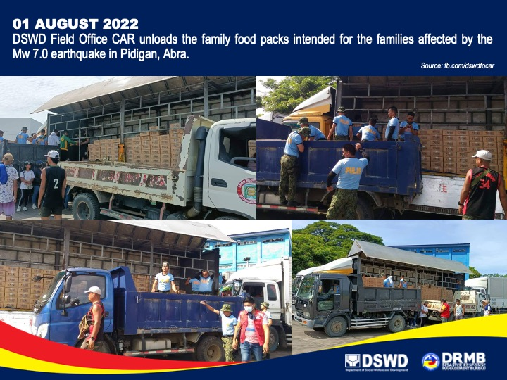

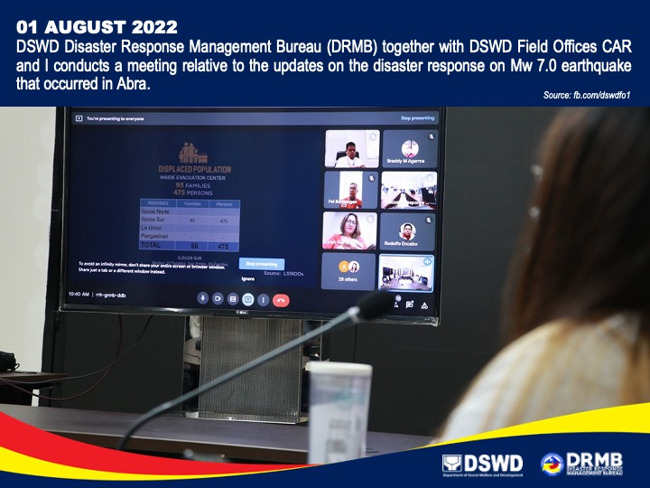

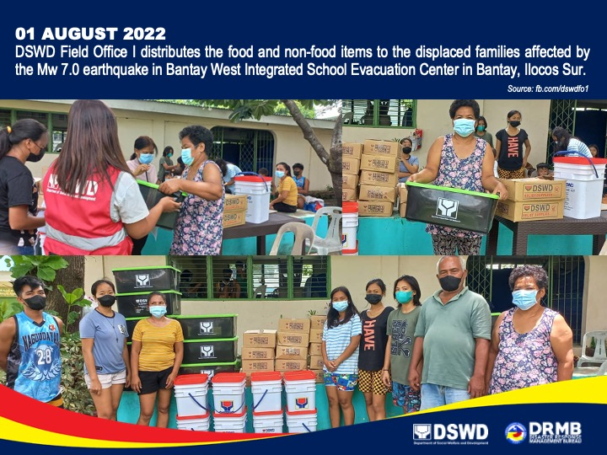

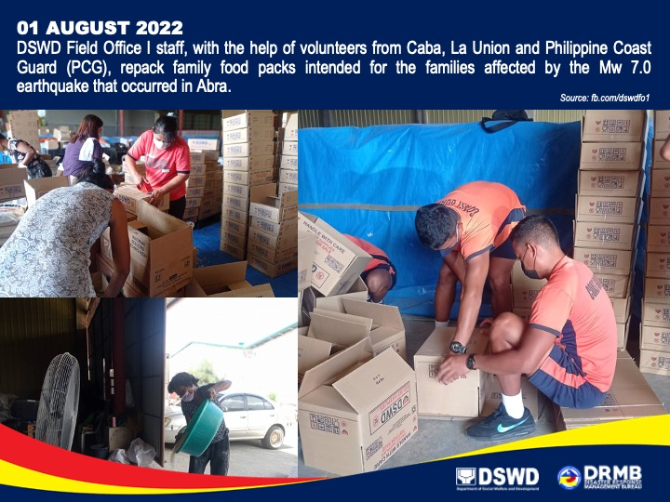

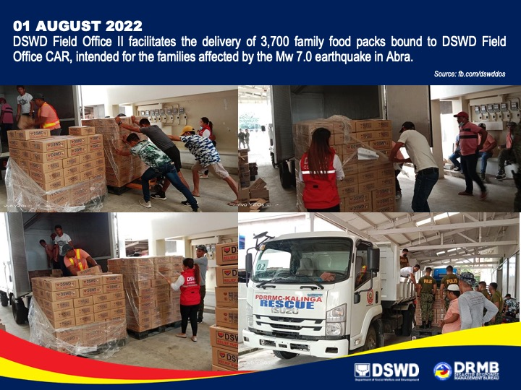

*****
The Disaster Response Operations Monitoring and Information Center (DROMIC) of the DSWD-DRMB is closely coordinating with the concerned DSWD FOs for any significant updates and actions taken relative to the Earthquake Incident.

Prepared by: Releasing Officer:

AARON JOHN B. PASCUA MARC LEO L. BUTAC
MARIE JOYCE G. RAFANAN
DIANE C. PELEGRINO

