DSWD DROMIC Report #2 on the Fire Incident in
Brgy. New Lower Bicutan, Taguig City
as of 07 August 2022, 6PM
- Situation Overview

On 04 August 2022 at 1:40 PM, a fire incident occurred at the DOTC Compound, Purok 1, Cabasaan Street, Brgy. New Lower Bicutan, Taguig City. The fire was declared under control at 2:49 PM. The cause of the fire is still under investigation.

Source: DSWD Field Office (FO) NCR

- Status of Affected Areas and Population

A total of 30 families or 129 persons are affected in Brgy. New Lower Bicutan, Taguig City (see Table 1).

Table 1. Number of Affected Families / Persons
REGION / PROVINCE / MUNICIPALITY | NUMBER OF AFFECTED
 | Barangays | Families | Persons
GRAND TOTAL | 1 | 30 | 129
NCR | 1 | 30 | 129
Metro Manila | 1 | 30 | 129
Taguig City | 1 | 30 | 129
Note: Ongoing assessment and validation being conducted.
Source: DSWD FO NCR

- Status of Displaced Population

- Inside Evacuation Center
There are 30 families or 129 persons currently taking temporary shelter at the Ricardo P. Cruz, Sr. Elementary School in Taguig City (see Table 2).

Table 2. Number of Displaced Families / Persons Inside Evacuation Center
REGION / PROVINCE / MUNICIPALITY | NUMBER OF EVACUATION CENTERS (ECs) |  | NUMBER OF DISPLACED
 |  |  | INSIDE ECs
 |  |  | Families |  | Persons
 | CUM | NOW | CUM | NOW | CUM | NOW
GRAND TOTAL | 1 | 1 | 30 | 30 | 129 | 129
NCR | 1 | 1 | 30 | 30 | 129 | 129
Metro Manila | 1 | 1 | 30 | 30 | 129 | 129
Taguig City | 1 | 1 | 30 | 30 | 129 | 129
Note: Ongoing assessment and validation being conducted.
Source: DSWD FO NCR

- Damaged Houses

A total of 20 houses were totally damaged in Brgy. New Lower Bicutan, Taguig City (see Table 3).

Table 3. Number of Damaged Houses
REGION / PROVINCE / MUNICIPALITY | NO. OF DAMAGED HOUSES
 | Total | Totally | Partially
GRAND TOTAL | 20 | 20 | -
NCR | 20 | 20 | -
Metro Manila | 20 | 20 | -
Taguig City | 20 | 20 | -
Note: Ongoing assessment and validation being conducted.
Source: DSWD FO NCR

- Cost of Humanitarian Assistance Provided

A total of ₱122,715.00 worth of assistance was provided by the DSWD to the affected families (see Table 4).

Table 4. Cost of Assistance Provided to Affected Families / Persons
REGION / PROVINCE / MUNICIPALITY | COST OF ASSISTANCE
 | DSWD | LGU | NGOs | OTHERS | GRAND TOTAL
GRAND TOTAL | 122,715.00 | - | - | - | 122,715.00
NCR | 122,715.00 | - | - | - | 122,715.00
Metro Manila | 122,715.00 | - | - | - | 122,715.00
Taguig City | 122,715.00 | - | - | - | 122,715.00
Source: DSWD FO NCR

- Response Actions and Interventions

- Standby Funds and Prepositioned Relief Stockpile
OFFICE | STANDBY FUNDS | STOCKPILE |  |  | TOTAL STANDBY FUNDS & STOCKPILE
 |  | FAMILY FOOD PACKS |  | OTHER FOOD AND NON-FOOD ITEMS (FNIs)
 |  | QUANTITY | TOTAL COST
TOTAL | 129,381,328.12 | 93,595 | 60,626,300.44 | 167,219,125.85 | 357,226,754.41
DSWD CO | 124,381,328.12 | - | - | - | 124,381,328.12
NRLMB NROC | - | 39,847 | 26,643,829.00 | 110,033,831.69 | 136,677,660.69
NRLMB VDRC | - | 51,729 | 32,831,910.00 | 49,058,205.80 | 81,890,115.80
DSWD FO NCR | 5,000,000.00 | 2,019 | 1,150,561.44 | 8,127,088.36 | 14,277,649.80
Note: The Inventory Summary is as of 07 August 2022, 4PM.
Source: DSWD-DRMB and DSWD-NRLMB

  - Standby Funds
    - ₱124.38 million Quick Response Fund (QRF) at the DSWD Central Office.
    - ₱5 million available at DSWD FO NCR.

  - Prepositioned FFPs and Other Relief Items
    - 91,576 FFPs available in Disaster Response Centers; of which, 39,847 FFPs are at the National Resource Operations Center (NROC), Pasay City and 51,729 FFPs are at the Visayas Disaster Resource Center (VDRC), Mandaue City.
    - 2,019 FFPs available at DSWD FO NCR.
    - ₱167.22 million worth of other FNIs at NROC, VDRC and DSWD FO NCR warehouses.
- Camp Coordination and Camp Management (CCCM)

DATE | ACTIVITIES
05 August 2022 | - The LGU of Taguig City through its City Social Welfare and Development Office (CSWDO) assisted the affected families at the evacuation center and served them hot meals.  - The LGU of Taguig City through its CSWDO coordinated with concerned agencies and conducted assessment and validation of the affected families using the Disaster Assistance Family Access Card (DAFAC) / White Card.

- Other Activities

DATE | ACTIVITIES
05 August 2022 | - DSWD FO NCR continuously coordinates with the LGU of Taguig City through its CSWDO for any request of augmentation support.

- Photo Documentation

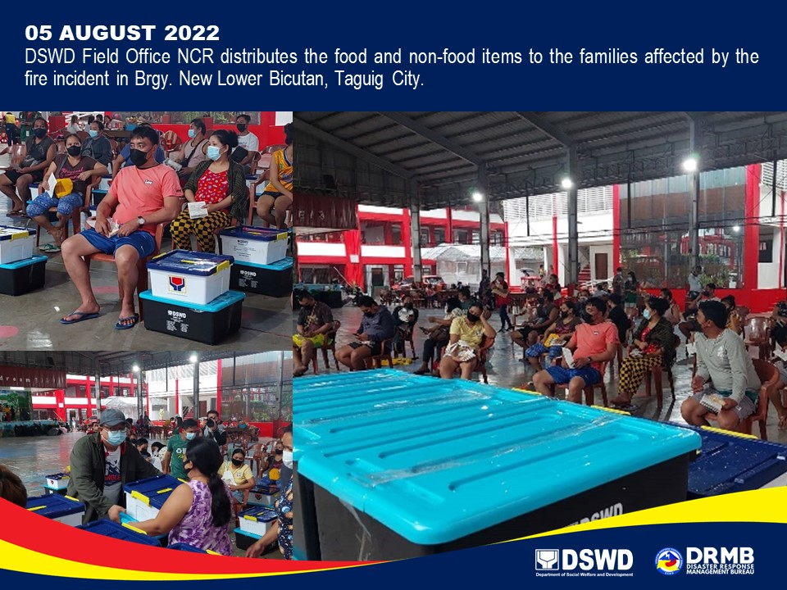

*****
The Disaster Response Operations Monitoring and Information Center (DROMIC) of DSWD-DRMB is closely coordinating with DSWD FO NCR for significant disaster response updates and assistance provided.

Prepared by:  DIANE C. PELEGRINO | Released by:  MARC LEO L. BUTAC

