DSWD DROMIC Report #2 on the Flashflood and
Landslide Incident in Naawan, Misamis Oriental
as of 04 October 2022, 6PM

- Situation Overview

On 17 August 2022 at around 12:30 PM, a flashflood and landslide incident occurred in Barangays Mapulog, Poblacion, Patag, and Tagbalogo in Naawan, Misamis Oriental after the Talaban River overflowed due to continuous rains caused by Southwest Monsoon. Barangay Tagbalogo was devastated by the landslide affecting families and individuals in the area.
Source: DOST-PAGASA Weather Bulletin and DSWD Field Office (FO) X

- Status of Affected Areas and Population

A total of 28 families or 140 persons are affected in Brgy. Tagbalogo, Naawan, Misamis Oriental (see Table 1).

Table 1. Number of Affected Families / Persons
REGION / PROVINCE / MUNICIPALITY |  | NUMBER OF AFFECTED
 |  | Barangays | Families | Persons
GRAND TOTAL |  | 1 | 28 | 140
REGION X |  | 1 | 28 | 140
Misamis Oriental |  | 1 | 28 | 140
 | Naawan | 1 | 28 | 140
Note: Ongoing assessment and validation being conducted.
Source: DSWD FO X

- Status of Displaced Population

- Outside Evacuation Center
There are 28 families or 140 persons temporarily staying with their relatives or friends in Naawan, Misamis Oriental (see Table 2).

Table 3. Number of Displaced Families / Persons Outside Evacuation Center
REGION / PROVINCE / MUNICIPALITY |  | NUMBER OF DISPLACED
 |  | OUTSIDE ECs
 |  | Families |  | Persons
 |  | CUM | NOW | CUM | NOW
GRAND TOTAL |  | 28 | 28 | 140 | 140
REGION X |  | 28 | 28 | 140 | 140
Misamis Oriental |  | 28 | 28 | 140 | 140
 | Naawan | 28 | 28 | 140 | 140
Source: DSWD FO X

- Damaged Houses

A total of 28 houses were partially damaged by the flashflood and landslide in Naawan, Misamis Oriental (see Table 3).

Table 3. Number of Damaged Houses
REGION / PROVINCE / MUNICIPALITY |  | NO. OF DAMAGED HOUSES
 |  | Total | Totally | Partially
GRAND TOTAL |  | 28 | - | 28
REGION X |  | 28 | - | 28
Misamis Oriental |  | 28 | - | 28
 | Naawan | 28 | - | 28
Note: Ongoing assessment and validation being conducted.
Source: DSWD FO X

- Cost of Humanitarian Assistance Provided

A total of ₱176,120.48 worth of assistance was provided to the affected families; of which, ₱168,620.48 from the DSWD and ₱7,500.00 from the Local Government Unit (LGU) (see Table 6).

Table 6. Cost of Assistance Provided to Affected Families / Persons
REGION / PROVINCE / MUNICIPALITY |  | COST OF ASSISTANCE
 |  | DSWD | LGU | NGOs | OTHERS | GRAND TOTAL
GRAND TOTAL |  | 168,620.48 | 7,500.00 | - | - | 176,120.48
REGION X |  | 168,620.48 | 7,500.00 | - | - | 176,120.48
Misamis Oriental |  | 168,620.48 | 7,500.00 | - | - | 176,120.48
 | Naawan | 168,620.48 | 7,500.00 | - | - | 176,120.48
Source: DSWD FO NCR

- Response Actions and Interventions

- Standby Funds and Prepositioned Relief Stockpile
OFFICE | STANDBY FUNDS | STOCKPILE |  |  | TOTAL STANDBY FUNDS & STOCKPILE
 |  | FAMILY FOOD PACKS |  | OTHER FOOD AND NON-FOOD ITEMS (FNIs)
 |  | QUANTITY | TOTAL COST
TOTAL | 125,632,764.98 | 82,079 | 54,990,802.50 | 231,269,423.50 | 411,892,990.98
DSWD CO | 120,389,264.48 | - | - | - | 120,389,264.48
NRLMB NROC | - | 32,321 | 21,736,638.00 | 144,862,900.04 | 166,599,538.04
NRLMB VDRC | - | 25,529 | 16,498,910.00 | 41,847,961.50 | 58,346,871.50
DSWD FO X | 5,243,500.50 | 24,229 | 16,755,254.50 | 44,558,561.96 | 66,557,316.96
Note: The Inventory Summary is as of 04 October 2022, 4PM.
Source: DSWD-DRMB and DSWD-NRLMB

  - Standby Funds
    - ₱120.39 million Quick Response Fund (QRF) at the DSWD Central Office.
    - ₱5.2 million available at DSWD FO X.

  - Prepositioned FFPs and Other Relief Items
    - 57,850 FFPs available in Disaster Response Centers; of which, 32,321 FFPs are at the National Resource Operations Center (NROC), Pasay City and 25,529 FFPs are at the Visayas Disaster Resource Center (VDRC), Mandaue City.
    - 24,229 FFPs available at DSWD FO X.
    - ₱231.27 million worth of other FNIs at NROC, VDRC, and DSWD FO X warehouses.

- Food and Non-food Items (FNIs)

DATE | ACTIVITIES
03 October 2022 | - DSWD FO X provided a total of 28 FFPs, 28 family kits, 28 hygiene kits, and 28 sleeping kits to the affected families.

- Other Activities

DATE | ACTIVITIES
16 September 2022 | - DSWD FO X continuously coordinates with the LGU of Naawan, Misamis Oriental for any request of relief augmentation.

- Photo Documentation

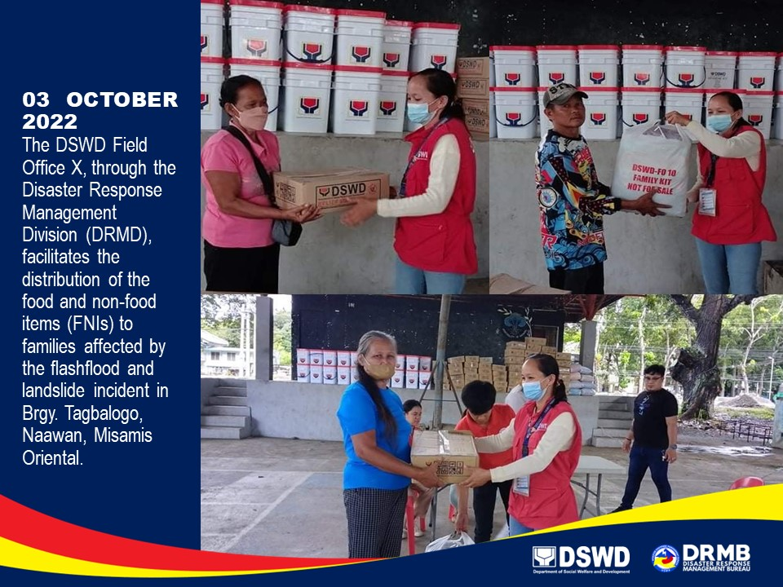

*****
The Disaster Response Operations Monitoring and Information Center (DROMIC) of DSWD-DRMB is closely coordinating with DSWD FO X for significant disaster response updates and assistance provided.

Prepared by:  AARON JOHN B. PASCUA  MARIE JOYCE G. RAFANAN | Released by:  MARC LEO L. BUTAC

