DSWD DROMIC Report on the Fire Incident in
Brgy. Domanpot, Asingan, Pangasinan
03 January 2023, 6PM

- Situation Overview
On 05 September 2022, at around 10:53 in the morning, a residential fire incident transpired in Brgy. Domanpot, Asingan, Pangasinan.
Source: DSWD Field Office (FO) ###

- Status of Affected Areas and Population

A total of two (2) families or seven (7) persons were affected by the fire incident in Brgy. Domanpot, Asingan, Pangasinan (see Table 1).

Table 1. Number of Affected Families / Persons
REGION / PROVINCE / MUNICIPALITY | NUMBER OF AFFECTED
 | Barangays | Families | Persons
GRAND TOTAL | 1 | 2 | 7
REGION I | 1 | 2 | 7
Pangasinan | 1 | 2 | 7
Asingan | 1 | 2 | 7
Source: DSWD FO I

- Status of Displaced Population

- Outside Evacuation Centers
A total of two (2) families or seven (7) persons sought temporary shelter with their relatives and/or friends (see Table 2).

Table 2. Number of Displaced Families / Persons Outside Evacuation Centers
REGION / PROVINCE / MUNICIPALITY | NUMBER OF DISPLACED
 | OUTSIDE ECs
 | Families |  | Persons
 | CUM | NOW | CUM | NOW
GRAND TOTAL | 2 | 2 | 7 | 7
REGION I | 2 | 2 | 7 | 7
Pangasinan | 2 | 2 | 7 | 7
Asingan | 2 | 2 | 7 | 7
Source: DSWD FO I

- Damaged Houses
A total of 2 (two) houses were totally damaged in Brgy. Domanpot, Asingan, Pangasinan (see Table 3).

Table 3. Number of Damaged Houses
REGION / PROVINCE / MUNICIPALITY | NO. OF DAMAGED HOUSES
 | Total | Totally | Partially
GRAND TOTAL | 2 | 2 | -
REGION I | 2 | 2 | -
Pangasinan | 2 | 2 | -
Asingan | 2 | 2 | -
Source: DSWD FO I

- Cost of Humanitarian Assistance Provided
A total of ₱35,730.90 worth of assistance was provided to the affected families; of which ₱13,330.90 was from DSWD and ₱22,400.00 from the Local Government Unit (LGU) (see Table 4).

Table 4. Cost of Assistance Provided to Affected Families / Persons
REGION / PROVINCE / MUNICIPALITY | COST OF ASSISTANCE
 | DSWD | LGU | NGOs | OTHERS | GRAND TOTAL
GRAND TOTAL | 13,330.90 | 22,400.00 | - | - | 35,730.90
CAR | 13,330.90 | 22,400.00 | - | - | 35,730.90
Benguet | 13,330.90 | 22,400.00 | - | - | 35,730.90
Bakun | 13,330.90 | 22,400.00 | - | - | 35,730.90
Note: The reflected DSWD assistance only covers the cost of relief items distributed to different affected areas.

Source: DSWD FO ###

- PHOTO DOCUMENTATION

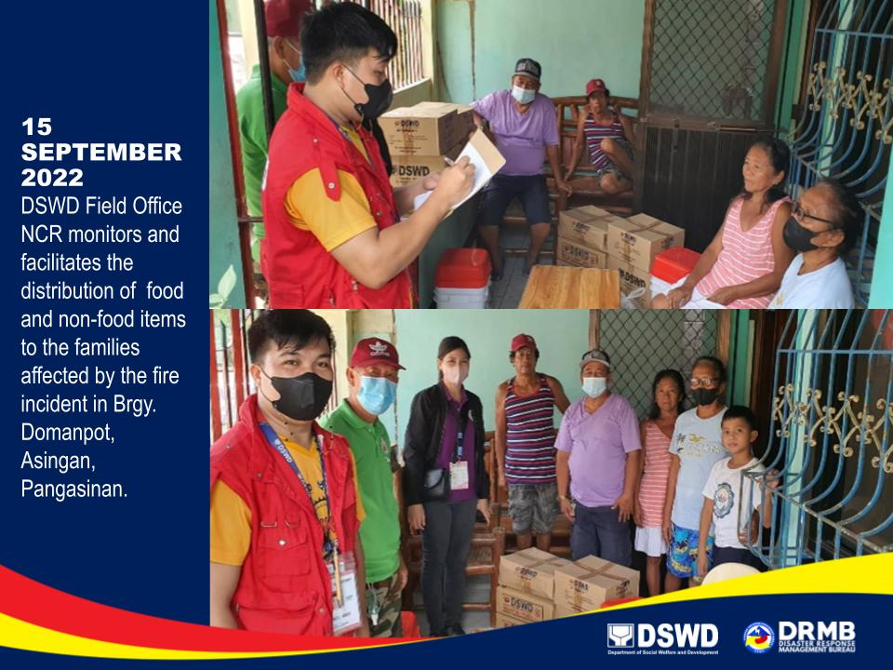
*****

This first and final report is based on the latest report submitted by DSWD FO I on 15 September 2022. The Disaster Response Operations Monitoring and Information Center (DROMIC) of DSWD-DRMB continues to closely coordinate with DSWD FO I for any request of Technical Assistance and Resource Augmentation (TARA).

Prepared by:  JOANNA CAMILLE R. JACINTO-LIZARDO | Reviewed by:  RODEL V. CABADDU  DROMIC-DRICDS
Released by:

KRYSTIAN HAROLD J. JAVIER
Officer-in-Charge, DROMIC

